| 9

# Test Matrices and Conditions

2

### GENERAL

limited series of crash tests are recommended to evaluate each class of roadside safety feature.

A

The purpose of this testing is to provide an established minimum level of performance for safety features as well as a basis for comparing different designs within each class. Each of the recommended tests is designed to assess one or more of the three principal evaluation criteria: occupant risk, vehicle trajectory, and structural adequacy. Further, as mentioned previously, the crash testing guidelines cannot include all possible impact conditions that may be experienced in the real world and it is not practical or feasible to test for all possible impact conditions. However, if a signifi cant “window of vulnerability” is identifi ed for any given design, the test matrices should be supplemented to explore the additional impact conditions.

The primary parameters that defi ne a full-scale crash test include impact speed, impact angle, test vehicle mass, and impact location. Each of these parameters is selected to represent a “worst practical condition” for a roadside feature crash. For impact speed and angle, the “worst practical condition” has been traditionally set at the 85th percentile level. Test vehicles are normally selected based upon vehicle body style and weight. Weights have generally been selected to approximate the 5th and 95th percen- tile levels for passenger vehicles. Impact locations on a safety feature are often selected to represent a critical impact point (CIP) that creates the greatest probability of test failure. Hence, the combination of 85th percentile impact speed, 85th percentile impact angle, 2nd and 90th percentile vehicle weights, and critical impact point is believed to represent a worst practical condition.

Note that many safety features, including guardrail terminals, crash cushions, and truck-mounted atten- uators, are designed to accommodate end-on impacts. Crash testing has shown that high-angle, end-on impacts on these features are much less likely to result in serious injury than impacts with lower angles. In keeping with the spirit of the “worst practical condition” philosophy, impact angles for end-on crash tests have been set well below the 85th percentile level.

* + 1. IMPACT CONDITIONS

The best available information from reconstruction of run-off-the-road passenger vehicle crashes on high-speed roadways (81, 86) indicates that the impact speed of 62 mph (100 km/h) and the impact angle of 25 degrees approximate the 85th percentile of the respective real-world impact conditions. Therefore, these

10 | Manual for Assessing Safety Hardware

values were selected to represent the limiting impact conditions for high-speed, high-volume roadways.

For lower volume, lower speed facilities, or both, the impact speed was reduced from 62 mph

(100 km/h) to 44 mph (70 km/h) or 31 mph (50 km/h), as appropriate. In recognition of the reduced cornering characteristics of large trucks, the impact angles for all large truck tests are reduced to 15 degrees. Impact speeds for single-unit trucks have also been reduced to 56 mph (90 km/h) while those for the heavy tractor-trailer type trucks are reduced to 50 mph (80 km/h) to further compensate for the lower operating speed and reduced cornering capabilities associated with combination vehicles.

Selection of the type, size, and weight of the test vehicles could have a signifi cant bearing on the magnitude of the impact associated with the crash tests. Both small and large passenger vehicles can pose a signifi cant and unique set of challenges for most types of roadside safety hardware. Evaluation of 2002 vehicle sales (147) reveals that weights of all classes of passenger vehicles have risen signifi - cantly since these guidelines were last revised (119). In order to minimize the weight increase while maintaining a large enough sales volume to assure ready availability of the test vehicles, the small car test vehicle was selected to be representative of the 2nd percentile heaviest passenger vehicle (instead of the traditional 5th percentile), and the light truck test vehicle was selected to be representative of the 90th percentile (instead of the traditional 95th percentile) heaviest passenger vehicle. The selected test vehicles are a sedan weighing approximately 2,420 lb (1,100 kg) for the small car test vehicle (designation 1100C) and a four-door, two-wheel drive, half-ton pickup truck weighing 5,000 lb (2,270 kg) for the light truck test vehicle (designation 2270P). An alternative test vehicle, designated as 1500A, was also identifi ed for use in evaluating the impact performance of staged energy absorb- ing systems. The 1500A test vehicle is a four-door passenger sedan weighing approximately 3,300 lb (1,500 kg). Three heavy truck test vehicles—a 22,000-lb (10,000-kg) single-unit truck, an 80,000-lb (36,000-kg) tractor-van-trailer combination, and an 80,000-lb (36,000-kg) tractor-tank-trailer combination—have also been identifi ed for evaluation of higher performance barriers. These vehicles are designated as 10000S, 36000V and 36000T, respectively. Detailed specifi cations for the test ve- hicles are presented in Chapter 4.

Impact locations for most full-scale crash tests are selected to represent the critical condition that would be most likely to lead to test failure. For longitudinal barriers, critical impact points (CIPs) are selected to maximize loading at rail splices and maximize the potential for wheel snag and vehicle pocketing. Note that any splice connection expected to be used in the fi eld must be implemented in the critical region during full-scale crash testing. Critical impact points for post-and-beam type bar- rier terminals and crash cushions are selected to represent the point where the system is believed to transition from gating to redirective behavior. General guidelines for selecting CIP locations for each class of safety feature are described in Section 2.3. Where possible, testing agencies are encouraged to utilize more detailed analysis, such as computer simulation, to estimate the CIP location for each full-scale crash test. Detailed procedures for estimating CIP locations for roadside safety features are presented elsewhere (115) and will not be repeated herein.

Chapter 2—Test Matrices and Conditions

| 11

* + 1. TOLERANCES ON IMPACT CONDITIONS

Most testing agencies use vehicular tow and cable guidance systems to propel a vehicle into a test article. Although these propulsion and guidance systems are reasonably accurate, modest variations in impact speed and angle are not uncommon. However, large deviations from target impact conditions can signifi cantly alter the severity of a test. Thus, reasonable limits must be established for both im- pact speed and angle. Testing agencies have demonstrated an ability to control impact speeds within a range of ±2.5 mph (4.0 km/h) from the target condition and to obtain actual impact angles within ±1.5 degrees of the desired value. Therefore, these limits are selected as the maximum tolerance for impact speed and angle. For crash tests with a target speed of 44 mph (70.0 km/h) or more, the actual impact speed should be no less than 2.5 mph (4 km/h) below the desired impact speed. For tests involv-

ing vehicle redirection, the impact angle should be no more than 1.5 degrees below the target value. Tolerances for crash tests with a target speed below 31 mph (50.0 km/h) are limited only by vehicle kinetic energy as described in the following paragraphs.

In some circumstances, longitudinal barriers (e.g., flexible cable barriers) may be positioned within sloped medians in order to shield motorists from obstacles and/or prevent cross-median crashes. For these situations, longitudindal barriers should be crash tested and evaluated with the barriers installed in representative sloped median terrain. When barriers are placed on sloped terrain, such as a flexible cable barrier placed within a median ditch, the target impact conditions (i.e., speed and angle) should be referenced to the time when the vehicle reaches the front slope break point (SBP). For most barriers placed on the front slope of depressed median ditches, vehicles will impact barriers with speeds and angles similar to those exhibited at the front SBP, except for minor speed changes attributed to free fall while extended over the front slopes prior to barrier contact and aerodynamic drag. For barriers positioned on the back slope of depressed median ditches, there is an increased likelihood of deviations in vehicle impact speed and angle due to vehicle-ground contact as the vehicle traverses through the ditch prior to barrier contact. For these events, testing laboratories should also document actual impact conditions as the vehicle strikes the barrier as best as possible.

The severity of an impact is normally measured in terms of impact severity (IS) for crash tests involv- ing vehicle redirection and kinetic energy (KE) for crash tests involving end-on impacts or breakaway devices. IS, as defi ned in Equation 2-1, has been shown to be a good indicator of the magnitude of loading on a longitudinal barrier.

IS = 1 2

*M* (*V* sin θ)2

(Eq. 2-1)

Where:

IS = impact severity, kip-ft (kJ)

*M* = vehicle mass, lb (kg)

*V* = impact speed, ft/s (m/s)

θ = impact angle, degrees

Total vehicle kinetic energy (KE), as defi ned in Equation 2-2, is considered a better measure of the severity of all head-on or end-on impacts, including tests of breakaway devices, crash cushions, ter- minals, and truck-mounted attenuators. Note that KE is also used as the measure of crash severity for oblique impacts on the ends of terminals and crash cushions.

2

KE =

1 2 *MV2*

(Eq. 2-2)

Where:

KE = kinetic energy, kip-ft (kJ)

Even when test speeds and impact angles are within the acceptable tolerances, the IS or KE values of a crash test can be unacceptably low. For this reason, an additional limiting condition is applied to the IS and KE values for full-scale crash tests. IS values for tests involving vehicular redirection and KE values for high-speed tests involving end-on impacts must be no more than 8 percent below the target values. For most full-scale crash tests, excessive impact speeds and angles do not improve the

likelihood of a successful test. Therefore, excessive speed and angles are not considered to be a cause for failing these tests, provided all impact performance evaluation criteria are met. The exceptions to

12 | Manual for Assessing Safety Hardware

this general rule are the low-speed tests, i.e., 19-mph (30-km/h) tests for support structures and work-zone traffi c control devices, and 31-mph (50-km/h) test for breakaway utility poles. Since these low-speed tests are intended to evaluate the kinetic energy required to activate the breakaway, fracture, or yielding mechanism of the device, it is recommended that the KE value should be no greater than 20 percent above the target value. Tests that do not fall into the acceptable ranges for IS or KE are considered to be invalid and should be repeated. Acceptable ranges for IS and KE values are listed in the crash test description tables in Section 2.2. Note that limiting IS and KE values are calculated based upon the vehicle test inertial mass and exclude the weight of loose ballast or dum- mies used in the test.

Although test vehicles are selected to have the appropriate mass, it is sometimes impossible to adjust vehicle weight to exactly match target values. Excessive vehicle mass can increase bar- rier loadings and can sometimes enhance vehicle stability. Similarly, inadequate vehicle mass can reduce barrier loading and possibly decrease vehicle stability. Therefore, upper and lower limits

have been established on vehicle gross static mass, as shown in Table 2-1. Note that ballast can be added to increase test vehicle mass and some vehicle components can be removed to decrease mass. Details of vehicle mass adjustment procedures are presented in Chapter 4.

Impact locations are normally selected to maximize the risk of test failure. Obviously, large errors in the impact location can dramatically affect the safety feature performance. Most vehicle guidance systems used in roadside safety testing have limited levels of accuracy. Based on a survey of crash testing laboratories, acceptable variations in target impact location have been established: 12 in. (300 mm) for side impacts and 6 in. (150 mm) for frontal collisions. In other words, the recom- mended maximum acceptable tolerance for the impact point is ±12 in. (300 mm), as measured along the face of the barriers, for tests of longitudinal barriers and sides of terminals or crash cushions. Similarly, test vehicles involved in frontal impacts, including tests of crash cushions, terminals, and structural supports, should contact the test article within ±6 in. (150 mm) of the target impact point as measured along the front of the test vehicle. Recommended impact points for all tests are pre- sented in Section 2.3.

TABLE 2-1. Vehicle Test Inertial Mass Upper and Lower Limits

|  |  |  |
| --- | --- | --- |
| **Test Vehicle Designation and Type** | **Target Vehicle Weight, lb (kg)** | **Acceptable Variation, lb (kg)** |
| 1100C (Passenger Car) | 2,420 (1,100) | ±55 (25) |
| 1500A (Passenger Car) | 3,300 (1,500) | ±220 (100) |
| 2270P (Pickup Truck) | 5,000 (2,270) | ±110 (50) |
| 10000S (Single-Unit Truck) | 22,000 (10,000) | ±660 (300) |
| 36000V (Tractor-Van Trailer) | 79,300 (36,000) | ±1,100 (500) |
| 36000T (Tractor-Tank Trailer) | 79,300 (36,000) | ±1,100 (500) |

Chapter 2—Test Matrices and Conditions

| 13

* + 1. SAFETY FEATURE ORIENTATION

Crash test conditions described in this chapter are relative to the alignment of the roadway. Because safety hardware is normally designed to be placed parallel to the roadway, vehicle impact angles relative to tested safety features will normally be the same when measured from the centerline of the tested system. However, some classes of hardware, such as fl ared guardrail terminals, are designed to be placed at an angle relative to the roadway. Safety features should be tested with the centerline ori- ented as it normally would be in service. Because impact angles are measured relative to the roadway alignment, actual impact angles measured relative to the system’s centerline for fl ared guardrail termi- nals and other systems not normally installed parallel to the roadway may be higher or lower than the values shown in the following sections.

### TEST MATRICES

* + 1. LONGITUDINAL BARRIERS

###### General

All longitudinal barriers, including roadside barriers, bridge rails, median barriers, and temporary barriers, are designed to contain, redirect, and shield vehicles from roadside obstacles. Therefore, the following evaluation guidelines apply to all barrier types. Barrier transition systems must be designed in concert with barrier development. Therefore, as shown in Table 2-2A, full-scale crash testing is recommended for both within the length-of-need (LON) and at the transition between two different barrier types. Note that, when two adjacent barriers have drastically different stiffness, the transition design often incorporates two signifi cant stiffness changes, one from the more fl exible barrier to the transition section and the other from the transition section to the more rigid barrier, both of which

can produce vehicle rollover, pocketing, or rail rupture (99). In this situation, the user should conduct transition testing at both locations, i.e., upstream of the end of the more fl exible barrier and upstream of the more rigid barrier.

Roadside barriers are generally classified according to stiffness into one of three categories: fl exible, semi-rigid, and rigid. Although the test matrix is the same for all three classifi cations of barrier, some consideration should be given to the type of barrier when constructing the test installation. Height variations during construction can adversely affect barrier performance. Increased mounting height is most likely to adversely affect barrier performance for small car impacts while reduced height is considered most likely to affect barrier performance for light truck impacts. Thus, for barrier systems with large allowable variations in mounting heights, small car tests should be conducted with barrier rail elements installed at the maximum acceptable height and light truck tests should be conducted with rail elements at the minimum acceptable height. Refer to Section 3.4.2 for specifi c installation details of various barriers.

When shielding motorists from roadside or median obstacles, it may be desired or necessary to install longitudinal barriers on roadside or median slopes. For example, it is not uncommon for flexible cable barrier to be placed within a depressed median. In these circumstances, full-scale crash testing should also be performed on barriers installed on or near sloped terrain representative of actual field conditions. Toward this goal, test matrices have been developed for evaluating cable barriers placed in depressed medians, more specifically symmetric V-shaped ditches. Successful testing and evaluation of cable barriers installed in V-ditches should allow for their placement in other less critical ditch configurations, such as stepped medians or flat bottom trapezoidal ditches. It should be noted that these test matrices were developed only for Test Level 3 (TL-3) applications. If a Test Level 4 (TL-4) cable barrier system is desired, it is recommended that any additional crash testing with large single-unit trucks be performed with the cable barrier installed on level or relatively flat terrain. These matrices were primarily developed based on research results obtained from a vehicle trajectory study of simulated small car, mid-size sedan, and light-truck passenger vehicle encroachments into 4H:1V and 6H:1V V-ditches at a speed of 62 mph and at an angle of 25 degrees (150). Further refinement of the test matrices occurred using results from prior crash tests of cable barriers placed in V-ditches and input from roadside safety experts and test laboratories.

For 4H:1V and 6H:1V median ditches, crash test matrices are provided for evaluating: (1) a single cable barrier system placed anywhere within a median ditch; (2) a single cable barrier system placed between 0 to 4 ft beyond the front or back slope break point (SBP); and (3) two cable barrier systems (i.e., double cable barrier) placed within a median ditch, each 0 to 4 ft away from a SBP. For single and double cable barrier systems placed at 0 to 4 ft away from a SBP, the test matrix is a subset of the matrix developed for placement of a cable barrier system anywhere within the ditch. Guidance for determining the appropriate subset of required crash tests is provided below. For cable barriers installed in 4H:1V depressed medians, a 46-ft wide ditch is recommended for the crash testing program. A 30-ft wide ditch is recommended for evaluating cable barriers installed in 6H:1V depressed medians. These widths were determined based on vehicle trajectory and kinematics through the ditch derived from vehicle dynamics simulations and crash testing experience. Further details for crash testing cable barriers installed on slopes or in ditches are provided below. Test matrices for the selected cable barrier-ditch combinations are summarized in Tables 2-2B through 2-2E. Recommended cable barrier placement for testing and evaluating cable barrier systems in 4H:1V and 6H:1V V-ditches is provided in Figures 2-2 and 2-3, respectively.

###### Description of Tests

These procedures establish a two digit naming system consistent with NCHRP Report 350 (119) for full-scale crash tests. The first digit is used to identify the test level followed by the second digit that identifi es the specific test in the series for each type of feature.

14 | Manual for Assessing Safety Hardware

TABLE 2-2A. Recommended Test Matrices for Longitudinal Barriers

|  |  |  |  |  |  |  |  |  |
| --- | --- | --- | --- | --- | --- | --- | --- | --- |
| **Test Level** | **Barrier Sectionc** | **Test No.** | **Vehic.** | **Impact Speed,a mph (km/h)** | **Impact Angle,a** θ**, deg.** | **Im- pact Point** | **Acceptable IS Range,a kip-ft (kJ)** | **Evaluation Criteriab** |
| 1 | Length-of- | 1-10 | 1100C | 31 (50.0) | 25 | (c) | ≥13 (17.4) | A,D,F,H,I |
| need | 1-11 | 2270P | 31 (50.0) | 25 | (c) | ≥27 (36.0) | A,D,F,H,I |
| Transition | 1-20d  1-21 | 1100C  2270P | 31 (50.0)  31 (50.0) | 25  25 | (c)  (c) | ≥13 (17.4)  ≥27 (36.0) | A,D,F,H,I  A,D,F,H,I |
| 2 | Length-of- | 2-10 | 1100C | 44 (70.0) | 25 | (c) | ≥25 (34.2) | A,D,F,H,I |
| need | 2-11 | 2270P | 44 (70.0) | 25 | (c) | ≥52 (70.5) | A,D,F,H,I |
| Transition | 2-20d  2-21 | 1100C  2270P | 44 (70.0)  44 (70.0) | 25  25 | (c)  (c) | ≥25 (34.2)  ≥52 (70.5) | A,D,F,H,I  A,D,F,H,I |
| 3 | Length-of- | 3-10 | 1100C | 62 (100.0) | 25 | (c) | ≥51 (69.7) | A,D,F,H,I |
| need | 3-11 | 2270P | 62 (100.0) | 25 | (c) | ≥106 (144) | A,D,F,H,I |
| Transition | 3-20d  3-21 | 1100C  2270P | 62 (100.0)  62 (100.0) | 25  25 | (c)  (c) | ≥51 (69.7)  ≥106 (144) | A,D,F,H,I  A,D,F,H,I |
| 4 | Length-of- need | 4-10  4-11  4-12 | 1100C  2270P  10000S | 62 (100.0)  62 (100.0)  56 (90.0) | 25  25  15 | (c)  (c)  (c) | ≥51 (69.7)  ≥106 (144)  ≥142 (193) | A,D,F,H,I  A,D,F,H,I A,D,G |
| Transition | 4-20d | 1100C | 62 (100.0) | 25 | (c) | ≥51 (69.7) | A,D,F,H,I |
| 4-21 | 2270P | 62 (100.0) | 25 | (c) | ≥106 (144) | A,D,F,H,I |
| 4-22 | 10000S | 56 (90.0) | 15 | (c) | ≥142 (193) | A,D,G |
| 5 | Length-of- need | 5-10  5-11  5-12 | 1100C  2270P  36000V | 62 (100.0)  62 (100.0)  50 (80.0) | 25  25  15 | (c)  (c)  (c) | ≥51 (69.7)  ≥106 (144)  ≥404 (548) | A,D,F,H,I  A,D,F,H,I A,D,G |
| Transition | 5-20d | 1100C | 62 (100.0) | 25 | (c) | ≥51 (69.7) | A,D,F,H,I |
| 5-21 | 2270P | 62 (100.0) | 25 | (c) | ≥106 (144) | A,D,F,H,I |
| 5-22 | 36000V | 50 (80.0) | 15 | (c) | ≥404 (548) | A,D,G |
| 6 | Length-of- need | 6-10  6-11  6-12 | 1100C  2270P  36000T | 62 (100.0)  62 (100.0)  50 (80.0) | 25  25  15 | (c)  (c)  (c) | ≥51 (69.7)  ≥106 (144)  ≥404 (548) | A,D,F,H,I  A,D,F,H,I A,D,G |
| Transition | 6-20d | 1100C | 62 (100.0) | 25 | (c) | ≥51 (69.7) | A,D,F,H,I |
| 6-21 | 2270P | 62 (100.0) | 25 | (c) | ≥106 (144) | A,D,F,H,I |
| 6-22 | 36000T | 50 (80.0) | 15 | (c) | ≥404 (548) | A,D,G |

a See Section 2.1.2 for tolerances on impact conditions. b See Table 5-1.

c See Figure 2-1 and Section 2.3.2 for impact point. d Test is optional.

TABLE 2-2B. Recommended TL-3 Test Matrix for Single Median Barrier Designed for Placement Anywhere in 4H:1V V-Ditch

|  |  |  |  |  |  |  |  |  |  |
| --- | --- | --- | --- | --- | --- | --- | --- | --- | --- |
| **Test**  **Designation**  **No.** | **Vehicle**  **Type** | **Impact**  **Conditions** | | **V-Ditch**  **Width**  **(ft)** | **Barrier**  **Position** | **Barrier**  **Locationa** | **Critical Impact Point** | **Acceptable**  **IS Rangeb**  **kip-ft (kJ)** | **Evaluation**  **Criteriac** |
| **Speed, mph**  **(km/h)** | **Angle**  **(deg)** |
| 3-10 | 1100C | 62 (100) | 25 | NA | Level Terrain | NA | Midspan Location | ≥51 (69.7) | A,D,F,H,I |
| 3-11 | 2270P | 62 (100) | 25 | NA | Level Terrain | NA | 1 ft Upstream from Post | ≥106 (144) | A,D,F,H,I |
| 3-13 | 2270P | 62 (100) | 25 | 46 | Front Slope | 12 ft from Front SBP | 1 ft Upstream from Post | ≥106 (144) | A,D,F,H,I |
| 3-14 | 1100C | 62 (100) | 25 | 46 | Front Slope | 12 ft from Front SBP | Midspan Location | ≥51 (69.7) | A,D,F,H,I |
| 3-15 | 1100C | 62 (100) | 25 | 46 | Back Slope | 4 ft from Ditch Bottom | Midspan Location | ≥51 (69.7) | A,D,F,H,I |
| 3-16 | 1100C | 62 (100) | 25 | 46 | Back Slope | 4 ft from Back SBP | Midspan Location | ≥51 (69.7) | A,D,F,H,I |
| 3-17 | 1500A | 62 (100) | 25 | 46 | Front Slope | Variable(d) | Midspan Location | ≥70 (95.1) | A,D,F,H,I |
| 3-18 | 2270P | 62 (100) | 25 | 46 | Back Slope | 8 ft from Back SBP | 1 ft Upstream from Post | ≥106 (144) | A,D,F,H,I |

a – See Figure 2-2A for barrier placement.

b – See Section 2.1.2 for tolerances on impact conditions.

c – See Table 5-1.

d – Testing laboratory should determine critical barrier position on front slope of ditch in order to maximize propensity for front end of 1500A vehicle to penetrate between vertically adjacent cables. Critical factors may include vertical cable spacing, position of cables relative to front bumper, location and type of cable release mechanisms, trajectory of vehicle’s front bumper, etc.

SBP – Slope Break Point

NA – Not Applicable

TABLE 2-2C. Recommended TL-3 Test Matrix for Single or Double Median Barrier Designed for Placement Between 0 to 4-ft Offset from Slope Break Point of 4H:1V V-Ditch

|  |  |  |  |  |  |  |  |  |  |
| --- | --- | --- | --- | --- | --- | --- | --- | --- | --- |
| **Test**  **Designation**  **No.** | **Vehicle**  **Type** | **Impact Conditions** | | **V-Ditch**  **Width**  **(ft)** | **Barrier**  **Position** | **Barrier**  **Locationa** | **Critical Impact Point** | **Acceptable**  **IS Rangeb**  **kip-ft (kJ)** | **Evaluation**  **Criteriac** |
| **Speed, mph**  **(km/h)** | **Angle**  **(deg)** |
| 3-10 | 1100C | 62 (100) | 25 | NA | Level Terrain | NA | Midspan Location | ≥51 (69.7) | A,D,F,H,I |
| 3-11 | 2270P | 62 (100) | 25 | NA | Level Terrain | NA | 1 ft Upstream from Post | ≥106 (144) | A,D,F,H,I |
| 3-13 | 2270P | 62 (100) | 25 | 46 | Front Slope | 4 ft from Front SBP | 1 ft Upstream from Post | ≥106 (144) | A,D,F,H,I |
| 3-14 | 1100C | 62 (100) | 25 | 46 | Front Slope | 4 ft from Front SBP | Midspan Location | ≥51 (69.7) | A,D,F,H,I |
| 3-15d,e | 1100C | 62 (100) | 25 | 46 | Back Slope | 4 ft from Ditch Bottom | Midspan Location | ≥51 (69.7) | A,D,F,H,I |
| 3-16e | 1100C | 62 (100) | 25 | 46 | Back Slope | 4 ft from Back SBP | Midspan Location | ≥51 (69.7) | A,D,F,H,I |
| 3-17 | 1500A | 62 (100) | 25 | 46 | Front Slope | Variable(f) | Midspan Location | ≥70 (95.1) | A,D,F,H,I |
| 3-18e | 2270P | 62 (100) | 25 | 46 | Back Slope | 8 ft from Back SBPg | 1 ft Upstream from Post | ≥106 (144) | A,D,F,H,I |

a – See Figure 2-2A for barrier placement.

b – See Section 2.1.2 for tolerances on impact conditions.

c – See Table 5-1.

d – Test no. 15 is unnecessary for V-ditches greater than or equal to 26 ft, as measured from front SBP to back SBP.

e – Test nos. 15, 16, and 18 are unnecessary for double median barrier system placed within median ditch, one on each side and 0 to 4 ft from a SBP.

f – Testing laboratory should determine critical barrier position from 0 to 4 ft on front slope of ditch in order to maximize propensity for front end of 1500A vehicle to penetrate between adjacent vertical cables. Critical factors may include vertical cable spacing, position of cables relative to front bumper, location and type of cable release mechanisms, trajectory of vehicle’s front bumper, etc.

g – A 46-ft wide ditch was selected to simplify the test matrix, thus resulting in barrier placement beyond the 0 to 4 ft range. However, narrower ditch widths provided similar risks for override with a barrier placed at the back SBP.

SBP – Slope Break Point

NA – Not Applicable

TABLE 2-2D. Recommended TL-3 Test Matrix for Single Median Barrier Designed for Placement Anywhere in 6H:1V V-Ditch

|  |  |  |  |  |  |  |  |  |  |
| --- | --- | --- | --- | --- | --- | --- | --- | --- | --- |
| **Test**  **Designation**  **No.** | **Vehicle**  **Type** | **Impact**  **Conditions** | | **V-Ditch**  **Width**  **(ft)** | **Barrier**  **Position** | **Barrier**  **Locationa** | **Critical Impact Point** | **Acceptable**  **IS Rangeb**  **kip-ft (kJ)** | **Evaluation**  **Criteriac** |
| **Speed, mph**  **(km/h)** | **Angle**  **(deg)** |
| 3-10 | 1100C | 62 (100) | 25 | NA | Level Terrain | NA | Midspan Location | ≥51 (69.7) | A,D,F,H,I |
| 3-11 | 2270P | 62 (100) | 25 | NA | Level Terrain | NA | 1 ft Upstream from Post | ≥106 (144) | A,D,F,H,I |
| 3-13 | 2270P | 62 (100) | 25 | 30 | Front Slope | 9 ft from Front SBP | 1 ft Upstream from Post | ≥106 (144) | A,D,F,H,I |
| 3-14 | 1100C | 62 (100) | 25 | 30 | Front Slope | 9 ft from Front SBP | Midspan Location | ≥51 (69.7) | A,D,F,H,I |
| 3-15 | 1100C | 62 (100) | 25 | 30 | Back Slope | 4 ft from Ditch Bottom | Midspan Location | ≥51 (69.7) | A,D,F,H,I |
| 3-16 | 1100C | 62 (100) | 25 | 30 | Back Slope | 1 ft from Back SBP | Midspan Location | ≥51 (69.7) | A,D,F,H,I |
| 3-17 | 1500A | 62 (100) | 25 | 30 | Front Slope | Variable(d) | Midspan Location | ≥70 (95.1) | A,D,F,H,I |
| 3-18 | 2270P | 62 (100) | 25 | 30 | Back Slope | Back SBP | 1 ft Upstream from Post | ≥106 (144) | A,D,F,H,I |

a – See Figure 2-2B for barrier placement.

b – See Section 2.1.2 for tolerances on impact conditions.

c – See Table 5-1.

d – Testing laboratory should determine critical barrier position on front slope of ditch in order to maximize propensity for front end of 1500A vehicle to penetrate between adjacent vertical cables. Critical factors may include vertical cable spacing, position of cables relative to front bumper, location and type of cable release mechanisms, trajectory of vehicle’s front bumper, etc.

SBP – Slope Break Point

NA – Not Applicable

TABLE 2-2E. Recommended TL-3 Test Matrix for Single or Double Median Barrier Designed for Placement Between 0 to 4-ft Offset from Slope Break Point of 6H:1V V-Ditch

|  |  |  |  |  |  |  |  |  |  |
| --- | --- | --- | --- | --- | --- | --- | --- | --- | --- |
| **Test**  **Designation**  **No.** | **Vehicle**  **Type** | **Impact**  **Conditions** | | **V-Ditch**  **Width**  **(ft)** | **Barrier**  **Position** | **Barrier**  **Locationa** | **Critical Impact Point** | **Acceptable**  **IS Rangeb**  **kip-ft (kJ)** | **Evaluation**  **Criteriac** |
| **Speed, mph**  **(km/h)** | **Angle**  **(deg)** |
| 3-10 | 1100C | 62 (100) | 25 | NA | Level Terrain | NA | Midspan Location | ≥51 (69.7) | A,D,F,H,I |
| 3-11 | 2270P | 62 (100) | 25 | NA | Level Terrain | NA | 1 ft Upstream from Post | ≥106 (144) | A,D,F,H,I |
| 3-13 | 2270P | 62 (100) | 25 | 30 | Front Slope | 4 ft from Front SBP | 1 ft Upstream from Post | ≥106 (144) | A,D,F,H,I |
| 3-14 | 1100C | 62 (100) | 25 | 30 | Front Slope | 4 ft from Front SBP | Midspan Location | ≥51 (69.7) | A,D,F,H,I |
| 3-15d,e | 1100C | 62 (100) | 25 | 30 | Back Slope | 4 ft from Ditch Bottom | Midspan Location | ≥51 (69.7) | A,D,F,H,I |
| 3-16e | 1100C | 62 (100) | 25 | 30 | Back Slope | 1 ft from Back SBP | Midspan Location | ≥51 (69.7) | A,D,F,H,I |
| 3-17 | 1500A | 62 (100) | 25 | 30 | Front Slope | Variable(f) | Midspan Location | ≥70 (95.1) | A,D,F,H,I |
| 3-18e | 2270P | 62 (100) | 25 | 30 | Back Slope | Back SBP | 1 ft Upstream from Post | ≥106 (144) | A,D,F,H,I |

a – See Figure 2-2B for barrier placement.

a – See Section 2.1.2 for tolerances on impact conditions.

b – See Table 5-1.

c – Test no. 15 is unnecessary for V-ditches greater than or equal to 24 ft, as measured from front SBP to back SBP.

d – Test nos. 15, 16, and 18 are unnecessary for double median barrier system placed within median ditch, one on each side and 0 to 4 ft from a SBP.

e – Testing laboratory should determine critical barrier position from 0 to 4 ft on front slope of ditch in order to maximize propensity for front end of 1500A vehicle to penetrate between adjacent vertical cables. Critical factors may include vertical cable spacing, position of cables relative to front bumper, location and type of cable release mechanisms, trajectory of vehicle’s front bumper, etc.

SBP – Slope Break Point

NA – Not Applicable

Chapter 2—Test Matrices and Conditions

| 15

Length of Test Section

Reference Post/Splice

X

Critical Impact Point (CIP)

θ

T EST 10

11

12

θ (D E G ) 25

25

15

En d A n c h o r

W

C

TEST 10, 11, and 12

Tran sitio n

X

St if f e r Ba r r ie r

θ

Critical Impact Point

T EST 20

21

22

θ (D E G ) 25

25

15

E nd A nchor

W

C

TEST 20, 21, and 22

NOTES: 1. See Section 2.3.2 for determination of “X.”

1. Recommended tolerance on “X” is ±300 mm.
2. See Section 2.3.2 for recommendations on impact point for work zone barriers.

Figure 2-1. Impact Conditions for Longitudinal Barrier Tests

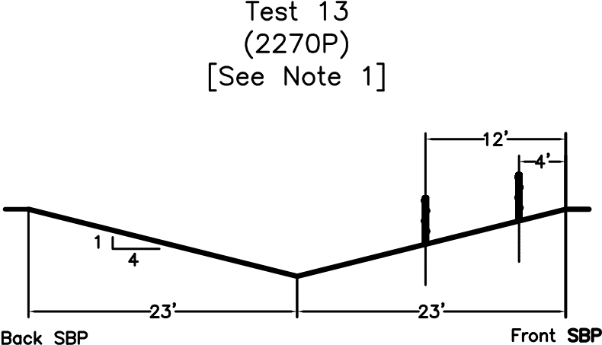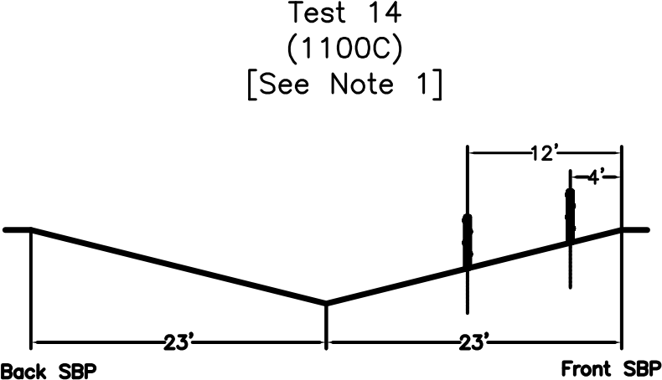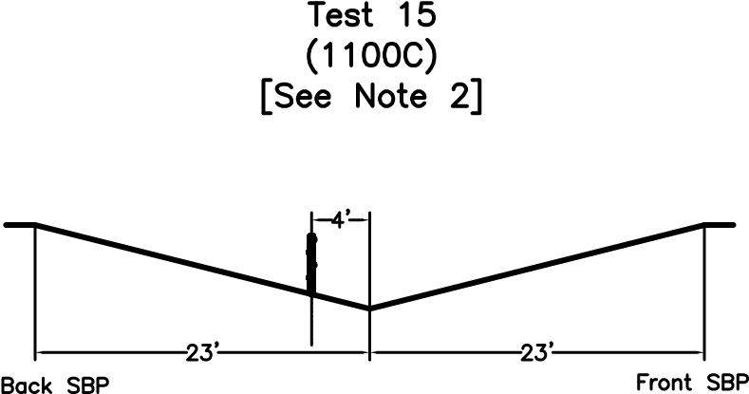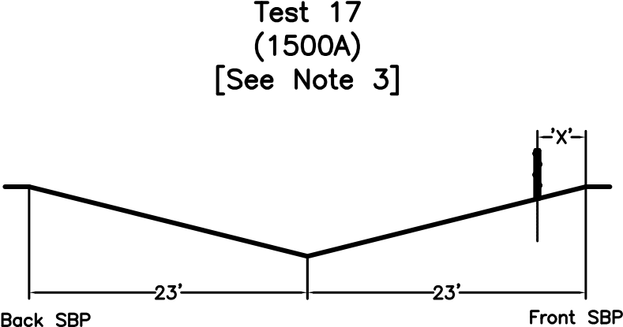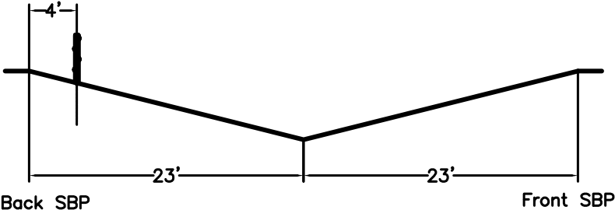

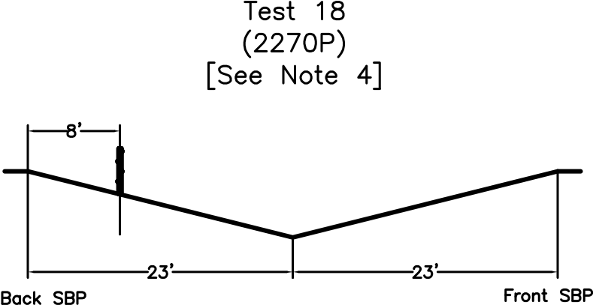

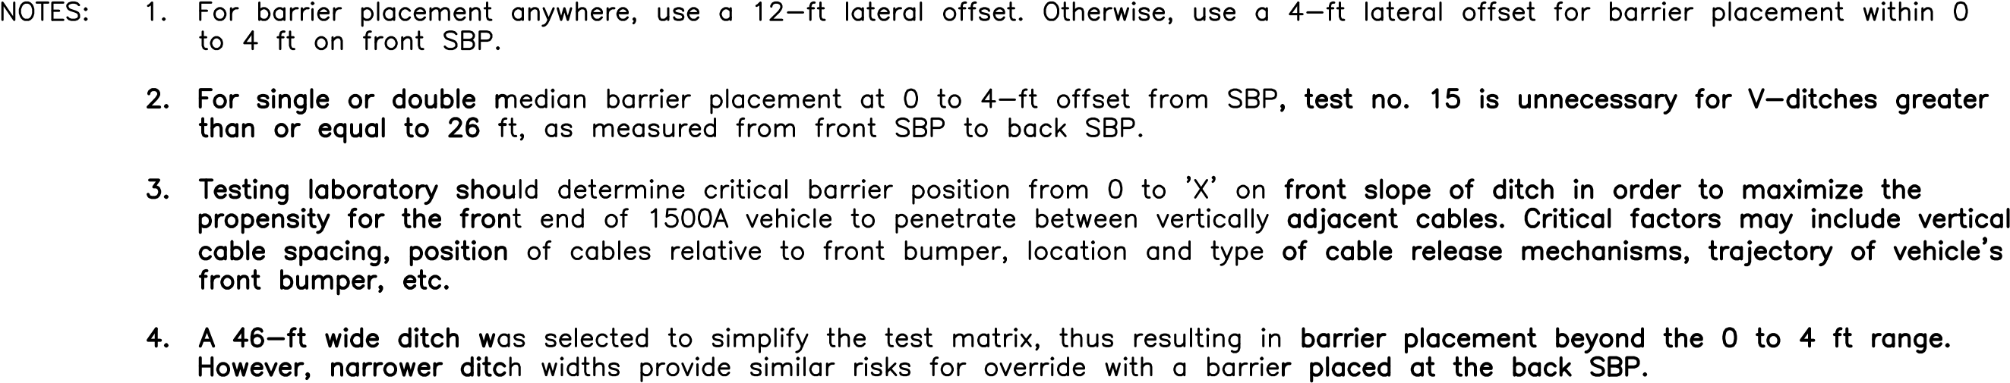

Figure 2-2A. Critical Cable Barrier Placement for 4H:1V V-Ditch

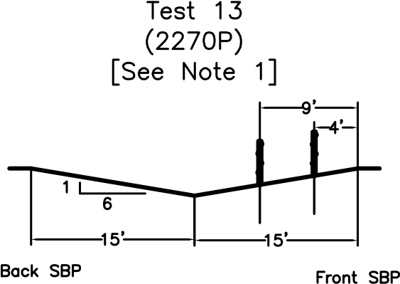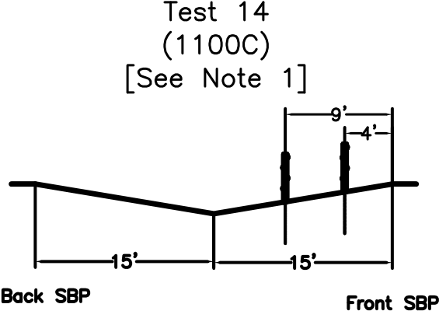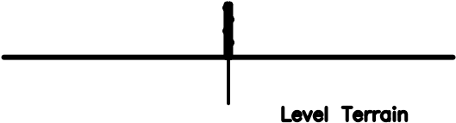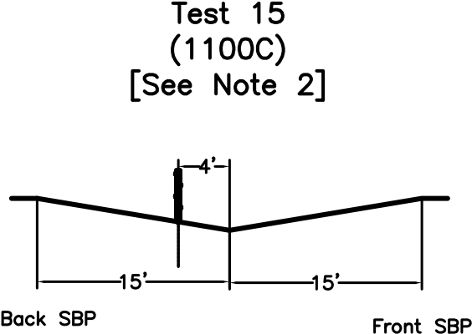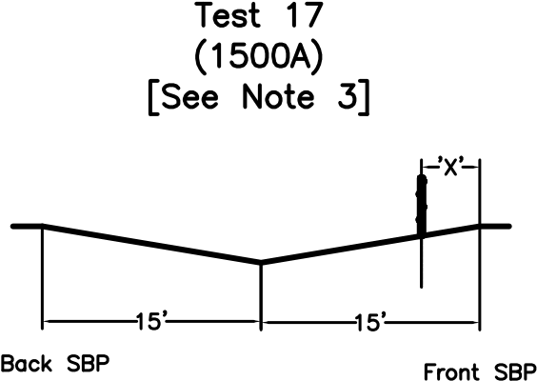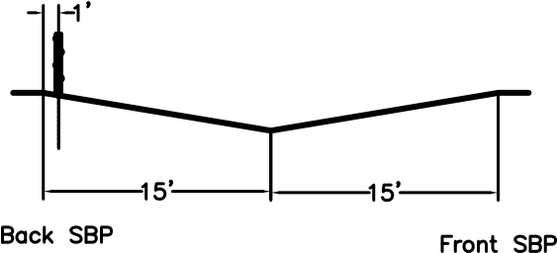

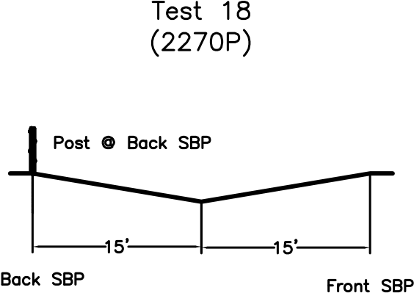

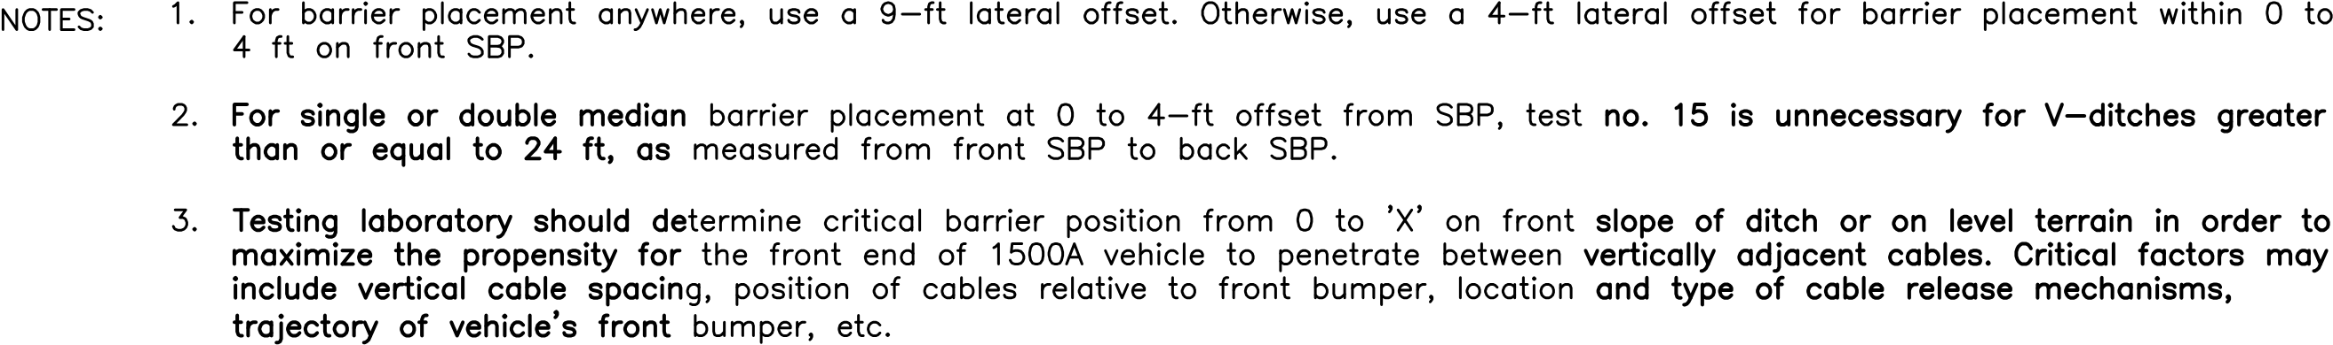

Figure 2-2B. Critical Cable Barrier Placement for 6H:1V V-Ditch

16 | Manual for Assessing Safety Hardware

**TEST 10**

Test 10 is designed to investigate a barrier’s ability to successfully contain and redirect small pas- senger vehicles impacting within the length-of-need. For small cars, the primary concerns are the potential for vehicle under-ride, wheel snag, rollover, and head-slap. For flexible cable barriers, additional concerns include cable interaction with and damage to the A-pillar, windshield, and roof. In order to evaluate the full range of barrier impact performance, testing agencies should consider installing the barrier at the maximum allowable height for small car tests. This is especially true for post-and-beam barrier sys- tems to maximize the risk of under-ride and wheel snag.

##### TESTS 11 and 21

Tests 11 and 21 provide maximum strength tests for Test Levels 1 through 3 and verify a barrier’s performance for impacts involving light trucks and SUVs for all test levels. Due to the high rollover frequencies observed in crash data and during historical full-scale crash testing with light truck ve- hicles, Tests 11 and 21 are required for all barrier systems. For flexible cable barriers, the primary concerns include vehicle containment, vehicle stability, A-pillar integrity, and working width. These tests are now required to also meet all occupant risk measures, including both lateral and longitudinal occupant impact velocity (OIV) and ridedown acceleration (RA) values.

##### TEST 20 (Optional)

Test 20 for a transition section is an optional test to evaluate the occupant risk and post-impact trajec- tory criteria for all test levels. It should be conducted if there is reasonable uncertainty regarding the impact performance of the system for impacts with small passenger vehicles.

##### TESTS 12 and 22

Tests 12 and 22 are conducted for Test Levels 4, 5, and 6. These tests are intended to evaluate the strength of the barrier in containing and redirecting heavy trucks.

**TEST 13**

Test 13 is designed to assess a cable barrier’s ability to contain and redirect light trucks and SUVs as well as prevent barrier override within the length-of-need when placed on a roadside slope or front slope of a median ditch. The 2270P vehicle provides a critical test due to its large mass moment of inertia, high center of mass, and high bumper trajectory relative to the ditch ground surface. For cable barriers designed to be installed anywhere in a median ditch, the cable barrier shall be placed 12 and 9 ft away from the front SBP of a 46-ft wide 4H:1V V-ditch and a 30-ft wide 6H:1V V-ditch, respectively. For cable barriers intended for use between 0 to 4 ft away from the slope break point, the barrier shall be placed 4 ft away from the front SBP of the 4H:1V or 6H:1V V-ditch.

**TEST 14**

The primary objective for Test 14 is to assess a cable barrier’s ability to safely contain and redirect small passenger vehicles without resulting in excessive vehicular instabilities and/or rollover when installed on a roadside slope or front slope of a median ditch. The risk for rollover may be aggravated by several factors, including: (1) roll and pitch rotations induced into the airborne vehicle prior to contacting the cable barrier; and (2) instabilities resulting from vehicle contact with the cable barrier while airborne. For cable barriers installed anywhere in a median ditch, the barrier shall be placed 12 and 9 ft away from the front SBP of a 4H:1V and a 6H:1V V-ditch, respectively. For cable barriers intended for use between 0 to 4 ft away from the slope break point, the barrier shall be placed 4 ft away from the front SBP of the 4H:1V or 6H:1V V-ditch.

**TEST 15**

Test 15 is designed to assess a cable barrier’s ability to safely contain and redirect small passenger vehicles as well as prevent barrier underride, component penetration into the occupant compartment, and excessive deformations of the A-pillar, roof, or windshield. For cable barriers installed anywhere in a median ditch, the barrier shall be placed 4 ft up the back slope from the bottom of the 4H:1V or 6H:1V ditch. For cable barriers intended for use between 0 to 4 ft away from the slope break point, Test 15 is not required for 4H:1V and 6H:1V V ditches greater than or equal to 26 and 24 ft wide, respectively, as measured from front SBP to back SBP. If Test 15 is required for cable barriers intended for use between 0 to 4 ft away from the slope break point due to the likelihood of installation within narrow V-ditches, it is recommended that testing be performed using the placement guidelines provided for barriers installed anywhere within a median ditch. Further, Test 15 is not required for evaluating a double cable barrier system that has one barrier placed on each side of a median ditch, each between 0 to 4 ft away from a SBP.

**TEST 16**

Test 16 is designed to assess a cable barrier’s ability to safely contain and redirect small passenger vehicles after traveling across the center of a ditch and up the back slope. In previous full-scale crash tests of cable barrier systems placed on the backslope of a V-ditch, small passenger vehicles have shown tendencies to either achieve an increased impact angle, aquire a yaw velocity, or rebound off of the ditch surface and become airborne. These vehicle behaviors may lead to an increased propensity for occupant compartment deformation and penetration, vehicular instability, rollover, and/or barrier override. For 4H:1V V-ditches, the cable barrier shall be placed 4 ft away from the back SBP for both a barrier designed for placement anywhere in the ditch or intended for use between 0 to 4 ft from the SBP. For 6H:1V V-ditches, the cable barrier shall be placed 1 ft away from the back SBP for both a barrier designed for placement anywhere in the ditch or intended for use between 0 to 4 ft from the SBP. Test 16 is not required for evaluating a double cable barrier system designed to have a separate cable barrier installation on each side of the ditch placed between 0 to 4 ft away from each SBP.

**TEST 17**

Test 17 is designed to evaluate a cable barrier’s ability to contain and redirect mid-size passenger sedans by preventing vehicle penetration through vertically adjacent cables. Although vehicle penetration through the barrier is the primary concern, this test also assesses risk associated with component penetration into the occupant compartment and excessive deformations to the A-pillar, windshield, or roof. For Test 17 and as determined by the testing laboratory, the critical barrier placement will occur on the front slope and range between 0 ft (i.e., front SBP) and some lateral offset away from the front SBP. For cable barriers installed on mostly level terrain or adjacent to steep roadside slopes (i.e., steeper than 3H:1V), test 17 ~~may be considered optional~~ is recommended for evaluating the risk for passenger vehicles to penetrate between cables depending on barrier configuration (i.e., cable spacing, cable heights, etc.). Critical barrier placement will consider vehicle and barrier geometries and maximize the propensity for the front end of the 1500A vehicle to penetrate between adjacent cables. The objective is to position the front bumper between the adjacent cables with the widest vertical cable spacing at time of impact. If multiple cable spacings have a similar maximum vertical spacing, the lowest of this group should be targeted to maximize the number of cables potentially in contact with the A-pillar, windshield, and roof during redirection.

**TEST 18**

Test 18 is designed to assess a cable barrier’s ability to safely contain and redirect light trucks and SUVs after traveling across the center of a ditch and up the back slope. In previous full-scale crash tests of cable barrier systems placed on the backslope of a V-ditch, passenger vehicles have shown tendencies to either achieve an increased impact angle, aquire a yaw velocity, or rebound off of the ditch surface and become airborne. These vehicle behaviors can lead to an increased propensity for vehicular instability, rollover, and/or barrier override. For 4H:1V V-ditches, the cable barrier shall be placed 8 ft away from the back SBP for both a barrier designed for placement anywhere in the ditch or intended for use between 0 to 4 ft from the SBP. For 6H:1V V-ditches, the cable barrier shall be placed at the back SBP for both a barrier designed for placement anywhere in the ditch or intended for use between 0 to 4 ft from the SBP. Test 18 is not required for evaluating a double cable barrier system designed to have a separate cable barrier installation on each side of the ditch placed between 0 to 4 ft away from each SBP.

Figure 2-1 displays impact conditions for tests 10, 11, 12, 20, 21, and 22. As shown in this figure, critical impact points are measured from a potential snag or fracture location as well as to maximize the propensity for underride, override, or penetration of flexible barriers such as cable barriers installed on a roadside slope or in a median ditch. In some cases, such as transition systems discussed previously, a barrier may have two or more critical impact locations. In this situation, testing agencies should consider testing each of the locations to verify acceptable barrier performance. Critical impact locations for each class of safety feature are defined in Section 2.3.

* + 1. TERMINALS AND CRASH CUSHIONS

###### General

Terminals and redirective crash cushions fulfi ll very similar functions. Terminals are designed to re- duce the severity of impacts with the end of a longitudinal barrier and function as a redirective barrier when struck along the side. Similarly, redirective crash cushions are designed to reduce the severity of head-on impacts with a fi xed object and function as a longitudinal barrier during impacts on the side of the device. However, even though terminals and redirective crash cushions are placed in the same testing category and subjected to the same set of full-scale crash tests, there are some differences in the evaluation criteria that user agencies should consider.

These differences arise primarily due to the classifi cation of crash cushions as either gating or non- gating. Gating crash cushions are designed to allow vehicles impacting near the beginning or nose of the system to safely pass through the unit and travel behind the cushion. Non-gating crash cushions

Chapter 2—Test Matrices and Conditions

| 17

are designed to capture almost all vehicles striking the end of the device and safely decelerate them to a stop. A non-gating crash cushion must capture impacting vehicles during angular tests on the end of the system.

Non-redirective crash cushions are designed to safely accommodate most vehicles striking the front of the cushion, but have no capability to redirect vehicles impacting near the rear of the device. As a result, most non-redirective cushions are designed to be wider than the hazard to be shielded and are typically used farther from traffi c where the risk of high-energy impacts near the rear of the cushion is lower. It is the responsibility of user agencies to determine where safety features addressed in this document have application, including redirective and non-redirective crash cushions.

Impact attenuating traffi c gates, referred to as resistance gates, are beginning to be placed in front of drawbridges, at-grade railroad crossings, or other locations where penetration of the gate could lead to a high risk of a severe crash. Because they are designed to attenuate head-on impacts and have no redirective capacity, resistance gates are considered a subset of non-redirective crash cushions.

Resistance gate systems are designed to block the wide areas at locations where they are deployed. As a result, most impacts involve vehicles striking the gate at angles near 90 degrees. Minor reductions in the impact angle from 90 to 75 degrees are not believed to increase the likelihood of test failure. Hence, impact attenuating gates are not subjected to low-angle, head-on tests included in the non-re- directive crash cushion test matrix. Further, impact attenuating gates cannot be struck along the side of the system and, thus, the crash test along the side of non-redirective crash cushions is also waived. Therefore, impact attenuating gates need only be subjected to Tests 40 and 41. Existing designs are believed to have only one attenuation stage and therefore Test 45 should not normally be necessary. Further, the impact point for all of tests is recommended to be at the quarter point along the face of the system. This impact point should explore asymmetric loading of the attenuation system and be representative of typical impact conditions for a two-lane gate design.

Some longitudinal barriers, such as flexible cable barriers or concrete median barriers, may be installed on roadside fill slopes or within median ditches. However, termination of these systems generally occurs on generally flat terrain. Consequently, the crash testing and evaluation of end treatments for these systems, such as crash cushions and guardrail end terminals, shall continue to be performed with those systems installed on flat, level terrain unless new information suggests procedural changes are in order to be more representative of actual field conditions.

Recommended tests for evaluating the impact performance of terminals and crash cushions are pre- sented in Table 2-3. Impact conditions are presented in Figure 2-3A for terminals and redirective crash cushions and Figure 2-3B for non-redirective crash cushions. These guidelines are applicable to both permanent features and temporary features used in work or construction zones. Reference should be made to the Glossary for defi nitions of these features.

18 | Manual for Assessing Safety Hardware

TABLE 2-3. Recommended Test Matrices for Terminals and Crash Cushions

|  |  |  |  |  |  |  |  |  |  |  |  |
| --- | --- | --- | --- | --- | --- | --- | --- | --- | --- | --- | --- |
| **Test Lev- el** | **Feature** | **Feature Typea** | **Test No.** | **Ve- hicle** | **Impact Speed,b mph (km/h)** | **Impact Angle,b θ, deg.** | **Impact Tolerances** | | **Im- pact Point** | **Evaluation Criteriac** | |
| **Mea- sured** | **Acc. Range, kip-ft (kJ)** | **Gating** | **Non-Gating** |
| 1 | Termi- nals and Redi- rective Crash Cush- ions | G/NG | 1-30 | 1100C | 31 (50.0) | 0 | KE | ≥72 (97.4) | (e) | C,D,F,H,I,N | A,D,F,H,I |
| G/NG | 1-31 | 2270P | 31 (50.0) | 0 | KE | ≥148 (202.0) | (e) | C,D,F,H,I,N | A,D,F,H,I |
| G/NG | 1-32 | 1100C | 31 (50.0) | 5-15 | KE | ≥72 (97.4) | (e) | C,D,F,H,I,N | A,D,F,H,I |
| G/NG | 1-33 | 2270P | 31 (50.0) | 5-15 | KE | ≥148 (202.0) | (e) | C,D,F,H,I,N | A,D,F,H,I |
| G/NG | 1-34 | 1100C | 31 (50.0) | 15 | IS | ≥5 (6.5) | (e,g) | C,D,F,H,I,N | A,D,F,H,I |
| G/NG | 1-35 | 2270P | 31 (50.0) | 25 | IS | ≥27 (36.0) | (e) | A,D,F,H,I | A,D,F,H,I |
| G/NG | 1-36 | 2270P | 31 (50.0) | 25 | IS | ≥27 (36.0) | (e,g) | A,D,F,H,I | A,D,F,H,I |
| G/NG | 1-37(a) | 2270P | 31 (50.0) | 25 | IS | ≥27 (36.0) | (e) | C,D,F,H,I,N | A,D,F,H,I |
| 1-37(b) | 1100C | ≥13 (17.4) |
| G/NG | 1-38 | 1500A | 31 (50.0) | 0 | KE | ≥98 (133.0) | (e) | C,D,F,H,I,N | A,D,F,H,I |
| Non- redirec- tive Crash Cush- ions | G | 1-40 | 1100C | 31 (50.0) | 0 | KE | ≥26 (35.6) | (f) | C,D,F,H,I,N |  |
| G | 1-41 | 2270P | 31 (50.0) | 0 | KE | ≥54 (73.5) | (f) | C,D,F,H,I,N |  |
| G | 1-42 | 1100C | 31 (50.0) | 5-15 | KE | ≥116 (158.0) | (f) | C,D,F,H,I,N |  |
| G | 1-43 | 2270P | 31 (50.0) | 5-15 | KE | ≥26 (35.6) | (f) | C,D,F,H,I,N |  |
| G | 1-44 | 2270P | 31 (50.0) | 20 | KE | ≥54 (73.5) | (f) | C,D,F,N |  |
| G | 1-45 | 1500A | 31 (50.0) | 0 | KE | ≥98 (133.0) | (f) | C,D,F,H,I,N |  |

a G/NG—Test applicable to gating and non-gating devices. G—Test applicable to gating devices. b See Section 2.1.2 for tolerances on impact conditions.

1. See Table 5-1.
2. See Equations 2-1 and 2-2.
3. See Figure 2-3A for impact point. f See Figure 2-3B for impact point.

g See Section 2.3.3 for impact point.

Chapter 2—Test Matrices and Conditions

TABLE 2-3. Recommended Test Matrices for Terminals and Crash Cushions (continued)

| 19

|  |  |  |  |  |  |  |  |  |  |  |  |
| --- | --- | --- | --- | --- | --- | --- | --- | --- | --- | --- | --- |
| **Test Lev- el** | **Feature** | **Feature Typea** | **Test No.** | **Ve- hicle** | **Impact Speed,b mph (km/h)** | **Impact Angle,b θ, deg.** | **Impact Tolerances** | | **Im- pact Point** | **Evaluation Criteriac** | |
| **Mea- sured** | **Acc. Range, kip-ft (kJ)** | **Gating** | **Non-Gating** |
| 2 | Termi- nals and Redi- rective Crash Cush- ions | G/NG | 2-30 | 1100C | 44 (70.0) | 0 | KE | ≥141 (191.0) | (e) | C,D,F,H,I,N | A,D,F,H,I |
| G/NG | 2-31 | 2270P | 44 (70.0) | 0 | KE | ≥291 (395.0) | (e) | C,D,F,H,I,N | A,D,F,H,I |
| G/NG | 2-32 | 1100C | 44 (70.0) | 5-15 | KE | ≥141 (191.0) | (e) | C,D,F,H,I,N | A,D,F,H,I |
| G/NG | 2-33 | 2270P | 44 (70.0) | 5-15 | KE | ≥291 (395.0) | (e) | C,D,F,H,I,N | A,D,F,H,I |
| G/NG | 2-34 | 1100C | 44 (70.0) | 15 | IS | ≥9 (12.8) | (e,g) | C,D,F,H,I,N | A,D,F,H,I |
| G/NG | 2-35 | 2270P | 44 (70.0) | 25 | IS | ≥52 (70.5) | (e) | A,D,F,H,I | A,D,F,H,I |
| G/NG | 2-36 | 2270P | 44 (70.0) | 25 | IS | ≥52 (70.5) | (e,g) | A,D,F,H,I | A,D,F,H,I |
| G/NG | 2-37(a) | 2270P | 44 (70.0) | 25 | IS | ≥52 (70.5) | (e) | C,D,F,H,I,N | A,D,F,H,I |
| 2-37(b) | 1100C | ≥25 (34.2) |
| G/NG | 2-38 | 1500A | 44 (70.0) | 0 | KE | ≥192 (261.0) | (e) | C,D,F,H,I,N | A,D,F,H,I |
| Non-re- directive Crash Cush- ions | G | 2-40 | 1100C | 44 (70.0) | 0 | KE | ≥51 (69.7) | (f) | C,D,F,H,I,N |  |
| G | 2-41 | 2270P | 44 (70.0) | 0 | KE | ≥106 (144.0) | (f) | C,D,F,H,I,N |  |
| G | 2-42 | 1100C | 44 (70.0) | 5-15 | KE | ≥228 (309.0) | (f) | C,D,F,H,I,N |  |
| G | 2-43 | 2270P | 44 (70.0) | 5-15 | KE | ≥51 (69.7) | (f) | C,D,F,H,I,N |  |
| G | 2-44 | 2270P | 44 (70.0) | 20 | KE | ≥106 (144.0) | (f) | C,D,F,N |  |
| G | 2-45 | 1500A | 44 (70.0) | 0 | KE | ≥192 (261.0) | (f) | C,D,F,H,I,N |  |

a G/NG—Test applicable to gating and non-gating devices. G—Test applicable to gating devices. b See Section 2.1.2 for tolerances on impact conditions.

1. See Table 5-1.
2. See Equations 2-1 and 2-2.
3. See Figure 2-3A for impact point. f See Figure 2-3B for impact point.

g See Section 2.3.3 for impact point.

20 | Manual for Assessing Safety Hardware

TABLE 2-3. Recommended Test Matrices for Terminals and Crash Cushions (continued)

|  |  |  |  |  |  |  |  |  |  |  |  |
| --- | --- | --- | --- | --- | --- | --- | --- | --- | --- | --- | --- |
| **Test Lev- el** | **Feature** | **Feature Typea** | **Test No.** | **Ve- hicle** | **Impact Speed,b mph (km/h)** | **Impact Angle,b θ, deg.** | **Impact Tolerances** | | **Im- pact Point** | **Evaluation Criteriac** | |
| **Mea- sured** | **Acc. Range, kip-ft (kJ)** | **Gating** | **Non-Gating** |
| 3 | Termi- nals and Redi- rective Crash Cush- ions | G/NG | 3-30 | 1100C | 62  (100.0) | 0 | KE | ≥288 (390) | (e) | C,D,F,H,I,N | A,D,F,H,I |
| G/NG | 3-31 | 2270P | 62  (100.0) | 0 | KE | ≥594 (806) | (e) | C,D,F,H,I,N | A,D,F,H,I |
| G/NG | 3-32 | 1100C | 62  (100.0) | 5-15 | KE | ≥288 (390) | (e) | C,D,F,H,I,N | A,D,F,H,I |
| G/NG | 3-33 | 2270P | 62  (100.0) | 5-15 | KE | ≥594 (806) | (e) | C,D,F,H,I,N | A,D,F,H,I |
| G/NG | 3-34 | 1100C | 62  (100.0) | 15 | IS | ≥19 (26) | (e,g) | C,D,F,H,I,N | A,D,F,H,I |
| G/NG | 3-35 | 2270P | 62  (100.0) | 25 | IS | ≥106 (144) | (e) | A,D,F,H,I | A,D,F,H,I |
| G/NG | 3-36 | 2270P | 62  (100.0) | 25 | IS | ≥106 (144) | (e,g) | A,D,F,H,I | A,D,F,H,I |
| G/NG | 3-37(a) | 2270P | 62  (100.0) | 25 | IS | ≥106 (144) | (e) | C,D,F,H,I,N | A,D,F,H,I |
| 3-37(b) | 1100C | ≥51 (69.7) |
| G/NG | 3-38 | 1500A | 62  (100.0) | 0 | KE | ≥392 (532) | (e) | C,D,F,H,I,N | A,D,F,H,I |
| Non-re- directive Crash Cush- ions | G | 3-40 | 1100C | 62  (100.0) | 0 | KE | ≥105 (142) | (f) | C,D,F,H,I,N |  |
| G | 3-41 | 2270P | 62  (100.0) | 0 | KE | ≥216 (294) | (f) | C,D,F,H,I,N |  |
| G | 3-42 | 1100C | 62  (100.0) | 5-15 | KE | ≥465 (631) | (f) | C,D,F,H,I,N |  |
| G | 3-43 | 2270P | 62  (100.0) | 5-15 | KE | ≥105 (142) | (f) | C,D,F,H,I,N |  |
| G | 3-44 | 2270P | 62  (100.0) | 20 | KE | ≥216 (294) | (f) | C,D,F,N |  |
| G | 3-45 | 1500A | 62  (100.0) | 0 | KE | ≥392 (532) | (f) | C,D,F,H,I,N |  |

a G/NG—Test applicable to gating and non-gating devices. G—Test applicable to gating devices. b See Section 2.1.2 for tolerances on impact conditions.

1. See Table 5-1.
2. See Equations 2-1 and 2-2.
3. See Figure 2-3A for impact point. f See Figure 2-3B for impact point.

g See Section 2.3.3 for impact point.

T e rm inal or C ras h C u s h ion Length

T e rm in al or C ras h C u s h io n Length

CL CL CL W

CL W

Y

θ = 0 D E G .

Y = O F F S ET = W /4

No rm a l Dire c tio n of T rav el

θ = 0 D E G . OF F S E T = 0

No rm a l Dire c tio n of T rav el

TEST 30

TESTS 31 AND 38

T e rm inal or C ras h C u s h io n Length

CL

W

C

θ

Im p a c t A n g le

θ ( deg.) T e r m inal T y pe

5–15 G a tin g

1 5 N o n -G a tin g

No rm a l Dire c tio n of T rav el

Chapter 2—Test Matrices and Conditions

| 21

Figure 2-3A. Impact Conditions for Terminal and Redirective Crash Cushion Tests

© 2009 by the American Association of State Highway and Transportation Officials.

All rights reserved. Duplication is a violation of applicable law.

#### TESTS 32 AND 33

T e rm in al or Crash Cus hio n L e ng t h

Figure 2-3A. Impact Conditions for Terminal and Redirective Crash Cushion Tests (continued)

Cr it ic a l Im p a c t Po in t (C IP )

CL

B e gin n in g of L e n gt h of N e e d

T e r m in al or C r ash Cus h io n L e ng t h C r it ic a l Im p a c t

Po in t (C IP )

CL

TES T θ (D E G )

1. 15
2. 25

TEST 3 5

CL

W CL

CL TEST 3 4 θ W

SEE SEC T IO N 2 .3 .3 .1 θ θ

S E E S E C T IO N 2.3.3.2

F O R DE T E RM IN A T IO N O F C IP

F O R DET E RMIN A T IO N O F C IP

No rm a l D ire c tio n of Tra v el

TEST 34 AND 35

TEST 36

No rm a l Dire ctio n of T ravel

No rm a l D ire c tio n

of Tra v el

T e rm in al or C r ash Cus hio n L e ng t h, L C r it ic a l Im pac t

Po in t (C IP )

CL

C r it ic a l Im p a c t Po in t (C IP )

CL

T e r m in al or C r ash Cus hio n L e ng t h , L

CL

CL

θ = 2 5 D E G .

W

θ

θ = 25 D E G .

W

θ

No rm a l Dire c tio n

No rm a l D ire c tio n of Tra vel

TEST 37 (FOR MEDIAN DEVICE)

of T r avel

No rm a l Dire c tio n

of T r avel

TEST 37 (FOR ROADSIDE DEVICE)

22 | Manual for Assessing Safety Hardware

© 2009 by the American Association of State Highway and Transportation Officials.

All rights reserved. Duplication is a violation of applicable law.

NOTE: Re co m m en de d T o l e ra nc e on Im p a c t P o in t in A l l S id e Im p a c t s = ±3 0 0 m m

L L

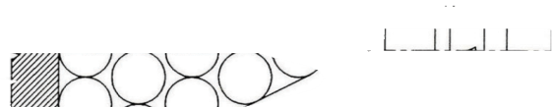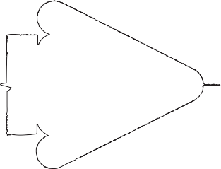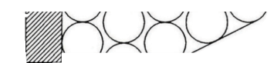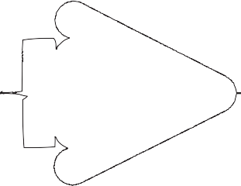

Figure 2-3B. Impact Conditions for Non-Redirective Crash Cushion Tests

CL CL

W

CL CL

Y

θ = 0 DEG.

Y = OFFSET = W/4

TEST 40

Normal Direction of Traffic

θ = 0 DEG. OFFSET = 0

Normal Direction of Traffic

TESTS 41 AND 45

L L

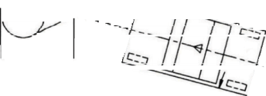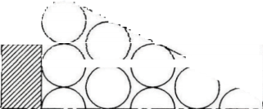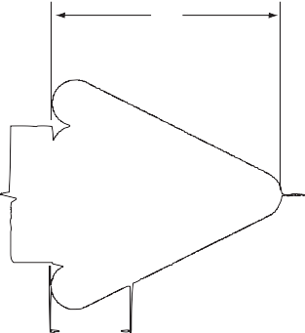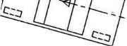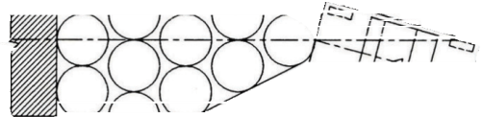

CL L

C

CL

θ = 15 DEG. OFFSET = 0

θ

Normal Direction of Traffic

TESTS 42 AND 43

θ = 20 DEG.

Critical CL

Impact

Point (CIP) θ

TEST 44

Normal Direction of Traffic

Chapter 2—Test Matrices and Conditions

| 23

© 2009 by the American Association of State Highway and Transportation Officials.

All rights reserved. Duplication is a violation of applicable law.

NOTE: Recommended Offset Tolerance for All Tests = ±0.05(W)

24 | Manual for Assessing Safety Hardware

###### Description of Tests

**TESTS 30 and 40**

Tests 30 and 40 are designed to examine the risk of vehicle instability, particularly for narrow termi- nal and crash cushion systems. Although Tests 32 and 42 often exhibit higher occupant risk criteria, the risk of vehicle instability is higher for Tests 30 and 40. Hence, Tests 30 and 40 should be conduct- ed even if a system successfully passes Tests 32 or 42.

These tests are conducted with the vehicle traveling parallel to the roadway and the center of the ve- hicle offset one quarter of its width to the left or right from the center of the safety feature. For purposes of locating the impact point for these tests, the center of a safety feature, such as a guardrail terminal, should be defined as the center of resistance for head-on impacts rather than the geometric center of the system. These tests are designed to primarily evaluate occupant risk and vehicle trajectory criteria. The vehicle offset should be chosen to maximize the risk of exceeding occupant risk or inducing vehicle instability. Consideration should be given to the direction of vehicle rotation induced by the vehicle offset as well as the potential for tire interaction with rails or other anchor components that do not move when the system is struck. For a W-beam guardrail terminal, the critical vehicle offset is typically toward the traffic side since vehicle contact with the backside support posts will maximize yaw rotation and the risk of instability. Vehicle offset to the field side might be considered when evaluating vehicle stability on sloped terrain behind the guardrail terminal. Dummy location, left or right, should also be selected to maxi- mize vehicle yaw movement. The risk of vehicle instability can sometimes be increased by reducing the offset somewhat to allow the vehicle’s tires to contact anchor components under the guardrail terminal or crash cushion.

**TESTS 31 and 41**

For devices intended to decelerate vehicles to a stop, these tests are designed to evaluate the capacity of the feature to absorb suffi cient energy to stop the 2270P vehicle in a safe and controlled manner. For gating systems, these tests are intended to evaluate occupant risk and vehicle trajectory criteria during high-energy, head-on impacts. These tests are conducted with the vehicle approaching parallel to the roadway with the center of the vehicle aligned with the centerline of the terminal or cushion. Again, the centerline of the device is defi ned as the center of resistance during end-on impacts.

##### TESTS 32, 33, 42, and 43

These tests are intended to examine the behavior of terminals and crash cushions during oblique im- pacts on the end or nose of the system. For most features, occupant risk and vehicle trajectory are the primary concerns. Note that the impact angle for these tests should be selected from the range shown in Table 2-3 such that the risk of failure is maximized. Non-gating, redirective systems are designed to capture vehicles impacting the end of the device at an angle. In this case, the critical impact angle is believed to be one that maximizes the lateral load on the device, maximizes the risk that a vehicle will gate through the system, and maximizes occupant risk measures. Hence, it is recommended that non-gating, redirective systems be tested at 15 degrees. However, gating redirective systems are de- signed to allow a vehicle to penetrate behind the system, and increasing the lateral load on the device will likely accentuate the gating process. Therefore, gating redirective terminals and crash cushions should be tested at much lower impact angles, closer to the 5-degree minimum value. The appropri- ate impact angle to be used in tests of non-redirective crash cushions is less clear. The crash cushion should be analyzed and impact angles selected to maximize occupant impact velocities and ridedown accelerations.

Chapter 2—Test Matrices and Conditions

| 25

##### TEST 34

Test 34 is intended to evaluate the impact performance of terminals and crash cushions at the critical impact point (CIP) where the behavior of these devices changes from gating or capturing to redirec- tion. Vehicle trajectory and occupant risk are the primary concerns for this test. Criteria for selecting the CIP for post-and-beam terminal or crash cushion systems are presented in Section 2.3.3.1. Whenever practical, fi nite element analysis should be conducted to identify critical impact points for post-and-beam systems as well as other terminals and redirective crash cushions.

##### TEST 35

Test 35 examines the capacity of a terminal or crash cushion for containing and redirecting heavy passenger vehicles. For this test, a 2270P vehicle is directed into the system at the beginning of the length-of-need at an impact angle of 25 degrees. Note that, for non-gating crash cushions, the begin- ning of the length-of-need should be very near the nose of the crash cushion. In this case, Test 35 should involve a vehicle impacting on the very end of the system where cushion behavior changes from capturing to redirective. Hence, for non-gating systems, this test is essentially a CIP impact with a light truck test vehicle.

##### TEST 36

This test is designed to examine the behavior of terminals and redirective crash cushions when at- tached to rigid barriers or other very stiff features. For this test, the 2270P test vehicle is directed into the terminal or crash cushion at its CIP with respect to the transition to the backup structure. Note that some terminals, including most W-beam guardrail terminals, are not attached directly to a stiff barrier or backup structure. Test 36 is only recommended for terminals or cushions directly attached to very stiff barriers or backup structures. General guidelines for determining CIP locations for this test are included in Section 2.3.3.2. Whenever possible, fi nite element analyses should be used to determine the CIP for Test 36.

##### TEST 37

Test 37 examines the behavior of crash cushions and terminals during reverse-direction impacts. This test is recommended for any safety feature that will be placed within the clear zone of opposing traffi c. This test involves a 2270P or 1100C vehicle striking the critical impact point (CIP) for reverse-direc- tion impacts. CIP locations for reverse direction impacts vary greatly from one system to another, and a generalized system for identifying these locations has yet to be developed. Note that the con-fi gurations shown in Figure 2-3A for Test 37 are intended for illustration purposes only and do not necessarily refl ect the actual test confi guration.

For most crash cushions with fender panels lapped against opposing traffi c, the CIP should be select- ed to maximize the risk of snagging on the end of the last fender panel lapped in this manner.

Many crash cushions attached to concrete barriers incorporate a tapered section between the wider cushion and the narrower barrier face. In this situation, Test 37 should normally be confi gured to fi rst strike the barrier or the tapered section in order to maximize the potential for snagging. The 2270P will generally be the critical vehicle for this test when a crash cushion is being evaluated.

For post-and-

26 | Manual for Assessing Safety Hardware

beam terminals utilizing a breakaway cable system, the 1100C will generally be the critical vehicle for this test, and the impact point should be selected to maximize the risk of the vehicle snagging on the anchor cable.

##### TESTS 38 and 45

Tests 38 and 45 are intended to examine the performance of crash cushions and end terminals during impacts by mid-size vehicles. The concern is that attenuator staging can be tuned to meet the testing requirements for the small car and heavy pickup truck without adequately accommodating mid-sized vehicles. For these tests, the centerline of the test vehicle is aligned with the centerline of the test article. Note that Tests 31 and 41 involve heavier vehicles impacting the systems under the same impact con- ditions. Thus, accelerometer data from Tests 31 and 41 can be used to identify if Tests 38 and 45 are needed. As described in Appendix G, accelerometer data from Tests 31 and 41 can be integrated to ob- tain the force versus defl ection characteristics of the terminal or crash cushion. The force vs. defl ection data can then be used to estimate the occupant impact velocity and ride-down acceleration for a 3,300-lb (1,500-kg) vehicle. Note that this analysis will be conservative because impact forces experienced dur- ing Tests 31 and 41 with the 2270P vehicle will be higher than those generated by a mid-sized vehicle due to the heavier mass and higher crush stiffness of the 2270P vehicle. If the force versus defl ection analysis predicts that the terminal or crash cushion will meet evaluation guidelines for occupant impact velocity (OIV) and RA for a 3,300-lb (1,500-kg) vehicle, Test 38 or 45 is not recommended.

##### TEST 44

Test 44 is designed to evaluate the ability of a non-redirective crash cushion to safely stop a large passenger vehicle in a side impact. For this test, the 2270P test vehicle is directed into the crash cushion at its CIP with respect to the transition to the backup structure. Note that non-redirective crash cushions are not designed to safely attenuate this impact and therefore occupant risk param- eters, evaluation criteria H and I, are not among the recommended evaluation criteria. However, these values should be reported as a means for user agencies to estimate the potential risk of using non-redirective crash cushions. Impacting vehicles should remain stable and upright during this test. If

a system truly has no redirective capacity, such as a sand inertial cushion, the centerline of the test vehicle should be directed at the corner of the shielded hazard as shown in Figure 2-3B. However, if a non-redirective crash cushion can be expected to provide some redirective capacity, general guide- lines for determining CIP locations presented in Section 2.3.3.2 for Test 36 should be followed.

###### Other Terminals and Crash Cushion Systems

Some wide-area terminals or crash cushions may not be specifi cally addressed by the crash test matrix presented above. For example, bull-nose and short-radius guardrails function as terminals and crash cushions, but their asymmetric and/or large nose confi gurations can make identifi cation of the appro- priate impact points for some tests very diffi cult. For these systems, the designer and testing agency should attempt to design test matrices that explore critical elements of the safety feature while apply- ing the basic intent and framework of the recommended tests and evaluation criteria. Recommended test vehicles, impact speeds, and impact angles should be applied with the most critical impact points for the safety feature under consideration.

Chapter 2—Test Matrices and Conditions

| 27

2.2.3 TRUCK- AND TRAILER-MOUNTED ATTENUATORS AND VARIABLE MESSAGE SIGN AND ARROW BOARD TRAILERS

###### 2.2.3.1 General

Truck- and trailer-mounted attenuators (TMAs) are designed to protect motorists from impacts with stationary or slow-moving trucks utilized in work zones and maintenance operations. During a TMA crash, the support truck is accelerated forward as the impacting vehicle is decelerated. Hence, the total velocity change during a TMA impact is strongly related to the mass of the support truck. Heavier support trucks will produce higher impacting vehicle velocity changes and require greater energy dissipation by the TMA. On the other hand, support trucks that are too light could produce high accel- erations for the operator and excessive roll-ahead distance, which is the length of travel of the support truck during the impact. The roll-ahead distance is used to identify the minimum required spacing between the support truck and construction or maintenance activities. Support truck operator risks

and factors affecting roll-ahead distance are discussed in Section A2.2.3 of Appendix A. Therefore, truck- and trailer-mounted attenuators should be rated in terms of both the lightest and heaviest al- lowable support vehicle. Note that Tests 50, 51, and 52 described in the following sections should be conducted with the heaviest allowable support vehicle or a rigidly blocked support truck for unlimited support-truck weight while Test 53 should be conducted with the lightest allowable support vehicle.

During the tests, the support truck should be placed in second gear and the parking brake set. Note that the support truck’s parking brake should be in good condition at the time of the test. TMAs designed for an unlimited support vehicle mass should be tested with the support truck blocked to pre- vent forward or lateral motion. Table 2-4 presents recommended crash tests and Figure 2-4 displays impact conditions for truck- and trailer-mounted attenuators (TMAs). Reference is made to Section

3.4.2.4 for support-truck parameters.

Variable message signs are common roadside fixed objects that are beginning to be used very widely in both permanent and work-zone applications. These devices are often placed near the travelway for maximum visibility. When not placed behind a barrier, variable message signs and arrow boards

can pose a significant hazard, especially to the occupants of small cars. Safety treatments for variable message signs and arrow boards should be subjected to Tests 50 and 51 from the truck- and trailer- mounted attenuator category.

28 | Manual for Assessing Safety Hardware

TABLE 2-4. Recommended Test Matrices for Truck- and Trailer-Mounted Attenuators

|  |  |  |  |  |  |  |  |
| --- | --- | --- | --- | --- | --- | --- | --- |
| **Test Level** | **Test No.** | **Vehicle** | **Impact Speed,a mph (km/h)** | **Impact Angle,a** θ**, deg.** | **Kinetic Energy Tolerance, kip-ft (kJ)** | **Impact Point** | **Evaluation Criteriab** |
| 1 | 1-50 | 1100C | 31 (50.0) | 0 | ≥72 (97) | (c) | C,D,F,H,I |
| 1-51  1-52 | 2270P  2270P | 31 (50.0)  31 (50.0) | 0  0 | ≥148 (202)  ≥148 (202) | (c)  (c) | C,D,F,H,I  C,D,F,H,I |
| 1-53 | 2270P | 31 (50.0) | 10 | ≥148 (202) | (c) | C,D,F,H,I |
| 1-54d | 1500A | 31 (50.0) | 0 | ≥98 (133) | (c) | C,D,F,H,I |
| 2 | 2-50 | 1100C | 44 (70.0) | 0 | ≥141 (191) | (c) | C,D,F,H,I |
| 2-51 | 2270P | 44 (70.0) | 0 | ≥291 (395) | (c) | C,D,F,H,I |
| 2-52 | 2270P | 44 (70.0) | 0 | ≥291 (395) | (c) | C,D,F,H,I |
| 2-53 | 2270P | 44 (70.0) | 10 | ≥291 (395) | (c) | C,D,F,H,I |
| 2-54d | 1500A | 44 (70.0) | 0 | ≥192 (261) | (c) | C,D,F,H,I |
| 3 | 3-50 | 1100C | 62 (100.0) | 0 | ≥288 (390) | (c) | C,D,F,H,I |
| 3-51  3-52 | 2270P  2270P | 62 (100.0)  62 (100.0) | 0  0 | ≥594 (806)  ≥594 (806) | (c)  (c) | C,D,F,H,I  C,D,F,H,I |
| 3-53 | 2270P | 62 (100.0) | 10 | ≥594 (806) | (c) | C,D,F,H,I |
| 3-54d | 1500A | 62 (100.0) | 0 | ≥392 (532) | (c) | C,D,F,H,I |

a See Section 2.1.2 for tolerances on impact conditions. b See Table 5-1.

c See Figure 2-3B for impact point. d Test is optional.

Chapter 2—Test Matrices and Conditions

| 29

W CL

CL

TMA

Truck

θ = 0 D E G . O FFS E T = 0

TEST S 5 0, 5 1 AND 54

CL

W

CL

Y

TMA

Truck

θ= 0 D E G .

Y = O FFS E T = W /3

TES T 5 2

Y

θ

CL

TMA Truck

C

W

θ= 1 0 D E G .

OF F S E T = W /4

TES T 5 3

NOT E: R e c o m m end e d O f f s et T o l e ra nce fo r Al l T e st s = ± 0 .0 5 (W )

Figure 2-4. Impact Conditions for TMA Tests

30 | Manual for Assessing Safety Hardware

###### 2.2.3.2 Description of Tests

**TESTS 50 and 51**

Test 50 is designed to evaluate the impact performance of TMAs during small car impacts. Test 51 is intended to examine the energy dissipation capacity of the TMA, structural adequacy, occupant risk, and the roll-ahead distance for the support truck during heavy passenger vehicle impacts. Both tests should be conducted with the heaviest allowable support truck or a rigidly blocked support truck for no upper support-truck weight limit.

##### TESTS 52 and 53

Tests 52 and 53 examine the capability of a TMA to safely attenuate off-center and angular impacts from heavy passenger vehicles. Structural adequacy of the TMA and occupant risk are the two pri- mary concerns for these tests. Test 52 should be conducted with the heaviest allowable support truck or a rigidly blocked support truck for no upper support-truck weight limit while Test 53 should be conducted with the lightest allowable support truck.

##### TEST 54 (Optional)

Test 54 is a new test designed to evaluate the staging of energy absorbers in a TMA for impacts involving mid-size automobiles. It is desirable that TMAs provide acceptable levels of protection for all passenger vehicles. There is some concern that existing designs are fi nely tuned to minimize the TMA length while meeting the requirements of the small passenger car and heavy pickup truck tests, and designers do not consider occupant risk parameters for mid-sized car impacts. On the other hand, if existing designs must be lengthened to meet the requirements of this new test, there is concern that costs and operational problems may increase greatly and that durability will be diminished. Therefore, Test 54 is considered optional. However, manufacturers and user agencies are encouraged to develop and implement TMAs that can safely accommodate mid-sized vehicles. As presented previously in the description of Tests 38 and 45, this test can be waived with an analysis of the accelerometer data from Test 51 that indicates proper attenuator staging.

The recommended full-scale crash tests only evaluate the impact performance of a TMA during pas- senger vehicle collisions. To date, no truck-mounted attenuators have been developed that are capable of safely accommodating heavy truck impacts. Further, the full-scale crash testing does not evaluate operational considerations, such as the potential for fatigue failure of structural elements, moisture absorption that increases unit weight, mobility of the system, or the infl uences of temperature varia- tions or other factors. *Performance and Operational Experience of Truck-Mounted Attenuators* (84) presents a synthesis of practices related to the selection of truck-mounted attenuators.

* + 1. SUPPORT STRUCTURES, WORK-ZONE TRAFFIC CONTROL DEVICES, BREAKAWAY UTILITY POLES, AND LONGITUDINAL CHANNELIZERS

###### General

Signs, luminaire and mailbox supports, work-zone traffi c control devices, and breakaway utility poles all incorporate vertical structural supports that can be an obstacle for errant vehicles. Breakaway devices, commonly used with sign and luminaire supports and utility poles, often incorporate me- chanical fuses that require a certain amount of kinetic energy to be activated. For these systems, the guidelines include a low-speed test to assess the system’s activation energy. Further, there is also a

Chapter 2—Test Matrices and Conditions

| 31

concern about the potential for occupant compartment intrusion, excessive deceleration, and vehicle instability during high-speed impacts with all features in this category. Note that occupant risk criteria for breakaway structures and work zone devices are much more stringent than those used for longi- tudinal barriers and crash cushions. In recognition of the capability of breakaway systems to provide a higher level of safety than is possible for longitudinal barriers and other safety features, these more stringent occupant risk criteria are implemented. Table 2-5 presents recommended crash tests for evaluation of support structures, work-zone traffi c control devices, breakaway utility poles, and longi- tudinal channelizers. Reference is made to the Glossary for definition of these features.

Support structures include sign supports, mailbox supports, luminaire supports, emergency call box supports, and road closure gates. Fire hydrants are also commonly located within the clear zone of urban and suburban roadways. Although not specifically included in these guidelines, whenever the impact performance of fi re hydrants is evaluated, impact criteria from other support structures should be utilized. Work zone traffic control devices include plastic drums, barricades, cones, vertical panels and their supports, and delineator posts. The guide- lines are applicable to both permanent and temporary work zone devices.

Lights, batteries, solar panels, fl ags, and other ancillary features are often attached to support struc- tures and work-zone traffi c control devices. These ancillary features can sometimes become separated and penetrate through a vehicle’s windshield. This behavior is most often observed with base bend- ing sign supports and work zone devices. These features should be tested with any common ancillary feature in place. Any other attachments that are normally incorporated in fi eld applications with

work zone traffi c control devices, such as sandbags, fl ags, sign panels, etc., should also be utilized during crash testing to ensure proper impact performance. Note that when lights and solar panels are mounted on tall permanent structures and a breakaway device is employed, the risk of windshield penetration is greatly reduced.

Water-filled plastic barrier systems pose a unique situation since they are designed for a wide range of structural capability and applications. The initial designs were intended as positive barriers with the ability to contain and redirect errant vehicles. However, some of the more recent designs are intended as channelizers, either used individually as stand-alone barricades or linked together to form a continuous unit. These devices, used singly or interlocked, are labeled as longitudinal channelizing devices in the *Manual on Uniform Traffi c Control Devices* (MUTCD) (51). For systems intended to be used as stand-alone barricades, the device should be tested as a barricade. For systems designed as positive barriers, it should be crash tested as a permanent or temporary barrier as presented in Section 2.2.1. For longitudinal chan- nelizers, or any channelizing device incorporating individual elements that are connected to form

a continuous unit, these systems are considered a separate class of hardware with different testing and evaluation guidelines, as described in Section 2.2.4.2 under tests 90 and 91. A device tested as a longitudinal channelizer that has the appearance of a positive barrier must be clearly identified as a channelizing device. The testing laboratory should prominently indicate that these systems are not

barriers on all test documentation and the manufacturers must permanently mark each individual unit produced with a warning indicating that the system is evaluated only as a channelizing device and not recommended for use as a positive barrier.

32 | Manual for Assessing Safety Hardware

A critical impact angle (CIA) should be determined for each test recommended in Table 2-5. The criti- cal impact angle should represent the worst case impact condition that is consistent with the manner in which the test article will be deployed along the roadway. For example, safety features that can

be used near an intersection could be struck from virtually any direction. In this case, testing should be conducted at both 90 degrees from the normal direction and at any orientation between 0 and 25 degrees that is deemed to represent the highest risk for the system to fail any of the recommended evaluation criteria. Features that are designed to be used along the outside of divided highways need only be evaluated for impact angles of 0 to 25 degrees. However, if this same feature can be used in locations where it could be subjected to reverse-side impacts, 0-to-25-degree and 155-to-180-degree impact envelopes should be considered. Some features will have more than one CIA. In this case, testing should be conducted with the CIA that is judged to have the greatest potential for test failure. Whenever no CIA clearly poses the greatest risk for test failure, multiple tests should be conducted.

Single support structures should normally be tested with the center of the support aligned with the left or right quarter point on the impacting vehicle. Previous testing has shown that the offset can lead to vehicle instability during high-speed testing. Further, if low-speed and high-speed tests are to be con- ducted with an 1100C vehicle, the same automobile can often be used for both tests, provided there

is only minor vehicle damage during the low-speed testing. Devices with multiple supports, such as a dual-leg sign system, should be tested such that the impacting vehicle engages the maximum number of supports possible.

As shown in Table 2-5, three full-scale crash tests are recommended for three of the classes of hard- ware in this category. Two of these tests involve high-speed impacts with 1100C and 2270P vehicles. Both tests are recommended to accurately identify the potential for test article intrusion into the windshield or roof of the two classes of test vehicle. Although two high-speed crash tests are recom- mended, it may not be necessary to run both tests. High-speed bogie tests have been successfully employed to identify test article trajectory and occupant risk parameters. High-speed bogie tests can be used to identify which of the two high-speed tests represents the greatest potential for failure. Thus, the number of full-scale crash tests may be reduced. Although it is not recommended as a general practice, some agencies have accepted work-zone features based solely upon results of high-speed bo- gie testing, provided there is clear evidence that the test article trajectory would not pose any hazard to the vehicle occupants and that occupant risk measures are well within recommended limits. Impact conditions for this class of safety features are shown in Figure 2-5.

Chapter 2—Test Matrices and Conditions

TABLE 2-5. Recommended Test Matrices for Support Structures, Work-Zone Traffic Control Devices, and Breakaway Utility Poles

| 33

|  |  |  |  |  |  |  |  |  |
| --- | --- | --- | --- | --- | --- | --- | --- | --- |
| **Test Lev- el** | **Feature** | **Test No.** | **Vehicle** | **Impact Speed,a mph (km/h)** | **Impact Angle,a** θ**, deg.** | **Accept- able KE Range, kip-ft (kJ)** | **Im- pact Point** | **Evaluation Criteriab** |
| 1 | Support Structures | 1-60  1-61  1-62 | 1100C  1100C  2270P | 19 (30)  31 (50)  31 (50) | CIA CIA CIA | ≤34 (41)  ≥72 (97)  ≥148 (202) | (c)  (c)  (c) | B,D,F,H,I,N  B,D,F,H,I,N  B,D,F,H,I,N |
| Work-Zone | 1-70 | 1100C | 19 (30) | CIA | ≤34 (41) | (c) | B,D,E,F,H,I,N |
| Traffi c Control | 1-71 | 1100C | 31 (50) | CIA | ≥72 (97) | (c) | B,D,E,F,H,I,N |
| Devices | 1-72 | 2270P | 31 (50) | CIA | ≥148 (202) | (c) | B,D,E,F,H,I,N |
| Breakaway | 1-80d | 1100C | 31 (50) | 0–25 | ≤94 (1 15) | (c) | B,D,F,H,I,N |
| Utility Poles | 1-82 | 2270P | 31 (50) | 0–25 | ≥148 (202) | (c) | B,D,F,H,I,N |
| Longitudinal | 1-90 | 1100C | 31 (50) | 0–25 | ≥72 (97) | (c) | C,D,F,H,I,N |
| Channelizers | 1-91 | 2270P | 31 (50) | 0–25 | ≥148 (202) | (c) | C,D,F,H,I,N |
| 2 | Support Structures | 2-60  2-61  2-62 | 1100C  1100C  2270P | 19 (30)  44 (70)  44 (70) | CIA CIA CIA | ≤34 (41)  ≥141 (191)  ≥291 (395) | (c)  (c)  (c) | B,D,F,H,I,N  B,D,F,H,I,N  B,D,F,H,I,N |
| Work-Zone | 2-70 | 1100C | 19 (30) | CIA | ≤34 (41) | (c) | B,D,E,F,H,I,N |
| Traffi c Control | 2-71 | 1100C | 44 (70) | CIA | ≥141 (191) | (c) | B,D,E,F,H,I,N |
| Devices | 2-72 | 2270P | 44 (70) | CIA | ≥291 (395) | (c) | B,D,E,F,H,I,N |
| Breakaway Utility Poles | 2-80  2-81  2-82 | 1100C  1100C  2270P | 31 (50)  44 (70)  44 (70) | 0–25  0–25  0–25 | ≤94 (1 15)  ≥141 (191)  ≥291 (395) | (c)  (c)  (c) | B,D,F,H,I,N  B,D,F,H,I,N  B,D,F,H,I,N |
| Longitudinal | 2-90 | 1100C | 44 (70) | 0–25 | ≥141 (191) | (c) | C,D,F,H,I,N |
| Channelizers | 2-91 | 2270P | 44 (70) | 0–25 | ≥291 (395) | (c) | C,D,F,H,I,N |
| 3 | Support Structures | 3-60  3-61  3-62 | 1100C  1100C  2270P | 19 (30)  62 (100)  62 (100) | CIA CIA CIA | ≤34 (41)  ≥288 (390)  ≥594 (806) | (c)  (c)  (c) | B,D,F,H,I,N  B,D,F,H,I,N  B,D,F,H,I,N |
| Work-Zone | 3-70 | 1100C | 19 (30) | CIA | ≤34 (41) | (c) | B,D,E,F,H,I,N |
| Traffi c Control | 3-71 | 1100C | 62 (100) | CIA | ≥288 (390) | (c) | B,D,E,F,H,I,N |
| Devices | 3-72 | 2270P | 62 (100) | CIA | ≥594 (806) | (c) | B,D,E,F,H,I,N |
| Breakaway Utility Poles | 3-80  3-81  3-82 | 1100C  1100C  2270P | 31 (50)  62 (100)  62 (100) | 0–25  0–25  0–25 | ≤94 (1 15)  ≥288 (390)  ≥594 (806) | (c)  (c)  (c) | B,D,F,H,I,N  B,D,F,H,I,N  B,D,F,H,I,N |
| Longitudinal | 3-90 | 1100C | 62 (100) | 0–25 | ≥141 (191) | (c) | C,D,F,H,I,N |
| Channelizers | 3-91 | 2270P | 62 (100) | 0–25 | ≥291 (395) | (c) | C,D,F,H,I,N |

a See Section 2.1.2 for tolerances on impact conditions. b See Table 5-1.

1. See Figure 2-5 for impact point.
2. Tests 1-80 and 1-81 have identical test conditions. Thus, only Test 1-80 is shown.

34 | Manual for Assessing Safety Hardware

0° ≤ θ ≤ 25°

W

C r it ic al Im pac t A n g le (C IA) θ

No rm a l D irec tion of T rav el

N O T ES:

1. Re co m m e n de d T o l e ra nc e on Im p a ct P o int is ±0.05W.
2. S e e S e ct io n 2 .2 .4.1 fo r Re co m m e n de d O r ie nt a t io n of T e s t A r t ic le, dis c u s s io n of C IA, O p t io n a l O f f s e t P o s it io n of V e h ic l e at Im p a c t, and Im p a c t C o n d it io n s fo r M u lt ip le Supports.

Figure 2-5. Impact Conditions for Support Structures, Work-Zone Traffic Control Devices, and Breakaway Utility Poles

###### Description of Tests

**TESTS 60, 61, and 62—Support Structures**

Three full-scale crash tests are recommended for evaluation of support structures. Test 60 is a low- speed impact with an 1100C test vehicle striking the test article at a speed of 19 mph (30.0 km/h). This test is designed to evaluate the kinetic energy required to activate the breakaway, fracture, or yielding mechanism in the support. The primary concern for this test is the potential for excessive ve- locity change and intrusion of structural components into the fl oor pan of the impacting vehicle. Tests 61 and 62 are intended to evaluate the behavior of the feature during high-speed impacts. The most common risks of failure for these tests include intrusion of the structural component into the vehicle windshield and the potential for vehicle instability. Occupant risk is a concern for all three tests.

##### TESTS 70, 71, and 72—Work-Zone Traffi c Control Devices

Three full-scale crash tests are recommended for evaluation of work-zone traffi c control devices. Although these systems can be placed either on pavement or on a fi rm surface, such as compacted gravel or sod, it is recommended that all tests be conducted with the system placed on a paved surface in order to provide consistent comparison between tested features. If test article supports are normally secured with sand bags or other weights in fi eld applications, they should also be utilized during crash testing.

Test 70 is designed to evaluate the ability of small vehicles to activate any breakaway, fracture, or yielding mechanism associated with the work zone feature during low-speed impacts. For free- standing, lightweight features, velocity changes during low-speed impacts will be within acceptable limits, even when a breakaway, fracture, or yielding feature is not incorporated. Therefore, Test 70 is considered optional for work-zone traffi c control devices weighing less than 220 lb (100 kg).

Chapter 2—Test Matrices and Conditions

| 35

Tests 71 and 72 are intended to evaluate the behavior of features during high-speed impacts. The most common risks of failure for these tests include intrusion of structural components into the vehicle windshield, vehicle instability, and occupant risk criteria. Note, however, that lightweight free- standing features cannot cause suffi cient velocity change to result in failure of the test under occupant risk criteria. Therefore, Tests 71 and 72 can be conducted without the instrumentation necessary for determining occupant risk whenever the test article has a total weight of 220 lb (100 kg) or less. In this case, vehicle intrusion, windshield damage, and vehicle stability are the primary performance evaluation factors.

##### TESTS 80, 81, and 82—Breakaway Utility Poles

Breakaway utility poles represent a special class of breakaway device that merits evaluation criteria that are different from other breakaway features. The mass of utility poles prevents these devices from meeting the more stringent occupant risk criteria utilized for other support structures. Three full-scale crash tests are recommended for evaluation of the performance of breakaway utility poles. Test 80 is intended to evaluate the ability of small vehicles to activate a utility pole breakaway mechanism and move the pole. The recommended test speed is set at 31 mph (50 km/h) in recognition that the high mass associated with utility poles would prevent activation at lower speeds. Two high-speed tests are recommended for these features in order to verify that the breakaway system performs acceptably for the full range of passenger vehicles. Note that only two tests are recommended for TL-1 systems because the maximum test speed is the same as the recommended low-speed test.

##### TESTS 90 and 91—Longitudinal Channelizers

As mentioned previously, some water-fi lled barrier systems are being used as channelizing devices. When utilized in this fashion, the barricades are not intended to function as positive barriers to contain and redirect impacting vehicles, but instead are designed to provide clear visual indication of the intended vehicle path through construction zones. Because these channelizers are not intended to function as positive barriers, longitudinal barrier impact performance criteria are inappropriate.

Further, because these structures are very heavy and do not incorporate any breakaway or frangible system, they cannot be evaluated based on the performance criteria for breakaway systems. Therefore, longitudinal channelizers have been placed in a separate hardware class. Two full-scale crash tests, one each with 1100C and 2270P vehicles, are recommended. Both tests should be run at an impact angle between 0 and 25 degrees. Just as with support structures, the test should be conducted at the CIA that will maximize the risk of vehicle rollover and/or excessive vehicle decelerations. Note that objective criteria for selecting a CIA have not been identifi ed. Designers are encouraged to examine vehicle behavior during tests of similar channelizers when selecting a CIA for a new design.

* + 1. ROADSIDE GEOMETRIC FEATURES AND PAVEMENT DISCONTINUITIES

Roadside geometric features include any roadside condition that deviates from a fl at surface, such as ditches, curbs, embankments, driveways, depressed or elevated medians, drainage structures, and

rock cuts. These features should be designed to be traversable by errant vehicles. Although computer simulations, such as the Highway Vehicle Object Simulation Model (HVOSM), have been widely used to study vehicle behavior during traversal of most geometric features, there is still a need to conduct full-scale tests to verify simulation results. Multiple geometric features often interact to affect the impact performance of a roadside design. For example, roadside ditch configurations can have

36 | Manual for Assessing Safety Hardware

a significant effect on the impact performance of a driveway slope. Further, the critical test condi- tions for some features change signifi cantly depending upon the design parameters. For example, the rollover risk during V-ditch traversals is maximized when an encroaching vehicle leaves the ground on the foreslope and then re-contacts the ground just past the middle of the ditch. For a shallow ditch with steep slopes, a 15-degree encroachment would produce this behavior whereas, for a deeper ditch or fl atter slopes, higher encroachment angles are required to attain this “worst practical condition.” As a result, it is impossible to identify a single set of test conditions that will adequately explore the impact performance of roadside geometric features.

Roadside geometric features should generally be designed and evaluated within the general frame- work of one of the six test levels for longitudinal barriers. However, critical impact angles should be selected for the particular geometric features under evaluation. Critical impact angles for geomet- ric features should be identified based upon the risk of rollover predicted by computer simulation. Further, it is recommended that computer simulation be used to identify critical roadside geometries and that full-scale crash testing be used to evaluate only these geometric conditions as a way of veri- fying simulation predictions.

Some roadside geometric features, such as driveways and parallel drainage structures, have proven diffi cult to design to meet TL-3 impact conditions. In many cases, agencies have found that designing such features to meet the 62-mph (100.0-m/h) encroachment condition is impractical and not cost- effective, even on highways where almost all safety features are designed to meet TL-3 requirements. However, practical and economical designs may be possible for intermediate speeds between TL-2 and TL-3. In this situation, it is recommended that additional encroachment speeds between 44 and 62 mph (70 and 100 km/h) be considered for use in roadside geometric feature design and testing. Additional research is needed to develop cost-effective safety treatments for these geometric features.

Pavement discontinuities include any irregularity in the paved surface, such as a pot hole or a drop-off at the edge of pavement. Full-scale crash testing has been utilized to evaluate vehicle behavior during impacts with these discontinuities. Unlike roadside features, pavement discontinuities are normally encountered at low encroachment angles. Further, as is the case with pavement edge drops, the risk to motorists is also a function of driver behavior. In these situations, it is prudent to identify the critical approach condition or driver behavior under which the testing should be conducted. For example, edge drops are normally tested in an “edge scrubbing condition” whereby the driver drops two wheels off of the pavement and then attempts to re-enter the travelway at a very shallow approach angle. If executed properly with a deep and steeply sloped pavement edge, the front tires will be restrained from regaining the pavement by the exposed edge. Increasing steering at this point can cause loss of control when the tires suddenly mount the pavement edge. The primary safety concern for pavement discontinuities include the potential for loss of control that can lead to vehicles intruding into oppos- ing traffi c lanes or run-off-the-road crashes and the possibility for high decelerations associated with major vertical pavement anomalies, such as long, deep pot holes. Wherever possible, impact condi- tions should be selected to be within the general framework for longitudinal barriers. Note, however, that low impact angles are much more common and, in many cases, more critical for pavement dis- continuities than are high impact angles. Section 5.5 presents additional discussions on the evaluation of crash test results from both pavement discontinuities and roadside geometric features.

Chapter 2—Test Matrices and Conditions

| 37

### IMPACT POINT FOR REDIRECTIVE DEVICES

* + 1. GENERAL

The impact point on a safety feature is the point at which the test vehicle fi rst contacts the test article. The impact point for a redirective barrier can affect its impact performance. The potential for wheel snag, pocketing, and structural failure are in some ways related to the impact point for many barrier systems. Within practical limits, impact points should be selected to represent the critical location along a barrier system that will maximize the risk of test failure. The impact point that maximizes the risk of test failure is labeled the critical impact point (CIP). The following sections present recom- mendations for locating CIPs for redirective barriers, crash cushions, and terminals.

The BARRIER VII computer program has been widely used as the primary tool for identifying CIP locations for longitudinal barrier tests (115). This program has been shown to be capable of accurately predicting the extent of snagging, pocketing, and barrier loadings during full-scale crash testing. Therefore, whenever possible, the BARRIER VII program should be used to estimate critical impact locations for redirective features. Procedures described in Appendix A may be used for this purpose.

More recently, the LS-DYNA computer program has been utilized for this same purpose. When cor- rectly implemented, the LS-DYNA program offers greater analysis capability and can include the evaluation of vehicle rollover into the analysis of CIP locations. However, the level of effort required to conduct an LS-DYNA simulation make its use solely for the purposes of determining CIP locations impractical. However, in cases where an LS-DYNA system model is developed during the process of designing a safety feature, it should also be used to identify critical impact locations.

When BARRIER VII or LS-DYNA analyses are impractical for determining critical impact points, the following guidelines, derived from BARRIER VII should be utilized.

* + 1. LONGITUDINAL BARRIERS

Most post-and-beam type longitudinal barriers have two potential CIPs, one associated with wheel snagging and pocketing at a hard point, such as a post, and another that produces the greatest load- ing on a critical railing component, such as a splice. When splices are coincident with the hard point, such as in guardrails that place the splice at the post, a single test can be conducted to evaluate both critical impact points. Other longitudinal barriers, including many bridge rails, place splices away from posts. In this case, it may be necessary to conduct two full-scale crash tests to properly evalu- ate critical impact points. Note, however, that only the 2270P test needs to be repeated, because it produces the greatest splice loading and hence the greatest chance for structural failure. Barriers that allow large lateral defl ections produce high barrier loadings and a large risk of snagging or pocketing on a post over a large “window of vulnerability.” In this case, a barrier’s CIP with respect to snagging and pocketing is very large and adjacent CIP locations may actually overlap to eliminate the concept of a critical impact point. This is the case for flexible barriers, such as most cable systems. As barriers are stiffened, the window of vulnerability is reduced to a few feet, and testing at the CIP becomes more important. For very stiff barriers, such as concrete bridge railings and approach guardrail transitions, the window of vulnerability associated with a CIP may be as short as one to two feet.

For flexible cable barrier systems, the critical impact point within the lengh-of-need should take into consideration the vehicle type as well as conditions that increase the propensity for override, underride, and penetration between the cables. For the small (1100C) and mid-size (1500A) passenger vehicles, the target impact point shall be at mid-span between support posts to evaluate the potential for underride or penetration between cables. For light-truck passenger vehicles (2270P) as well as other heavy trucks, the target impact point shall be limited to 12 in. (300 mm) upstream from a post for all test conditions. Critical impact points for flexible cable barrier systems are provided in Tables 2-2B through 2-2E. At this time, guidelines for selecting the CIP to evaluate approach guardrail transitions between flexible cable barriers and stiffer longitudinal barrier systems are unavailable. As such, computer simulation with LS-DYNA or BARRIER VII is recommended for identifying the CIP for the required transition crash tests.

Cable barrier systems are often implemented with a range of acceptable post spacings. For cable barriers placed within V-ditches for which a range of post spacing options is desired, critical vehicle behaviors and/or barrier system performance cannot be evaluated using only one post-spacing. However, it is highly impractical to perform the full matrix of crash tests, as shown in Tables 2-2B through 2-2E, on each post-spacing alternative intended for use in median ditches. Recommended guidance for selecting critical post-spacing for crash testing and evaluating cable barrier systems with multiple post spacing options intended for use in median ditches are provided in Table 2-6A and further discussed in Section A2.3 of Appendix A.

TABLE 2-6A. Recommended Post Spacing for Evaluating Cable Barriers Placed within Median Ditches

|  |  |  |  |  |
| --- | --- | --- | --- | --- |
| **Test Designation No.** | **Vehicle Type** | **Barrier Position** | **Primary Evaluation Factors** | **Post Spacing** |
| 3-10 | 1100C | Level Terrain | Stability, Occupant Compartment Deformation, Underride, & Penetration | Narrowest |
| 3-11 | 2270P | Level Terrain | Working Width & Stability | Both |
| 3-13 | 2270P | Front Slope | Stability, Override & Working Width | Narrowest |
| 3-14 | 1100C | Front Slope | Stability, Occupant Compartment Deformation, & Penetration | Narrowest |
| 3-15 | 1100C | Back Slope | Underride, Occupant Compartment Deformation,& Occupant Risk | Widest |
| 3-16 | 1100C | Back Slope | Stability, Override, & Penetration | Narrowest |
| 3-17 | 1500A | Front Slope | Penetration & Occupant Compartment Deformation | Widest |
| 3-18 | 2270P | Back Slope | Override & Penetration | Widest |

Most crashworthy cable median barrier systems have been constructed with three to four longitudinal cable elements. Since median barriers can be struck on either side, the side of the support posts to which the cable elements are attached may alternate from post to post or by cable element. Although several cables often contribute to successful vehicle containment and redirection, errant vehicles have been successfully captured with as few as one cable. In crash tests of light trucks into cable median barriers, there has been a demonstrated propensity for support posts and attached cables (particularly those on the non-impact side of the support post) to be pushed downward by the impacting vehicle. This behavior can lead to increased propensity for light-truck passenger vehicles to penetrate through or override the cable barrier system.

Therefore, it is recommended that a cable median barrier be crash tested and evaluated with the primary capture cable for the appropriate design vehicle placed in its most critical position (i.e., the back or non-impact side of the support post). For barrier systems in which the attachment of the primary capture cable alternates between the impact and non-impact sides of posts, the CIP should be selected to be upstream from a post with the primary capture cable attached to the back (non-impact) side of the post. In general, the primary capture cable will correspond to the highest cable element located between the critical bumper height and mid-height of the front headlight, referred to as the critical capture zone. Generally speaking, the mid-height of the front headlight is positioned at an elevation below the front corner of the engine hood. If no cable exists within this critical capture zone, the primary capture cable should be taken as the lowest cable above this critical region. Considering a vehicle oriented at 25 degrees with respect to a tangent barrier system, the critical bumper height corresponds to a point on the corner of the front bumper that first contacts the cable barrier, or a hypotehtical vertical plane parallel to the cable barrier system. When selecting the primary capture cable, testing laboratories may consider performing vehicle dynamics simulations or using existing simulated vehicle trajectories for passenger vehicles traversing 6H:1V and 4H:1V median ditches (150, 151, 152, 153, 154, 155, 156) in order to identify the predicted vertical contact location of the vehicle in relation to the barrier face. Further, testing laboratories may also consider the height of critical vehicle components (i.e., top and critical height of front bumper, mid-height of headlight, engine hood height, etc.) when selecting the critical cable.

###### 2.3.2.1 Tests with 1100C and 2270P Vehicles

Computer simulations have demonstrated that critical impact points are controlled primarily by the post dynamic yield force per unit length of barrier, *Fp*, and the effective plastic moment of the barrier rail element(s), *Mp* (115). Post yield forces can be controlled by either post strength or soil confi ne- ment. *Fp* is calculated as shown in Equation 2-3.

*F*

*F* = *y*

*p S*

(Eq. 2-3)

Where:

*Fp* = post dynamic yield force per unit length of barrier

*Fy* = dynamic yield force of a single post

*S* = post spacing

*Mp* is the effective plastic moment of all barrier rail elements. For a single rail barrier system, *Mp* is merely the plastic moment of the rail element. The effective plastic moment of a multiple rail system is the sum of the plastic moment of the highest beam and the plastic moments of lower beams reduced by a ratio of the heights of the highest and lower rail elements as given in Equation 2-4.

*M* = *M*

+ Σ*M*

⎛ *Hi* ⎞

(Eq. 2-4)

*p h i* ⎜ ⎟

⎝ *Hh* ⎠

Where:

*Mp* = effective plastic moment of all barrier rail elements

*Mh* = plastic moment of highest rail element above ground or deck

*Mi* = plastic moment of a lower barrier rail element

*Hi* = height of a lower rail element

*Hh* = height of highest rail element

A more detailed discussion of *Fp* and *Mp* as well as tables of typical values can be found in Appendix A. Figure 2-6 can be used to locate the critical impact point as defi ned by the distance *x* for the length-of-

need portion of post-and-beam type longitudinal barriers (Tests 10 and 11) for a given test level. The fi gures show plots of the critical impact distance *x* for values of *Fp* and *Mp* for a given barrier system. Distances shown are measured upstream from the reference post/splice as shown in Figure 2-1. A rail splice should be located at or just upstream of the reference post, provided this is consistent with in-service practice. Interpolation may be used to fi nd the *x* values for points between the curves, and extrapolation may be used to fi nd the *x* values for points above the upper curve or below the lower curve.

Chapter 2—Test Matrices and Conditions

| 39

Figures 2-12 through 2-17 are used to locate the CIP for transitions between longitudinal barriers hav- ing different lateral stiffness (Test 20 and 21). The fi gures show plots of the critical impact distance *x* for values of *Fp* and *Mp* for a given barrier system. Distances shown are measured from the upstream end of the stiffer system as shown in Figure 2-1. Properties of the more fl exible barrier should be used for determining *Fp* and *Mp*. Interpolation may be used with these fi gures as described above for Figures 2-6 through 2-11. Note that these fi gures were developed with a transition to a rigid barrier. When the stiffer barrier is not rigid, the distance *x* will increase slightly. However, crash testing and simulation have shown that this effect is relatively small and can usually be ignored. A more detailed discussion of the above procedures can be found in Appendix A.

Rigid barrier CIP locations have been estimated from full-scale crash testing and computer simu- lations. Table 2-6 shows CIP estimates for rigid barriers. Note that these estimates may be a little imprecise because of the limited testing and simulation conducted to date with the new test vehicles. As testing experience with these vehicles increases, agencies should re-examine the values recom- mended in Table 2-6 and revise them as needed. Also, these numbers represent minimum *x* values for non-rigid barriers. Thus, whenever extrapolations of curves shown in Figures 2-6 through 2-17 give CIP values lower than those shown in Table 2-6, the *x* distances from Table 2-6 should be used.

Extensive computer modeling with the LS-DYNA program has been conducted with free-standing concrete barriers. Although most of this effort has been focused upon barrier design, these models should be used when practical to estimate critical impact locations. Critical impact locations should be determined based upon the degree of shear displacement as the test vehicle approaches a joint and the amount of barrier tipping during the crash. Shear displacements at a joint can lead to snagging and barrier tipping can lead to vaulting and vehicle rollover. When computer models are unavailable, CIP distances shown in Table 2-6 should be used for temporary barrier testing.

TABLE 2-6. Critical Impact Point for Rigid Barrier Tests with 1100C and 2270P Vehicles

|  |  |
| --- | --- |
| **Test Designationa** | *x* **Distance,b ft (m)** |
| 1-10, 2-10 | 3.3 (1.0) |
| 3-10, 4-10, 5-10, 6-10 | 3.6 (1.1) |
| 1-11, 2-11 | 2.6 (0.8) |
| 3-11, 4-11, 5-11, 6-11 | 4.3 (1.3) |

1. See Table 2-2A for test details.
2. See Figure 2-1 for illustration of x distance.

40 | Manual for Assessing Safety Hardware

Critical Impact Point for Test 10, Test Level 1

6 -

5 -

4.0

4 -

3 - 3.5

*Fp* (kip/ft)

2 -

1 -

4.5

5.0

5.5

0 -

-

-

4.0

5 10 15 20 25

-

-

-

---------- CIP “x” (ft)

*Mp* (kip*ft)

Critical Impact Point for Test 10, Test Level 1

2.5 -

2.0 -

1.5 -

*Fp* (kip/ft)

3.5 3.5 3.5

1.0 -

0.5 -

4.0

5.0

-

-

-

-

-

4.0

4.5 4.5

4.0

30 40 50 60 70

---------- CIP “x” (ft)

*Mp* (kip*ft)

SEE FIGURE 2-1 FOR “x”

Figure 2-6. Critical Impact Point for Test 10, Test Level 1

Chapter 2—Test Matrices and Conditions

| 41

Critical Impact Point for Test 10, Test Level 2

6 -

5.0 4.5

5 -

4.0

5.5

4 -

3 -

*Fp* (kip/ft)

6.0

2 -

1 -

0 -

6.5

7.0

7.5

8.0

-

-

-

-

6.0

5.5

5.0

* 1. 6.5

7.5

8.0

-

5 10 15 20 25

---------- CIP “x” (ft)

*Mp* (kip*ft)

Critical Impact Point for Test 10, Test Level 2

6 -

5 -

4 -

*Fp* (kip/ft)

3 -

2 -

1 -

7.5

-

7.0

5.0

5.5

6.5 6.0

-

4.5

4.0

3.5

30 40 50 60 70

-

-

-

---------- CIP “x” (ft)

*Mp* (kip*ft)

SEE FIGURE 2-1 FOR “x”

Figure 2-7. Critical Impact Point for Test 10, Test Level 2

42 | Manual for Assessing Safety Hardware

Critical Impact Point for Test 10, Test Levels 3, 4, 5, 6

6 -

6.0

5 -

4 - 7.5

*Fp* (kip/ft)

3 -

9.0

2 -

10.5

12.0

1 -

13.5

15.0 16.5

-

7.5

9.0

10.5

13.5 12.0

15.0

-

-

5 10 15 20 25

-

-

---------- CIP “x” (ft)

*Mp* (kip*ft)

Critical Impact Point for Test 10, Test Levels 3, 4, 5, 6

6 -

5 -

4 -

6.0

*Fp* (kip/ft)

3 -

2 -

7.5

1 -

15.0

-

13.5

9.0

10.5

12.0

-

-

-

-

30 40 50 60 70

---------- CIP “x” (ft)

*Mp* (kip*ft)

SEE FIGURE 2-1 FOR “x”

Figure 2-8. Critical Impact Point for Test 10, Test Levels 3, 4, 5, and 6

Chapter 2—Test Matrices and Conditions

| 43

Critical Impact Point for Test 11, Test Level 1

6 -

5.0

5 -

4 -

*Fp* (kip/ft)

3 -

4.5

4.0

4.5

3.5

4.0

5.0

2 - 5.5

1 -

6.0

6.5

5.5

6.0

6.5

-

5.0

5 10 15 20 25

-

-

-

-

---------- CIP “x” (ft)

*Mp* (kip*ft)

Critical Impact Point for Test 11, Test Level 1

6 -

5 -

4 -

4.0

*Fp* (kip/ft)

3 -

3.5

2 -

4.5

5.0

1 - 5.5

6.0

-

6.5

-

-

-

30 40 50 60 70

-

---------- CIP “x” (ft)

SEE FIGURE 2-1 FOR “x”

*Mp* (kip*ft)

Figure 2-9. Critical Impact Point for Test 11, Test Level 1

44 | Manual for Assessing Safety Hardware

Critical Impact Point for Test 11, Test Level 2

6 -

6.0

5 -

4 -

6.0

*Fp* (kip/ft)

3 -

7.5

2 -

9.0

7.5

10.5

1 - 12.0

13.5

15.0

-

9.0

10.5

12.0

13.5 15.0

-

5 10 15 20 25

-

-

-

---------- CIP “x” (ft)

*Mp* (kip*ft)

Critical Impact Point for Test 11, Test Level 2

4.0 -

3.5 -

3.0 -

2.5 -

*Fp* (kip/ft)

2.0 -

1.5 -

7.5

6.0

1.0 -

0.5 -

15.0

-

13.5

12.0

10.5

9.0

30 40 50 60 70

-

-

-

-

---------- CIP “x” (ft)

*Mp* (kip*ft)

SEE FIGURE 2-1 FOR “x”

Figure 2-10. Critical Impact Point for Test 11, Test Level 2

Chapter 2—Test Matrices and Conditions

Critical Impact Point for Test 11, Test Levels 3, 4, 5, 6

| 45

7 -

6 -

10.5

5 - 9.0

4 -

*Fp* (kip/ft)

12.0

3 -

13.5

2 -

15.0

16.5

9.0

12.0

13.5

10.5

1 - 18.0

19.5

16.5 15.0

21.0

-

-

18.0

21.0

19.5

5 10 15 20 25

-

-

-

---------- CIP “x” (ft)

*Mp* (kip*ft)

Critical Impact Point for Test 11, Test Levels 3, 4, 5, 6

40 -

35 -

30 -

25 -

*Fp* (kip/ft)

20 -

15 -

10 -

4.5

6.0

7.5

4.5

6.0

5 - 9.0

10.5

12.0

-

-

-

-

10.5

12.0

-

7.5

9.0

-

-

10 20 30 40 50 60 70

---------- CIP “x” (ft)

*Mp* (kip*ft)

SEE FIGURE 2-1 FOR “x”

Figure 2-11. Critical impact point for Test 11, Test Levels 3, 4, 5, and 6

46 | Manual for Assessing Safety Hardware

Critical Impact Point for Test 20, Test Level 1

12 -

10 -

3.5

8 -

*Fp* (kip/ft)

6 -

4 -

2 -

3.5

0 -

-

-

-

-

-

-

-

0 20 40 60 80 100 120

---------- CIP “x” (ft)

*Mp* (kip*ft)

SEE FIGURE 2-1 FOR “x”

Figure 2-12. Critical Impact Point for Test 20, Test Level 1

Chapter 2—Test Matrices and Conditions

| 47

Critical Impact Point for Test 20, Test Level 2

12 -

10 -

8 -

*Fp* (kip/ft)

6 -

4 -

2 -

5.00

5.25

0 -

4.75

4.00

4.25

4.50

0 5 10 15 20 25

---------- CIP “x” (ft)

*Mp* (kip*ft)

Critical Impact Point for Test 20, Test Level 2

3.5 -

|  |  |  |
| --- | --- | --- |
|  | 4.00  4.25  4.50  4.75  5.00  5.25 |  |
|  |  |
|  |  |
|  |  |
|  |  |
|  |  |
|  |  |

3.0 -

2.5 -

2.0 -

*Fp* (kip/ft)

1.5 -

1.0 -

0.5 -

0 -

30 45 60 75 90 105 120

---------- CIP “x” (ft)

*Mp* (kip*ft)

SEE FIGURE 2-1 FOR “x”

Figure 2-13. Critical Impact Point for Test 20, Test Level 2

48 | Manual for Assessing Safety Hardware

Critical Impact Point for Test 20, Test Levels 3, 4, 5, 6

12 -

10 -

8 -

*Fp* (kip/ft)

6 -

5.0

4 -

2 - 7.0

6.5

6.0

5.5

7.5

0 -

-

-

-

-

-

-

0 5 10 15 20 25

---------- CIP “x” (ft)

*Mp* (kip*ft)

Critical Impact Point for Test 20, Test Levels 3, 4, 5, 6

10 -

8 -

6 -

*Fp* (kip/ft)

4 -

5.0

2 -

5.5

0 -

-

-

6.0

6.5

7.0

-

7.5

-

-

40 60 80 100 120

---------- CIP “x” (ft)

*Mp* (kip*ft)

SEE FIGURE 2-1 FOR “x”

Figure 2-14. Critical Impact Point for Test 20, Test Levels 3, 4, 5, and 6

Chapter 2—Test Matrices and Conditions

| 49

Critical Impact Point for Test 21, Test Level 1

8 -

7 -

3.5

6 -

5 -

*Fp* (kip/ft)

4 -

3 -

2 -

5.0

1 -

4.5

4.0

0 -

-

-

-

-

0 5 10 15 20

---------- CIP “x” (ft)

*Mp* (kip*ft)

Critical Impact Point for Test 21, Test Level 1

12 -

10 -

8 -

*Fp* (kip/ft)

6 -

4 -

2 -

3.5

0 -

-

-

4.0

4.5

5.0

-

-

-

-

-

30 45 60 75 90 105 120

---------- CIP “x” (ft)

*Mp* (kip*ft)

SEE FIGURE 2-1 FOR “x”

Figure 2-15. Critical Impact Point for Test 21, Test Level 1

50 | Manual for Assessing Safety Hardware

Critical Impact Point for Test 21, Test Level 2

12 -

10 -

8 -

5.00

*Fp* (kip/ft)

5.25

6 -

4.75

4 -

2 -

0 - 7.00

5.50

5.75

6.00

6.25

6.50

6.75

-

-

-

-

-

5 10 15 20 25

---------- CIP “x” (ft)

*Mp* (kip*ft)

Critical Impact Point for Test 21, Test Level 2

7 -

6 -

5 -

4 -

*Fp* (kip/ft)

4.75

3 -

5.00

2 -

5.25

1 -

5.50

5.75

6.00

6.25

6.50

6.75

0 - 7.00

30 45 60 75 90 105 120

---------- CIP “x” (ft)

*Mp* (kip*ft)

SEE FIGURE 2-1 FOR “x”

Figure 2-16. Critical Impact Point for Test 21, Test Level 2

Chapter 2—Test Matrices and Conditions

| 51

Critical Impact Point for Test 21, Test Levels 3, 4, 5, 6

12 -

10 -

8 -

*Fp* (kip/ft)

6 -

4 -

8.25

9.00

9.75

10.50

11.25

12.00

7.50

6.75

8.25

9.00

9.75

2 - 10.50

11.25

12.00

0 -

-

-

-

-

-

5 10 15 20 25

---------- CIP “x” (ft)

*Mp* (kip*ft)

Critical Impact Point for Test 21, Test Levels 3, 4, 5, 6

12 -

10 -

8 -

*Fp* (kip/ft)

6 -

4 -

6.75

6.00

7.50

2 -

8.25

9.00

9.75 10.50

11.25

0 - 12.00

-

-

-

-

-

-

-

30 45 60 75 90 105 120

---------- CIP “x” (ft)

*Mp* (kip*ft)

SEE FIGURE 2-1 FOR “x”

Figure 2-17. Critical Impact Point for Test 21, Test Levels 3, 4, 5, and 6

52 | Manual for Assessing Safety Hardware

###### 2.3.2.2 Tests with 10000S, 36000V, and 36000T Vehicles

Large trucks do not exhibit the same sensitivity to wheel snag as automobiles and pickup trucks. Therefore, the critical impact point for these vehicles should be chosen to maximize loading on critical barrier elements such as joints and splices. CIP locations for heavy trucks were estimated from results of full-scale crash testing of vertical instrumented walls and are measured from the point of contact to the point of maximum loading. Table 2-7 shows CIP estimates for heavy truck impacts with rigid barri- ers. Slightly larger x values are indicated for non-rigid or safety-shaped concrete barriers.

Note that positive *x* values indicate that the point of maximum loading is downstream from impact and negative values indicate that it is upstream of the impact point. Computer simulation should be used

to refi ne the estimates shown in Table 2-7 whenever practical. Note that no testing has been conducted with the 10000S vehicle and therefore recommended CIP locations are based upon testing with the smaller truck recommended by NCHRP Report 350. As testing experience with the new test vehicle increases, agencies should refi ne the CIP estimates shown in Table 2-7.

TABLE 2-7. Critical Impact Point for Heavy Vehicle Tests

|  |  |
| --- | --- |
| **Test Designationa** | *x* **Distance,b ft (m)** |
| 4-12 | 5.0 (1.5) |
| 5-12 | –1.0 (–0.3) |
| 6-12 | 2.0 (0.6) |

1. See Table 2-2A for test descriptions.
2. See Figure 2-1 for illustration of x distance.
   * 1. TERMINALS AND REDIRECTIVE CRASH CUSHIONS

Terminals and redirective crash cushions can have up to four tests where CIPs need to be determined— Tests 34, 36, 37, and 44. Methods for choosing CIP locations for each of these tests are summarized in the following sections.

###### Test 34

This test is designed to evaluate the potential for vehicle instability when small cars impact the side of a terminal or crash cushion near the beginning of the system. For this test, the CIP is defi ned as the point at which the behavior of the terminal or crash cushion changes from redirecting the impacting vehicle to either capturing the vehicle or allowing it to gate through the system. For post-and-beam guardrails, this defi nition implies that the CIP is the point farthest from the impact head where an impacting vehicle will still break the leading post. For these terminals and crash cushions, computer programs, such as BARRIER VII and LS-DYNA, can be used to estimate this point. The BARRIER VII program has

been employed to identify the CIP for tangent W-beam guardrail terminals mounted on 6 in. by 8 in. (150 mm by 200 mm) wood posts and one full-scale crash test was conducted to examine the fi ndings. The original simulation indicated that the CIP should be between the leading post and the point where the cable anchor bracket is attached to the guardrail. After studying the simulation fi ndings and a single full-scale crash test, it is recommended that the CIP for tangent guardrail terminals should be approxi- mately 1 to 2 ft (0.3 to 0.6 m) downstream from the leading post. Steel breakaway posts would be likely to perform differently. BARRIER VII or LS-DYNA should be used, when practical, to determine

Chapter 2—Test Matrices and Conditions

| 53

Rigid Object Terminal or Crash Cushion

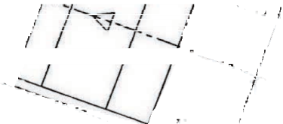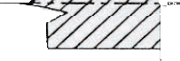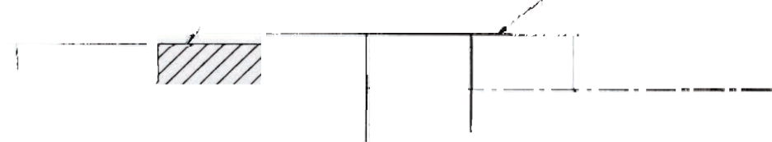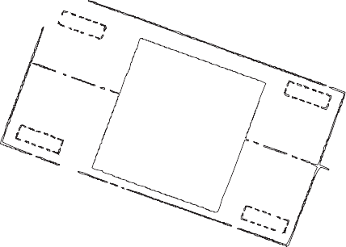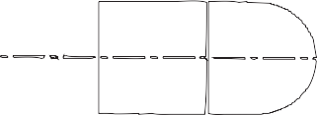

CL

D

D/2

12 in. (305 mm) from First Structurally Stiff Splice Component

θ = 15 DEG. CL

θ

Normal Direction of Traffic

Figure 2-18. Critical Impact Point for Test 34 on Non-Gating Crash Cushions

specifi c CIP locations for the terminal or crash cushion under evaluation. Most non-gating crash cush- ions use relatively rigid diaphragms that provide solid support for the redirective panels. As a result, vehicles striking even a few inches downstream from the start of the fi rst full-strength side panel will be redirected. Therefore, the CIP should be considered to be upstream of the beginning of the fi rst

full-strength side panel. Detailed fi nite element analysis programs, such as LS-DYNA, can be used to help estimate the CIP for these systems. Figure 2-18 displays a recommended impact condition for non-gating crash cushions that may be used when detailed modeling is not available.

###### Test 36

Test 36 is intended to examine the transition between a crash cushion and a rigid or nearly rigid backup structure or barrier end. The primary concern for this test is that the crash cushion will not provide suffi cient rigidity to prevent severe wheel snag or pocketing on the end of the rigid feature. LS-DYNA, or other explicit fi nite element codes, can be used to determine the critical impact point for this test. When practical, these models should be employed to select the CIP for Test 36. At this time, few studies have been conducted to identify critical impact points for these features. Crash cush- ions secured against lateral movement by cables or other moderately fl exible systems are expected

to have a CIP between 9 and 11 ft (2.7 and 3.4 m) from a rigid support structure. Systems anchored against movement by diaphragms attached directly to a concrete pad or to steel railings placed on the ground are examples of stiff crash cushion designs that are expected to have a CIP between 7 and 9 ft

(2.1 and 2.7 m). Whenever practical, fi nite element modeling should be used to identify the critical impact point for Test 36.

###### Test 37

This test is intended to examine the behavior of crash cushions and terminals during reverse direction impacts. As discussed previously, CIP locations for reverse direction impacts vary greatly from one

54 | Manual for Assessing Safety Hardware

system to another and there is no generalized system for identifying these locations. For most crash cushions with fender panels lapped against opposing traffi c, the CIP should be selected to maximize the risk of snagging on the end of the last fender panel lapped in this manner. Many crash cushions attached to concrete barriers incorporate a tapered section between the wider cushion and the nar- rower barrier face. In this situation, Test 37 should normally be confi gured to fi rst strike the barrier or the tapered section in order to maximize the potential for snagging. For post-and-beam terminals utilizing a breakaway cable system, the impact point should be selected to maximize the risk of the vehicle snagging on the anchor cable. Finally, for fl exible barriers, the critical impact location should be selected to maximize the risk of one or more longitudinal elements, such as a cable, riding over

the front of an impacting vehicle. This situation would maximize the risk of the terminal snagging the front of the vehicle.

###### Test 44

Test 44 is designed to evaluate the ability of a non-redirective crash cushion to stop a large passenger vehicle in a side impact. The CIP is selected to maximize the risk of the vehicle impacting the backup structure. For non-redirective crash cushions that truly have no redirective capacity, the centerline of the test vehicle should be directed at the corner of the shielded obstacle. However, if the non-redirec- tive crash cushion has some redirective capacity, general guidelines for determining CIP locations presented in Section 2.3.3.2 for Test 36 should be followed.

### 2.4 SIDE IMPACT

All impact performance guidelines published to date include crash tests involving tracking vehicles. In other words, all tests are confi gured to have the impacting vehicle rolling forward into a roadside safety feature without any yawing or sideslip motion. However, crash data analyses have shown that approximately half of all run-off-the-road crashes involve non-tracking vehicles in a yawing or sideslip motion at the time of impact (39). Furthermore, crash data studies also appear to indicate that the impact performance of roadside features can be adversely affected by non-tracking behavior (80, 117).

Although the effects of non-tracking impacts on the impact performance of many roadside features are not fully understood, it is clear that side impacts have the highest potential for severe injuries for many narrow roadside features, such as large signs, luminaire poles, narrow crash cushions, and

terminals (106). The side impact scenario with the greatest potential for injury involves the door of an impacting vehicle striking the safety feature with the vehicle in a broadside skid. In this situation, the safety feature can penetrate a long distance into the occupant compartment with a high likelihood of striking and injuring vehicle occupants.

Although two sets of crash testing guidelines have been developed for side impact testing (104, 105), few roadside safety features have been designed to accommodate side impacts. Furthermore, it is an- ticipated that most large structural supports and terminals and crash cushions would likely fail either of the side impact testing guidelines referenced above.

Chapter 2—Test Matrices and Conditions

| 55

In recognition of the preliminary state of roadside safety feature design to accommodate side im- pacts, the lack of compatibility with vehicle design, and the ever changing vehicle fl eet, the impact performance evaluation guidelines contained herein do not specifi cally recommend any side impact testing. Additional research is needed to identify strategies for accommodating side impacts into narrow roadside features. The latest side impact testing guidelines can be found in *Measurement of Heavy Vehicle Impact Forces and Inertial Properties* (12). Users are encouraged to conduct full- scale crash tests under these guidelines whenever practical in order to build a better understanding of the effi cacy of the proposed procedures and the performance of modern safety features during side impacts.