American Association of State Highway and Transportation Offi| 211

Measurement of Vehicle Deformation
E

n order to determine the amount of interior crush deformation, both pre-impact and post-impact measurements of the vehicle interior must be taken. Accurate determination of the position of the
I
floorboard is often critical to this determination. Four sets of measurements are recommended: two pre-impact data sets and two post-impact data sets. These two sets of data allow for the accurate deter- mination of interior crush deformation.

E1 PRE-IMPACT MEASUREMENTS

First, a reference line along the fl oorboard is established at the longitudinal centerline of the vehicle, extending from the fi rewall to the back of the interior of the vehicle. This reference line serves as the X- axis for the measurement of lateral displacement. A second reference line is drawn along the back of the vehicle’s interior, serving as the Y-axis for measurements along the vehicle’s length. Accordingly, if the impact points are on the driver side of the vehicle, the Y-component values are negative. If the impact points are on the passenger side, the Y-component values are positive. All X points are positive. The coordinate system is shown in Figure E-1.

D a shboard 25 24 23

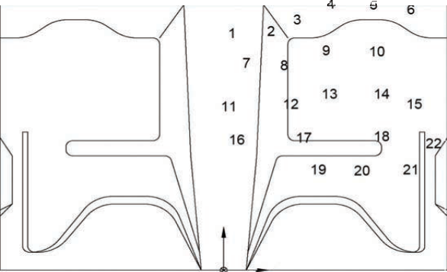
Do o r Do o r

X

Y Z

Figure E-1. Pre-Impact Measurement

212 | Manual for Assessing Safety Hardware

Ten to fi fteen points should be plotted uniformly on the interior side of the vehicle’s roof and fi ve to ten points should also be plotted across both the dash and the interior wall adjacent to the vehicle impact zone. The X and Y values for each point are then measured in the X-Y coordinate system,
using a level to ensure in-plane measurements. These measurements are to have a minimum accuracy of ±1/8 in. (3 mm). Some consideration should be given to the expected deformations when selecting the number and locations of points to plot. More points should be plotted when a narrow intrusion is anticipated, such as from a luminaire pole falling on a vehicle’s roof. When there is a signifi cant risk of direct impact on an unusual part of the occupant compartment, such as the underside, additional points should be plotted across the associated area of the vehicle as shown in Figure E-1.

In order to measure vertical locations, a swivel laser bracket (or similar leveling device) is aligned with the back interior wall of the vehicle above the X-Y axis created above. The vertical position of the swivel laser bracket is documented in two ways. First, the outline of the bracket is marked on the rear wall of the vehicle. Second, at least two reference points elsewhere on the vehicle are also marked and documented. Because these reference points are required to maintain the same vertical
orientation for post-impact measurements, these reference points must be placed in locations that have a very low probability of deformation. The vertical location of the swivel laser level and its corre- sponding reference points are designated as the origin of the vertical axis, Z1. An example of a swivel laser bracket is shown in Figure E-2.

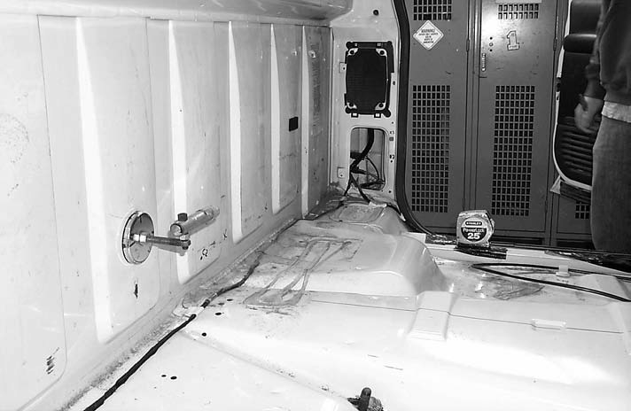

Figure E-2. Placement of Swivel Laser Bracket

Having established the origin for the coordinate system, the vertical locations of each of the refer- ence points are then measured using a tape measure and the laser swivel bracket. It is paramount that the vertical location be measured accurately; accordingly, the tape measure should be plumbed with a level. Positive Z-values are above the horizontal plane created by the swivel laser bracket; negative Z-values correspond to points below the horizontal plane. The measurement of vertical positions is shown in Figure E-3.

Appendix E—Measurement of Vehicle Deformation | 213

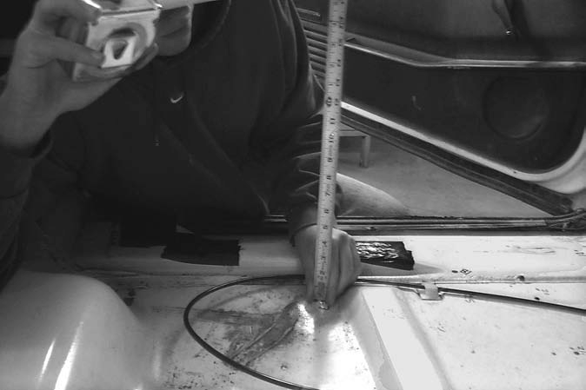

Figure E-3. Measurement of Vertical Positions

A second origin, X′-Y′-Z′, is then chosen to provide a reference frame for shifts due to distortions in the original reference frame. In order to create this second origin, string lines parallel (but not coin- cident) with the original reference X and Y axes are selected. This new X′-Y′-Z′ coordinate system should be selected in a manner that minimizes deformations, preferably away from the impact side of the vehicle. The steps above are repeated in order to acquire X′, Y′, and Z′ locations for each of the points.

E2 POST-IMPACT MEASUREMENTS

After impact, post-impact measurements are taken in the same manner as described above, using the previously defi ned X-Y-Z and X′-Y′-Z′ coordinate systems. A typical plotting diagram for the crush data points and recording spreadsheet are shown in Figure E-4. It may be useful to develop a spread- sheet that automatically plots the crush points on the fl oor pan drawing.

E3 PHOTOGRAPHIC DOCUMENTATION

Detailed photographs should be included in the crash test report to allow readers to identify both the locations of the pre-impact measurement grid and document the extent of deformation during the test. Particular attention should be provided to any area of the vehicle interior where signifi cant deforma- tion is observed.

214 | Manual for Assessing Safety Hardware

Vehicle Pre/Post Crush Info Set 1
TEST: |  |  |  |  |  | Note: If impact is on driver side, need to enter negative number for Y.
VEHICLE:
Point | X | Y | Z | X′ | Y′ | Z′ | DEL X | DEL Y | DEL Z
1 |  |  |  |  |  |  | 0 | 0 | 0
2 |  |  |  |  |  |  | 0 | 0 | 0
3 |  |  |  |  |  |  | 0 | 0 | 0
4 |  |  |  |  |  |  | 0 | 0 | 0
5 |  |  |  |  |  |  | 0 | 0 | 0
6 |  |  |  |  |  |  | 0 | 0 | 0
7 |  |  |  |  |  |  | 0 | 0 | 0
8 |  |  |  |  |  |  | 0 | 0 | 0
9 |  |  |  |  |  |  | 0 | 0 | 0
10 |  |  |  |  |  |  | 0 | 0 | 0
11 |  |  |  |  |  |  | 0 | 0 | 0
12 |  |  |  |  |  |  | 0 | 0 | 0
13 |  |  |  |  |  |  | 0 | 0 | 0
14 |  |  |  |  |  |  | 0 | 0 | 0
15 |  |  |  |  |  |  | 0 | 0 | 0
16 |  |  |  |  |  |  | 0 | 0 | 0
17 |  |  |  |  |  |  | 0 | 0 | 0
18 |  |  |  |  |  |  | 0 | 0 | 0
19 |  |  |  |  |  |  | 0 | 0 | 0
20 |  |  |  |  |  |  | 0 | 0 | 0
21 |  |  |  |  |  |  | 0 | 0 | 0
22 |  |  |  |  |  |  | 0 | 0 | 0
23 |  |  |  |  |  |  | 0 | 0 | 0
24 |  |  |  |  |  |  | 0 | 0 | 0
25 |  |  |  |  |  |  | 0 | 0 | 0
26 |  |  |  |  |  |  | 0 | 0 | 0
27 |  |  |  |  |  |  | 0 | 0 | 0
28 |  |  |  |  |  |  | 0 | 0 | 0
29
30

Dashboard

Door Door

X

Y Z
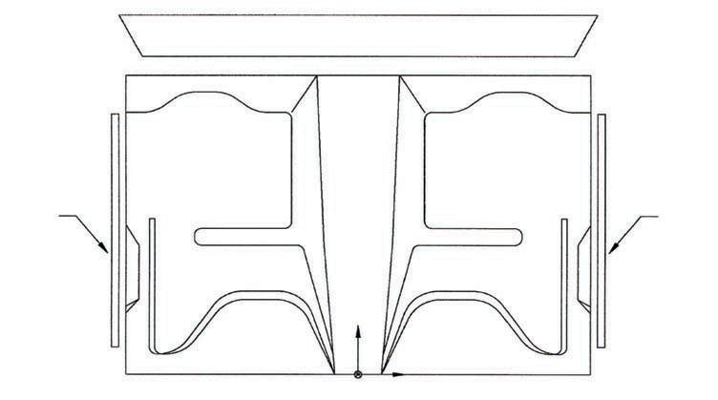
Figure E-4. Vehicle Deformation Spreadsheet

Appendix E—Measurement of Vehicle Deformation | 215

E4 PROCEDURE FOR MEASURING EXTERIOR CRUSH

The procedure for measuring external crush is described in depth in “Vehicle Measurement Techniques,” published by the United States Department of Transportation (148). The procedure sum- marized below is based on this publication.

The purpose of obtaining crush measurements is to develop a mechanism for linking vehicular defor- mations from full-scale crash tests to real world crash data collected in the NASS-CDS. Further, the measurements provide a basis for determining vehicle crush energy.

The basis for fi eld data collection is the point-to-point vehicle measurement technique. The measure- ments are obtained by establishing a reference line, measuring the residual crush, and subtracting the bumper/body taper to obtain the resultant crush profi le. An example of a confi gured reference line is shown in Figure E-5.

R eference Line

Tape M easure

Ov e ra ll Length

Tape
Me a s u re

E qual D istances

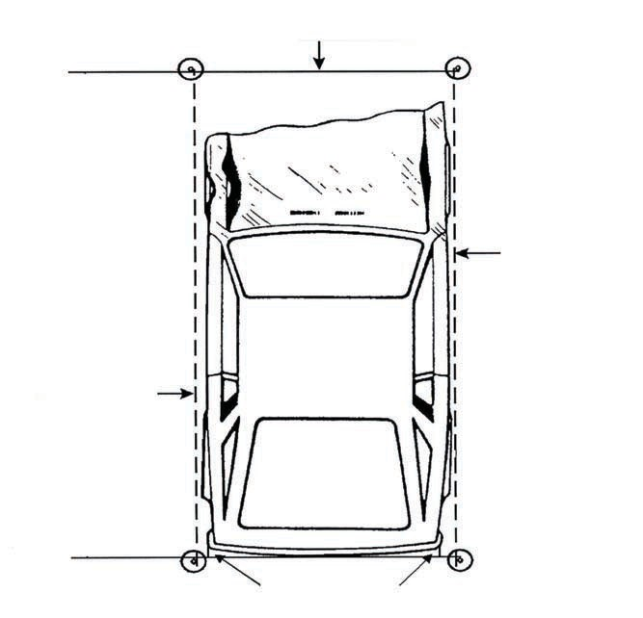
Figure E-5. Reference Line Configuration

The Field Length, or Field L, is the length of contact and induced damage measured parallel to the undeformed end or side plane of the vehicle. For impacts where the induced damage extends across the entire width of the end plane, the undeformed end width (UEW) is used in reconstruction pro- grams as the length. For narrow impacts, such as pole impacts, the Field L value is used. Examples of fi eld length measurements are shown in Figure E-6.

216 | Manual for Assessing Safety Hardware

U E W = R econ. P rogram L U ndeform ed E nd W idth (U E W )

F ie ld L F ield L = R econ. L

LF
Bu m p e r C orner

Bu m p e r Co rn e rs
RF
Bu m p e r Co rn e r

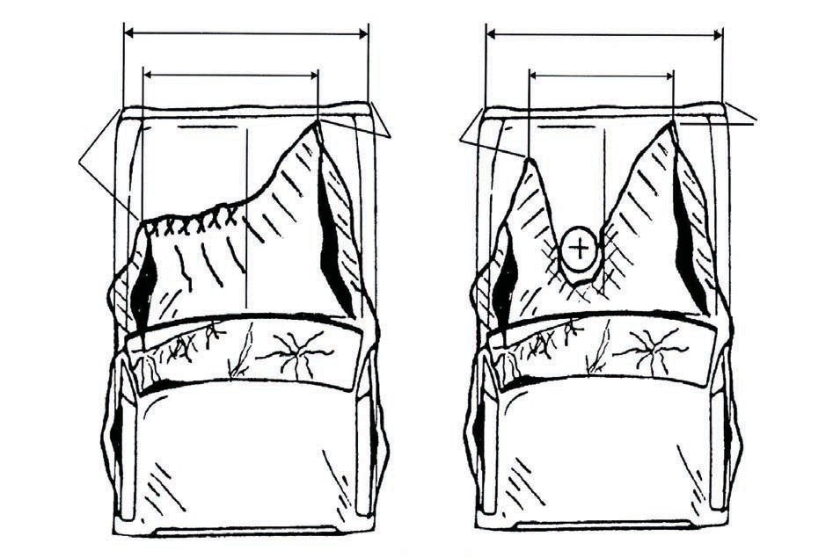
Figure E-6. Field Length Measurement

Crush depth measurements, or C dimensions, are taken at six equally spaced locations across the
Field L. A contour gauge is used to measure crush depths, as shown in Figure E-7. It is critical to ensure that the contour gauge is parallel to the original end plane of the vehicle. Note that a vehicle damage profi le is not always uniform. Vehicle crush should be measured at the vertical location of the most rigid structure in the damaged plane (i.e., frame or side door beam).

Appendix E—Measurement of Vehicle Deformation | 217

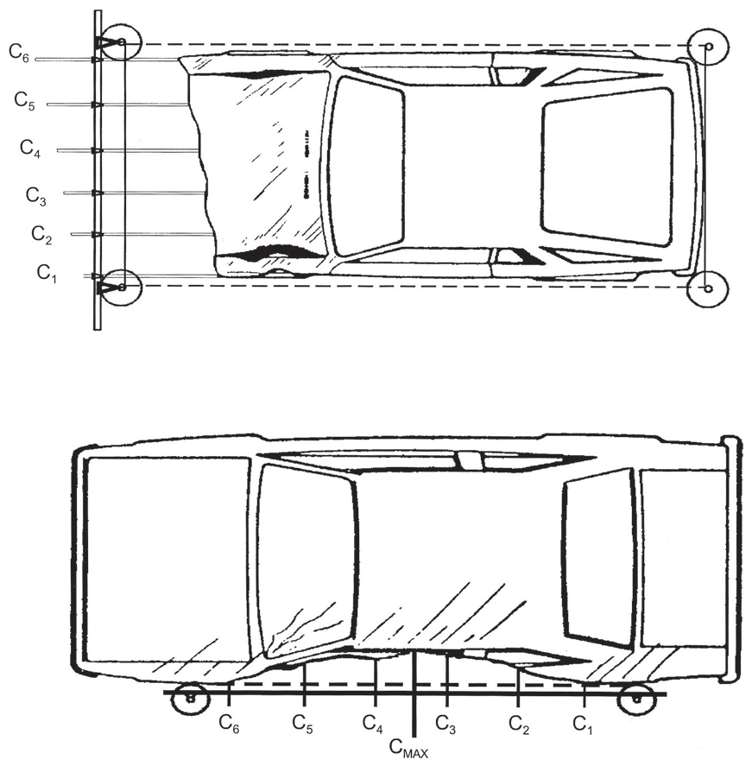

Figure E-7. Crush Depth Measurements

The fi nal requisite values to be measured identify the location of the damage with respect to the center of gravity of the vehicle, as shown in Figure E-8. The contact damage dimension, Dc , is the distance from the center of the contact damage width to either the vehicle’s damaged end-plane center or the damaged vehicle’s wheelbase center, for end-plane and side-plane impacts, respectively.

218 | Manual for Assessing Safety Hardware

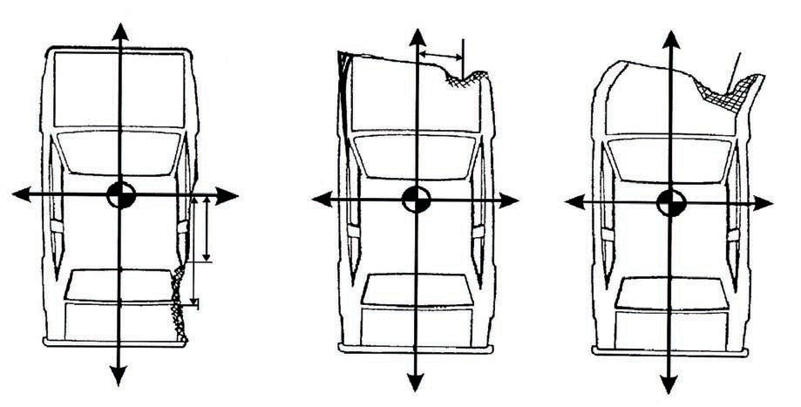
+ + +
DC

Original End Plane Center
DC

– + – + – +
DFL
Center of
DC Field L

Center of Contact
A Damage B C

– – –
Figure E-8. Crush Depth Measurements

The Field L dimension, DFL, is the distance from the center of the Field L (including both contact and induced damage) to the vehicle’s damaged endplane center or the damaged wheelbase center, measured along the general slope of the damaged plane.

For end impacts, the vehicle’s damaged centerline should be used (i.e., even a shifted or damaged center point on the endplane) to measure DFL. For side impacts, the center of the vehicle’s damaged wheelbase should be used (i.e., even if the vehicle’s end is shifted).

444 N Capitol St. NW Ste. 249 Washington, DC 20001

www.transportation.org

