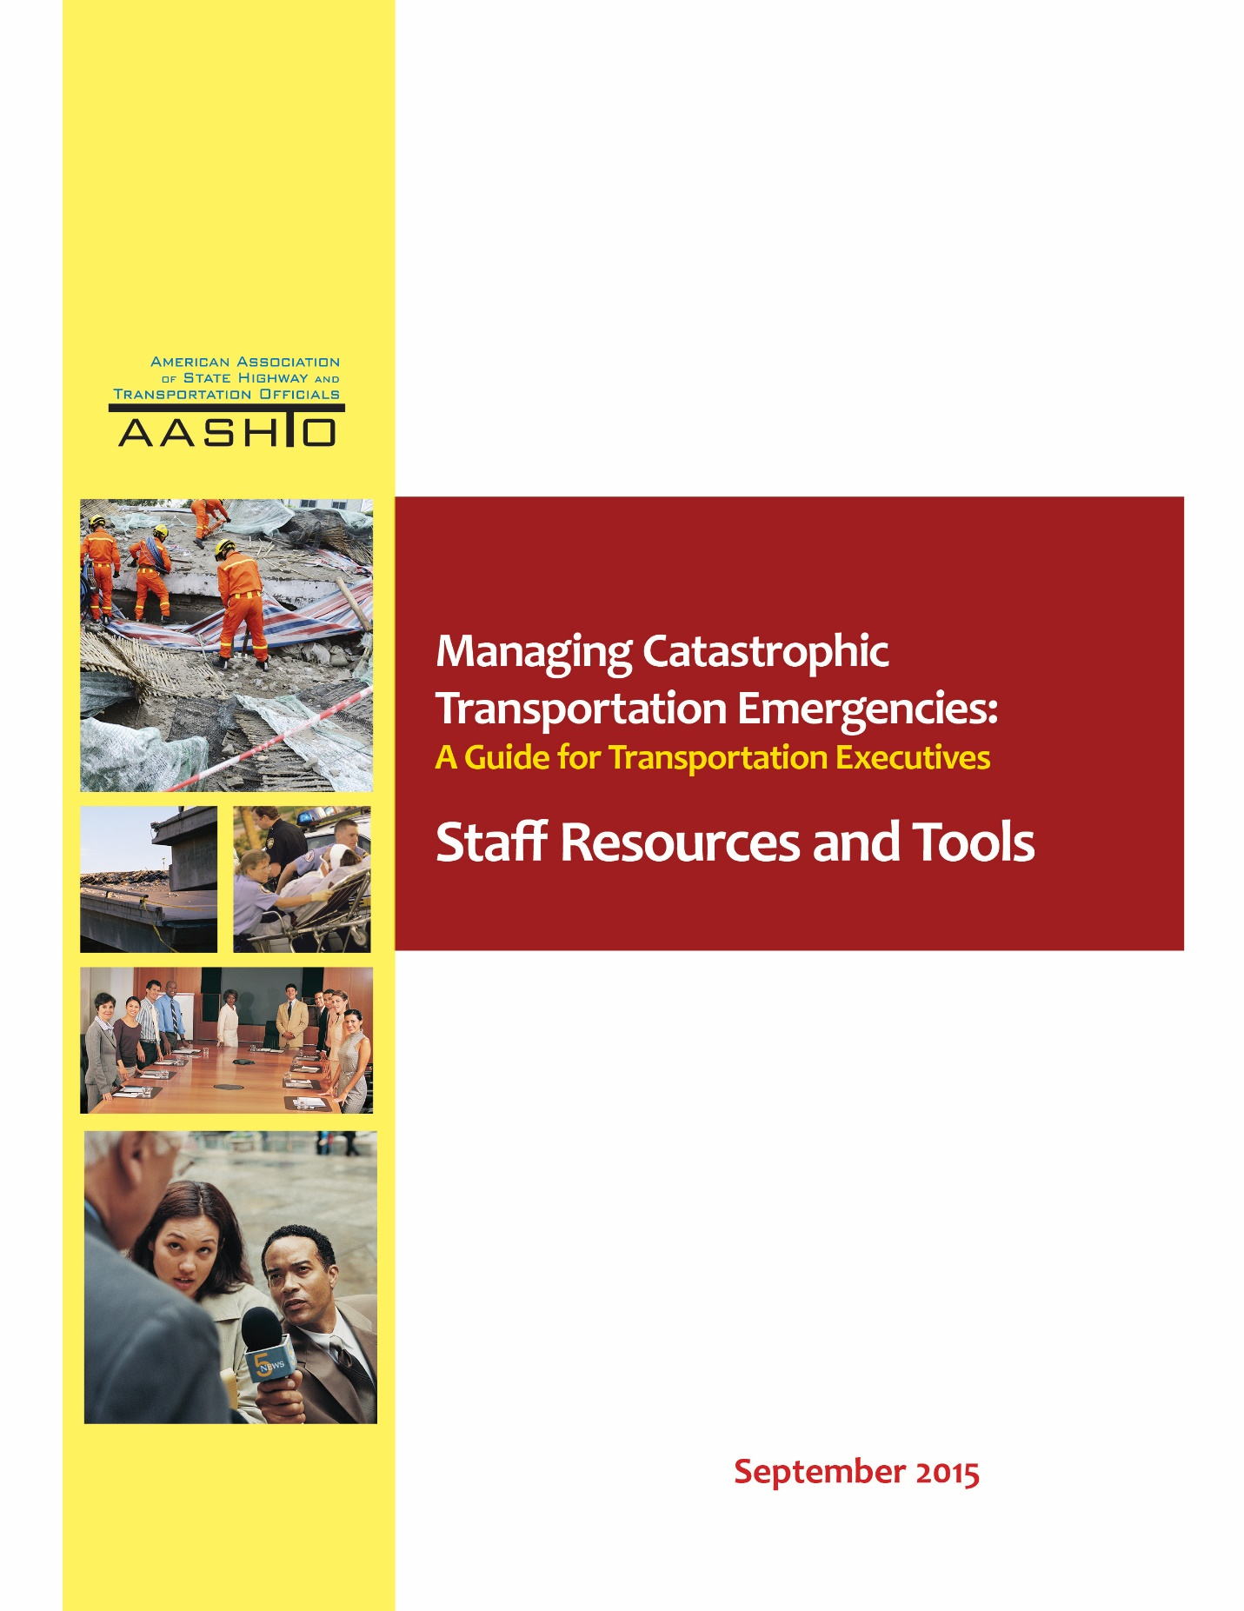

Contents
Introduction 3
Resources 4
- EXECUTIVE HANDOUT: “FIRST DAY” OVERVIEW 4
- EXECUTIVE HANDOUT: CEO DECISIONS BEFORE/DURING/AFTER EVENT 4
- STAFF TEMPLATES 12
  - 1-PAGE AGENCY WALLET CARD EXAMPLES 12
  - AGENCY RESOURCES TEMPLATE 14
  - EMERGENCY CONTACT LIST TEMPLATE 15

Introduction
To assist in the transition of a new CEO, staff resources and tools have been developed as a supplement to Managing Catastrophic Transportation Emergencies: A Guide for Transportation Executives. The resources—a set of executive Handouts—were based on the thoughts and advice from CEO peers who have been in similar positions. The tools were based on the experiences of current and retired transportation staff who have supported their CEOs in emergency response.
Two executive handouts were developed. One provides insights into the new position and is designed to be given to the new CEO to read on their first day. The other provides an overview of key CEO decisions to be made before, during, and after an event occurs and is designed to be used an ongoing resource by the executive. The tools provide examples of resource and emergency contact sheets and wallet cards in current use by some state DOTs.

Two-Page Executive Handout for First Day
The executive handout on the following pages was designed to be given to new CEOs to read on their first day in the new position. It was developed based on insights and advice from CEO peers.

WELCOME AND INTRODUCTION

Congratulations on being appointed the new CEO of your organization. This can be one of the most powerful and exciting opportunities in your career. Your time in public service will be critical to those you serve, even though it may often go unseen.
At some point during your tenure, you will be called upon to deal with a major emergency or disaster. One need only watch the evening news to become aware of the potential for loss of life, devastation, and havoc that can occur as the result of manmade or environmental incidents and disasters such as floods, storms, fires, earthquakes, terrorist events, explosions, gunman events, and hazardous materials incidents. When it does happen, the day-to-day methods that you use in your operation will be insufficient to handle the large-scale
emergency.
A comprehensive emergency management program does the following:
• Examines potential emergencies and disasters based on the risks posed by likely hazards.
• Develops and implements programs aimed toward reducing the impact of these events on your agency.
Your agency must be prepared for those risks that cannot be eliminated, and be prepared for the actions required to deal with the consequences of actual events and to recover from those events.

Emergency operations planning activities are divided into four phases.
- Mitigation—Taking sustained actions to reduce or eliminate risk to people and property from emergencies and their effects.
- Preparedness—Building the emergency management function to respond effectively to, and recover from, any event.
- Response—Conducting emergency operations to save lives and property by doing such things as evacuating victims; providing food, water, shelter, and medical care to those in need; and restoring critical services.
- Recovery—Rebuilding so that you can function on your own, return to normal operations, and protect against future hazards.

Former and current transportation executives were interviewed to understand CEO actions and decisions during events to better understand concepts for preparing to manage transportation emergencies. Here is a summary of the thoughts and advice from others who have been in your position.

1
THOUGHTS AND ADVICE FROM PEERS
WHO HAVE BEEN IN YOUR POSITION

1) During an emergency/crisis situation, you may sit at the nexus of multiple stakeholders, resources, authorities, and responsibilities. You need to understand these relationships and how best to manage and apply them during emergencies and crises. Don’t get down in the weeds with everyday items, but do stay in touch with the overall big picture.

2) You must have the full confidence of the elected official (typically the governor) to whom you report. You need to understand the political implications of the event and provide guidance to “ensure that we are not stepping into a political mine field.”

3) You will set the agenda for the agency and staff and must establish priority for planning, preparation, training for, and responding to emergencies since that is what the agency’s reputation (and funding) may be built on. The public does remember how the DOT responded when the major incident or weather event occurred. This requires frequent refreshing of both the message and the training/planning/exercising since key staff turns over often and experience with actual emergencies may be lost as key staff retires or moves to other positions.

4) You must have confidence in key operations staff and give them the freedom to respond based on their own initiative when emergencies arise. You should make sure to develop solid relationships with key operations staff to ensure that they know what to do and will keep you adequately informed with clear, accurate, and timely information as emergency situations unfold. Manuals and workshops, while helpful, are less important than knowing key staff, how to reach them when needed, and what they can do with the resources they have when the emergency happens.

5) You and the agency rely on vendors and contractors to augment agency resources when emergencies arise and you and key staff must have established personal and contractual relationships with those vendors and contractors who will be called upon when the emergency comes. They must be able to trust you.

6) Because many emergencies require coordinated responses from multiple local, state, and federal agencies, you must know the leadership in partner agencies both within your state and, in some cases, neighboring states, since some emergencies are regional in nature (e.g., floods, hurricanes, snowstorms) and require multi-state coordination. These relationships include multi-agency and multi-jurisdictional (including multi-state) plans, communications strategies, training, exercises, resource sharing, and agreements needed to support your agency’s response to emergencies.

7) You may be the public face of the state's response to emergencies, especially if the event involves damage to or destruction of transportation infrastructure or incidents that close or restrict major transportation facilities. In these cases, you need to cooperate with the media to provide the best information possible so that others (e.g., Operations personnel) can focus on repairing the facilities and restoring mobility rather than responding to media questions.

8) Remember 1) the importance of COMMUNICATION with all parties involved in preparing for and responding to emergencies that affect transportation assets or require responses from transportation agencies, and 2) the need to establish solid RELATIONSHIPS with all parties who must work together effectively when emergencies happen - and emergencies WILL happen.

9) Reinforce to staff that you trust them and that you will work with them to make the operation better (listening to their needs) and make them understand you know how difficult their job can be.

10) Learn before you speak…. trust before you criticize.

11) Ride with the field response staff.
2
Executive Handout:
Key Decisions Before/During/After Event
The following executive handout provides an overview of key CEO decisions to be made before, during, and after an event occurs, designed to be used as an ongoing resource by the executive.
CEO Decisions: Emergency Events
BEFORE: Prevent/Protect/Mitigate
Decisions | Advice from Peers
What events do we need to be prepared for? | Know events your agency experienced in the past. What additional threats are there? What mitigation approaches are available?
Is key staff in place? | Get familiar with your people and the DOT roles in emergency management during an incident.
Do we have the right people in place to do the job? | Pay attention to staff placement and replacement.
Has staff been trained? | Put programs in place to ensure that staff has training and experience to be able to think on their feet. Conduct interagency training and exercises with other state agencies, such as emergency management and state patrol.
Do we have current plans in place? | Have plans in place with protocol of actions for staff that include back-up plans, COOP plans, resilience/recovery plans, and customer communication plans.  Make sure internal emergency procedures and emergency response protocols are in place and have been practiced.
Do we have MOUs in place? | Hold planning meetings and prepare mutual aid agreements. Ensure that agency plans and procedures complement the state’s overall emergency structure and plans.
Do we have the right equipment and materials? | Be sure you have equipment and materials ready and in place for expected and unexpected events. Do you have flexibility to adapt to changing situations?
Do we have contracts in place? | Establish vendor relationships prior to an event. Have contracts with contractors in advance, if possible.
How can we improve? | Make sure lessons learned from past events are implemented.  Ensure recommended actions and lessons learned from drills/exercises are documented and implemented.  Reinforce understanding within the agency that emergency response and preparedness is a critical, primary part of agency mission and one of the most rewarding parts of the job.
Do we have effective public communications in place? | Can our web site and phone number site (511) handle anticipated increase in traffic, e.g. on travel and weather information page?  Does the DOT PIO have contacts for other agencies to make sure that everyone is sending out the same message to the public?
Who do I need to meet with? | Establish relationships in advance. Partnership and relationship are critical in all levels of the emergency response community. Remember, “if they know you, they will trust you.”  Develop internal communications with key operations staff and with external agencies such as emergency management and state patrol.  Establish and maintain confidence of the elected officials. Understand the importance of dealing with politics.
DURING: Respond
Decisions | Advice from Peers
What needs to get done? | Establish priorities when necessary, such as clearing highways as soon as possible to support the response.
What are the priorities? | Tell your people that they will need to make decisions and that you will stand by them.
What support does the local response need? | Be visible to your staff and talk to them face-to-face. Tell them that you are here to help them get their job done.  Know what can be authorized under code from what others are recommending.
Who do I need to communicate with? | Communicate early and regularly with critical audiences. Be transparent with information and public data.
How do I gain confidence of public? | Be visible to the public early in a crisis to give a face to the responses. Does the DOT PIO have contact with other agencies to make sure that everyone is sending out the same message to the public?
What messages should be delivered? | Demonstrate that you are in charge and that your agency’s primary goal is to do whatever is necessary to protect public safety and address the needs of people involved in the event. Empathy is critical. Let the public know that leadership is concerned about them.
Where should I go? | Get oriented on where to go and whom to contact. Visit communications and operations centers at the district or local level.
What can I do to help my staff? | Know what the staff wants you to do during the event.  Remember that you cannot do everything yourself. Know when to step back and let employees and contractors perform their jobs.
Does the situation need to be escalated from local response? | What are the internal escalation points? Is the escalation process working?  Understand the incident management escalation points—from local to regional to national—and the resulting changes in communication protocols.
What can I do to help other state and regional agencies? | Be an advocate for your agency with other agencies so they can understand your capabilities and resources. Ask your counterparts at the state level what you can do to help them.  Collaboration is critical to your success.  - Cities, counties/parishes, MPOs  - Regional authorities—seaports, airports, toll authorities  - Transit  - Public safety agencies  - Community leaders—business leaders, church/mosque/synagogue leaders, critical neighborhood leaders  - Local school districts  - Media
AFTER: Recover
Decisions | Advice from Peers
When do we get back to normal operations? | Know or establish criteria that determine when your agency goes back to normal operations versus emergency response mode.  Prepare how to transition response/recovery efforts back to the local community when necessary.
How do we get back to normal? | Understand any long-term recovery needs and issues, e.g. restoration of damaged or lost infrastructure. Identify repair/replacement decisions and approaches. Do your staff and local agencies know the criteria for reimbursement from FHWA and FEMA if damage qualifies for funding?  Evaluate phased approaches such as using temporary solutions and multi-modal approaches to expedite recovery.  Identify how to transition from emergency mode to normal operations.
What worked well and what needs to improve? | Ensure that an after-action report is done and the recommendations and remedial actions become part of the agency’s corrective action program. Make sure that the information is shared with everyone that was involved.  Get regular, periodic updates on remedial actions to ensure they are being implemented.
What can we do to implement lessons learned from the event? | Make sure there is support for changes made from lessons learned.  Create a culture in which people learn and are sustained, even when mistakes are made.
Questions to Ask: Planning/Preparedness
- What is my system’s current level of security and preparedness?
- Does the agency have plans in place to respond to various classes of emergencies? In the last two years, how many real-time disasters have we responded to? What additional threats should we consider for our operations?
- Are state emergency response plans current and adequate to respond?
- Are the response programs centralized or decentralized? Who is responsible for the plans and responses at the working level?
- Are plans, documents, and contact lists updated semiannually/annually? Are the documents easily available online? Is there a sufficient number of paper copies available?
- How are the state’s functions and emergency management agencies coordinated? What are the role and authority of the governor’s immediate staff?
- How is the state’s fusion center organized? What products does it produce?

Questions to Ask: Training/Exercises
- Does the agency practice and/or train for emergencies?
- When did your agency last conduct exercises/drills?
- What other agencies participated and what other key agencies were not present?
- Has your agency’s role in the drills/exercises been realistic to operations?
- Who is in charge of the exercises? Do we need to have someone in on the planning to make them more realistic?

Questions to Ask: Communications/Coordination
- What agency is responsible for your state’s communications system? Do they have a back-up plan?
- Do all emergency responders in your agency know who the go-to person is in case of an incident? Who will notify you and provide regular updates?
- Does key staff have the contact information for other key staff (e.g., do we have staff wallet cards)? Does the contact list contain cell, home, personal cell, and personal email addresses to use as back-up?
- Are the state’s first responder communications sufficiently interoperable?
- What technical means of communication are available?
- How can the agency cooperate more effectively with law enforcement and other emergency responders?
- Ask your counterparts at the state level from the National Guard, state police, and governor’s office of emergency preparedness what you can do to help them. What barriers do they have with your agency?
- Visit communications/operations centers at the district or local level. What do they expect from you?
- Does staff know whom to notify at the local FHWA office when an incident occurs?
- Has staff contacted bordering states to obtain contact information for their counterparts?
- Has staff communicated with local public works (larger counties/cities) to see if they have a response plan? Does their plan work with yours?

Questions to Ask: Feedback/Corrective Actions
- What steps can be taken to identify and prioritize action for mitigating and managing these threats?
- What went right? What did not?
- Are plans, documents, and contact lists updated semiannually/annually?
- Does your agency have the proper equipment to respond to the incident?
- Does incident response staff have back-up relief to sustain 24/7 coverage for an extended period of time?
- Is staff aware of the ongoing efforts of AASHTO/TRB as related to security/emergency response?
- Has the agency conducted after-action reviews of real-time incidents and exercises/drills? What went well and what are the major areas needing improvement?

Staff Templates

1-PAGE (Double-Sided) AGENCY WALLET CARD

Here are two examples of state DOT wallet cards with key contacts for the agency. To supplement the wallet card, these contacts can be programed into the state director’s office phone and cell phone (and Sat phone if there is one).

EXAMPLE: Illinois Department of Transportation

IN CASE OF EMERGENCY
IDOT Employee Crisis Contact Information
Emergency Preparedness for You and Your Family

In case of a crisis involving IDOT facilities and the surrounding community, use the following information to stay updated on events:

IDOT Hotline (toll free): 1-xxx-xxx-xxx

IDOT Hotline (local): xxx-xxx-xxxx

Report an event: xxx-xxx-xxxx

Check IDOT status: www.idotdr.com

Enter your Emergency Contact Information below. This information will assist Emergency Personnel and your family in the case of extreme situations involving DOT facilities and surrounding communities:

Contact | Phone Number

1-PAGE (Double-Sided) AGENCY WALLET CARD

EXAMPLE: Wisconsin Department of Transportation

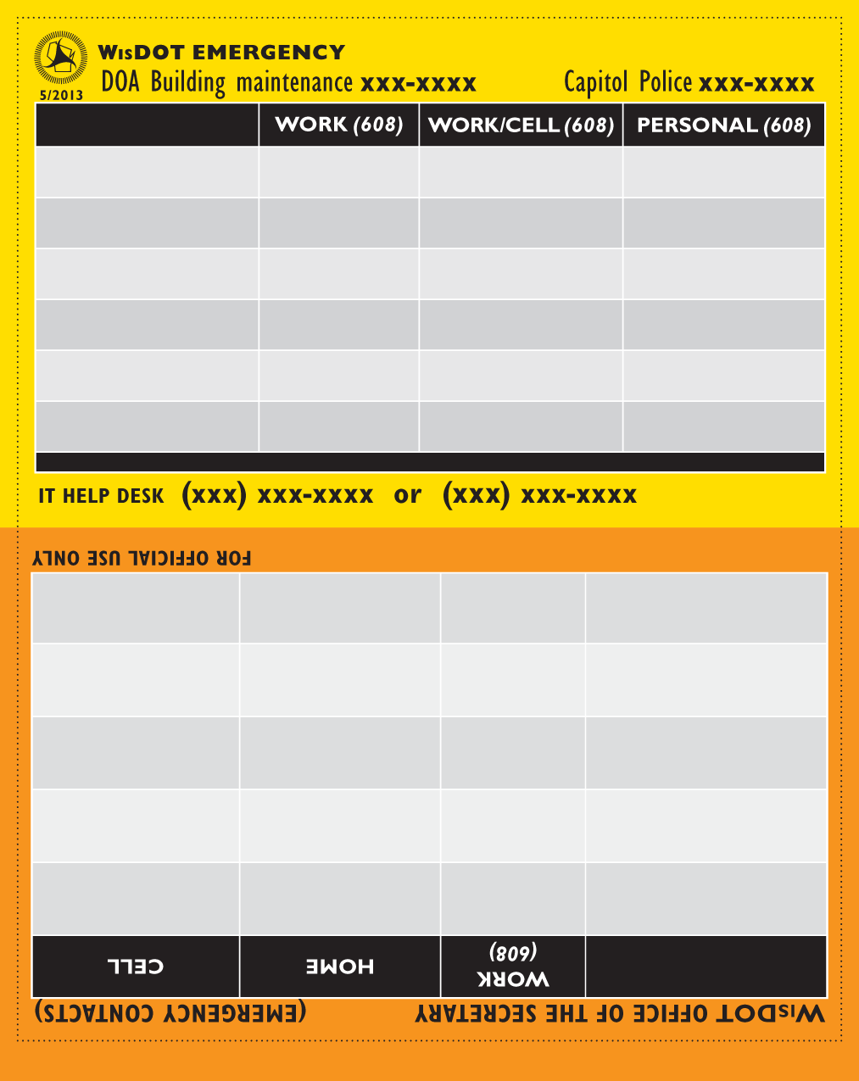
Agency Resources Contact Sheet Template
Area Engineer |  | Phone No.
Area Supt. |  | Phone No.
Area Super. |  | Phone No.
Sub-Area Super. |  | Phone No.

Equipment
 | Pickups |  | Bucket Trucks
 | Loaders |  | Flashing Light Trailers
 | Backhoes |  | Variable Message Boards
 | Water Trucks |  | Type III Barricades
 | Trucks |  | Water Pumps
 | Graders |  | Chainsaws
 | Bobcats |  | Equipment Trailers
 | Concrete Safety Barriers

Employee | Radio Call Number | Cell Phone Number

Agency Contact Sheet Template
Organization
Agency/Sub-Organization | POC Name | Position Title | E-mail | Telephone
Internal
Homeland Security Coordinator
Emergency Management
Coordinator
ESF-1 Coordinator
District Contacts
District A
District B
(continue list as necessary)
Federal Government
U.S. Department of
Transportation (U.S. DOT)
Federal Aviation Administration (FAA)
Federal Highway
Administration (FHWA)
Local FHWA Contact
Federal Motor Carrier
Safety Administration
(FMSCA)
Surface Transportation Board (STB)
Pipeline and Hazardous Materials Safety Admin.
(PHMSA)
U.S. Department of Homeland
Security (U.S. DHS)
Office of Infrastructure
Protection (IP)
Protective Security
Advisor (PSA)

Organization
Agency/Sub-Organization | POC Name | Position Title | E-mail | Telephone
TSA, Highway and Motor
Carriers Division
U.S. Army Corps of
Engineers (U.S. ACE)
Division A
District A
District B
U.S. Coast Guard (USCG)
District A
District B
Federal Bureau of Investigation (FBI)
Bureau of Alcohol, Tobacco, Firearms, and Explosives (ATF)
(continue list as necessary)
Interstate
State A
DOT
Other organization
as appropriate
State B
DOT
Other organization as
appropriate
(continue list as necessary)
State
State Homeland
Security Agency
State Emergency
Management Agency
State Senior Security Advisor

Organization
Agency/Sub-Organization | POC Name | Position Title | E-mail | Telephone
DOT’s Partner Agencies at the State Level
Agency 1 (enter title)
Agency 2 (enter title)
Agency 3 (enter title)
(continue list as necessary)
Turnpike Authority
State Police/Highway Patrol
Law Enforcement
National Guard
Health Agency
(continue list as necessary)
Local
County/Parish A
Sheriff's Office
Engineer
Fire Department
Chief Executive's Office
Highway Department
(continue list as necessary)
Municipality A
Law Enforcement
Organization(s)
Transportation Department
Fire Department
(continue list as necessary)
Organization
Agency/Sub-Organization | POC Name | Position Title | E-mail | Telephone
Local Airports
Airport A
Airport B
Airport C
(continue list as necessary)
Local Transit Agencies
Agency A
Agency B
Agency C
(continue list as necessary)
Local Toll Road Agencies
Agency A
Agency B
Agency C
(continue list as necessary)
Other Partners
American Association of State Highway and Transportation Officials
Transportation Research Board
(continue list as necessary)

