CTPP 5-Year
Data Access Software
Functional Specification

17-Apr-2013
Prepared by:
Beyond 20/20, DBx Geomatics

Version 1.0

Contents
1 Overview 2
2 Software Components 2
3 CTPP Application Initial Screen 2
4 Finding / selecting a table 5
5 Selecting Geography 6
5.1 General Principles 6
5.2 General Flow 7
5.3 Selecting geography 8
5.3.1 Members tab 8
5.3.2 Members by map tab (Geography Selection Map) 10
6 Viewing a table 14
7 Making selections on dimensions 16
7.1 Members tab 16
7.2 Totals tab 17
7.3 Percentages tab 18
7.4 Custom groups tab 20
7.5 Calculated members tab 20
8 Data accuracy – the Output dimension 24
9 Organizing a report 26
10 Viewing the data on a thematic map 27
10.1 Thematic Map Interface (Base) 27
10.1.1 Thematic Analysis 28
10.1.2 Map Display 35
10.1.3 Thematic Map Interface - Flows 49
11 Charts 54
12 Saving results 55
12.1.1 Saving the report view 56
12.1.2 Managing selections on a dimension (Selection sets) 56
12.1.3 Download to Excel, CSV and mapping formats 58

Overview

This document describes the User Interface functionality for the CTPP Professional Services Proposal.

Note that this interface will change throughout the development process. Color selections shown have not been finalized.

Software Components

The web software components used for the projects will be:

1. SQL Server 2012
2. CartoVista 4.0
3. Perspective 6.0

The CartoVista and Perspective products will be integrated for mapping as a customization to each product. Both Perspective and CartoVista will also require additional features to support the proposed User Interface.

CTPP Application Initial Screen

The initial entry screen for the application is shown below.

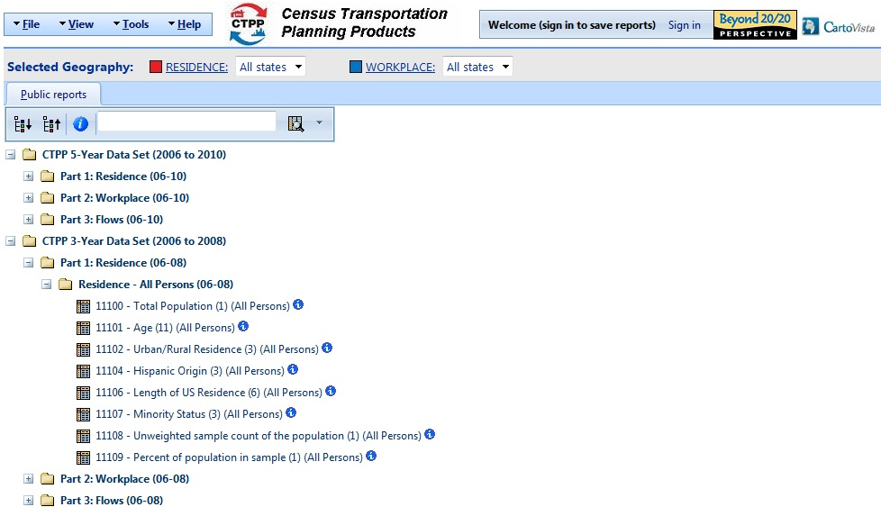

The initial view is the pre-defined set of public reports, corresponding to the tables provided by Census. These will be organized into folders that separate data by data release (3-year, 5-year, etc), part (residence, workplace, flow), universe, and possibly whether or not the tables contain perturbed data. In the future, system administrators may wish to save charts or maps. These will have different icons to the left of the report title. Initially, there will be data for the 3-year (2006-2008) and 5-year (2006-2010) data sets, but it is anticipated that other data sets will be added to the system.

When a user has signed in, there will be separate tabs for “Public Reports” and “My Reports”. When a user saves a report, these will be available on the “My Reports” page. Users will only be able to save reports by opening an existing report (Public or one of their own), modifying it, and then saving it with a different name. Administrators, by contrast, will also have the ability to create reports by browsing the source data cubes, initiated by clicking a “Create Report” button. This button will not be shown for normal users.

Geography selection is independent of the report and will persist for the duration of the session. These are selected through the Residence/Workplace links shown below the toolbar. The initial selections for users visiting the site will be “All States”, consisting of the states as well as US totals. Users will be able to modify their geography selections. These can be named/saved by the user and will be available for selection in the dropdowns to the right of the Residence/Workplace labels.

On all pages, the user will have the option of logging into the system. A user will need to sign in to save either geography selections or new reports. This is indicated in the text adjacent to the “Sign In” button. After clicking the “Sign in” button, the end user has the option to self-register by clicking the register button below.

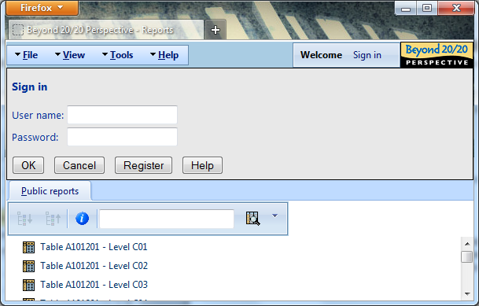

Self-registration opens the Registration dialog. The dialog has a special “User type:” field followed by the drop-down as shown.

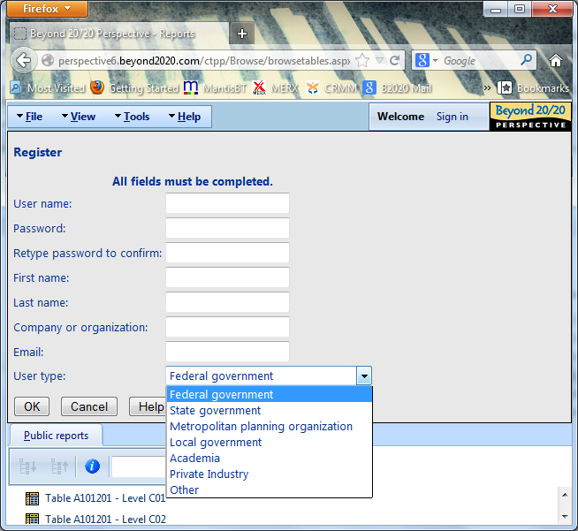

As indicated, User Type is one of “Federal Government”, “State Government”, “Metropolitan Planning Organization”, “Local Government”, “Academia”, “Private Industry”, or “Other”. The default is Federal Government.

Finding / selecting a table

The user will have the ability to search for report text --- through the report notes. Report notes are shown below for each report using the “i” information icon following the reports name in the Report List page and will contain the names of the words on which each report can be searched (for example, dimension names, member names, synonyms).
The application has both simple and advanced search as shown below:
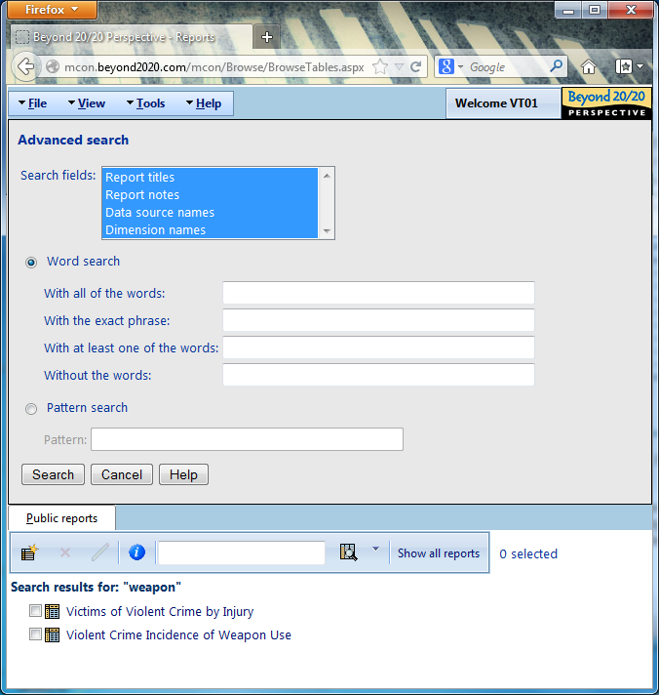

Selecting Geography

General Principles
We have strived to simplify the user experience as much as possible. The principles used in the process to select geography are:

- Geography selection is fundamental to getting data, and is (for the most part) independent of the table being selected.

- Once users have defined the set of geographies they like, they're likely to reuse these geos for multiple studies.

- A key differentiator for the CTPP product is the ability to present flow data, so the UI should bring the concept of flows to the fore.

- If a user is analyzing flow data, they are more likely to want to do more analysis on the same residence/workplace geographies in parts 1/2 than using different geographies in these tables.

General Flow
Based on these principles, the following flow has been designed:

- There will be drop-down lists at the top of all pages of the application showing the name (if there is one) of the currently activated list of residence and workplace geographies. By having both lists always available, users are encouraged to think about the data in terms of the flows that may be generated (although this is not strictly mandated).

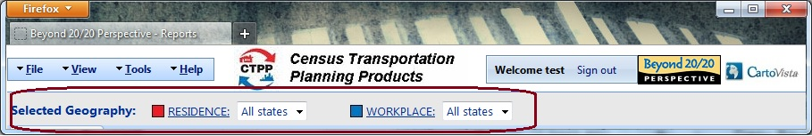

- If users have saved multiple different lists by name, these names will appear in the drop-down for easy switching between these geography lists. A user will need to log in to save a list by name, but can modify their current selection (called "unnamed list") whether or not they are logged in. Changing the current selection will be accomplished by clicking on the “Residence” or “Workplace” link at the top of the page.

- These lists will apply regardless of which table (in which part) is opened. Obviously, if the user opens a Part 1 table, the list of Workplace geographies will be ignored, and similarly Residences will be ignored when opening a Part 2 table.

- As the tables make no sense when no geography is selected, users will always have selections made on both lists. The default will be a list of "All States" on each of them. This option will be available to all users at all times, regardless of whether they've signed in or not.

- When selecting geographies, users will be able to use either the map or the lists or flip back and forth between them.

- Changes may be made to the current geography list -- for example by drilling down into a geography in the report view. This will automatically change the current selection on that dimension to "unnamed list". Users will be able to return to any saved list by simply selecting the list from the drop-down.

- Flow tables will only ever show one level of flow data at a time. When opening a Part 3 table, the system will look at the currently selected residences and workplaces and determine which flows make sense. It will then generate another drop-down list box allowing the use to pick which level of flow data they want to see. If, for example, the residence list consists of counties, places and pumas, and the workplace list consists of counties and places, the following flow levels would be available to the user: county-to-county, place-to-place, county-to-place, puma-to-place.

Selecting geography

From any page on the site, users will be able to modify their geography selections by clicking on the word “Residence” or “Workplace”. These words are hyperlinks where they appear at the top of the page to show the current user selections, and where they appear in the actual tables. This hyperlink takes the user to the geography Member Selection page for the corresponding dimension.

From within this page, the user will be able to return to the list of reports or, if a table is already open, view the effect of the changed selections in the table.

The selection of geography will be level-based (one level at a time). Six separate tabs will provide flexible selection and ad hoc capabilities for geography. This section of the document describes the first two tabs. The other tabs are described in more detail in section 7 below. For the geography dimension, their behavior is modified to reflect the need to select geography level as part of selecting any member for calculations.

Members tab
The Members tab for Geographic dimensions is shown below.
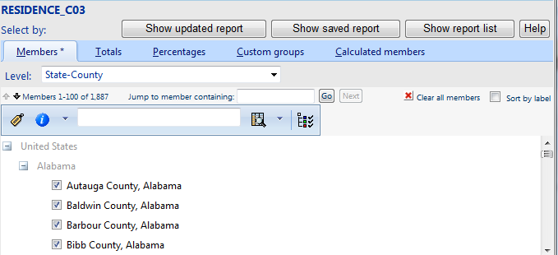

- The “Level:” drop-down at the top will define the level on which selection is being done. User can select members at multiple levels. All level selections will be added together.

- The contents of current geographic level are shown in the logical context of other hierarchy levels. For example in the screen shot above, the contents of “State-County” level are shown inside “State” level which in turn is shown inside “Nation (US Total)” level. All external parents are greyed out and not selectable.

- The “Clear all” button will be used to remove all selections at current level.

- “Sort by label” box is used to sort the level selections (in the table) by currently selected label set.

- The toolbar contains button for expanding/collapsing different levels of the tree.

- Expanding/collapsing a greyed out external member will only do it locally without more members being fetched from the server. For example collapsing “Alabama” in the above screen shot will not display data for more states (only first 100 real members will still be present on the page, with Alabama counties collapsed).

- If search is performed then search results will always be shown in the hierarchy context. Users will be able to select members for the table from those items shown in the search results.

- The immediate parents (e.g. “Alabama” in the screen shot) of current level members will contain 2 buttons (green and red icons – not shown) to select/un-select all children.

- If any member of the current level contains children in the next hierarchy level, it will be clickable. Clicking the member will open selection page for the next level with all its children already selected.

Members by map tab (Geography Selection Map)

This tab allows selecting geography members using a map interface. When clicking on the tab, the Geography Selection Map interface is displayed.

By convention, the residence geographies are displayed on the map in Red while the workplace geographies are displayed in Blue.

The highlighted features are simply displayed with a Yellow Highlight.

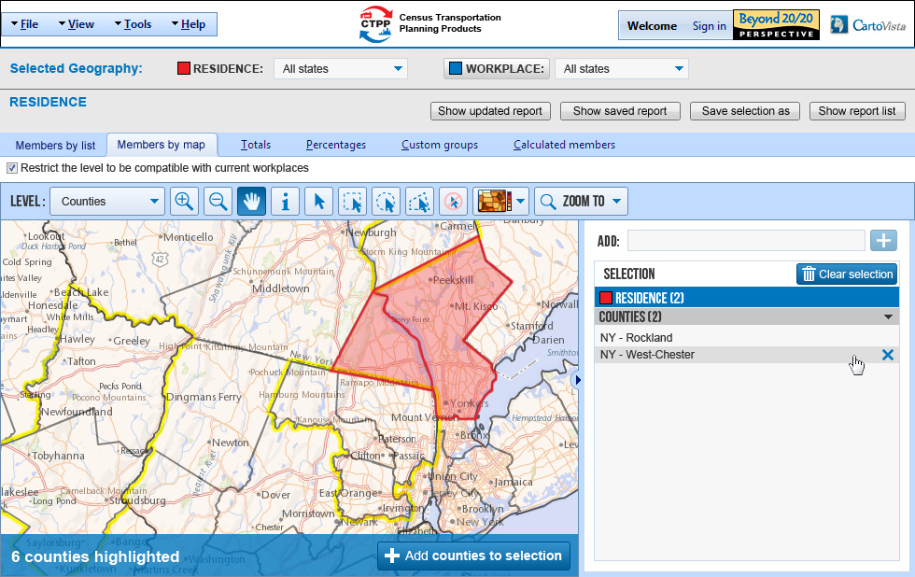
Figure 1: Selection Interface with 2 selected members

Geographic Level Restriction Checkbox

The checkbox “Restrict the level to be compatible with current workspace / residence” displayed above the top bar can be used to limit the geographies to select from. When enabled, only geographies that are compatible with each other will be available for selection by the end user.

Top Bar

The Geography Selection Map includes a top bar with several map controls to choose the geographic level to select from and navigate within the map.

Figure 2: Selection Top Bar

Geographic Level and Map Navigation Tools

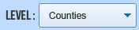

The Geographic Level Dropdown allows choosing the geographic level to select from. The user can choose from one of the following values:

- State
- County
- Minor Civil Division (MCD)
- Place
- Metropolitan Statistical Area (MSA)
- Metropolitan Statistical Area – Principal City
- Public Use Microdata Sample Area (PUMA)
- Urbanized Area
- Tract
- Traffic Analysis District (TAD)
- Traffic Analysis Zone (TAZ)

In addition, for the Workplace dimension, users will be able to select “Outside the USA”.

Navigation

The toolbar includes the following map navigation tools:

 | Zoom-in Tool | Click on the map to display a closer view or draw a rectangle
 | Zoom-out Tool | Click on the map to display a wider view
 | Pan Tool | Click and drag the map to recenter

Querying the map (Info Tool)
 | Info Tool / Info Tool Window | Displays information about the geographic level features (attributes) for a specific point on the map. Results are displayed using the Info Tool Window. The info tool window also displays the clicked map coordinates in latitude/longitude.
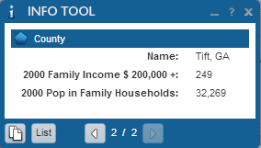
Figure 3: Info Tool Window

Selection Tools
 | Direct Selection Tool | Select features by clicking on the map
 | Rectangular Selection Tool | Draw a rectangle on the map to select features
 | Circular Selection Tool | Draw a circle on the map to select features
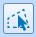 | Polygonal Selection Tool | Draw a polygon on the map to select features
 | Unselect All Tool | Unselect all features from the map

NOTE: All selection tools support SHIFT/CONTROL for multi-select.

Feature selection behavior
When features are selected on the map, they are displayed with yellow outer glow. The number of highlighted features (in the current geographic level) is displayed in the status bar at the bottom of the map.

A button (e.g. Add Counties to selection) is available to add the highlighted features to the selection. When you click on the button, the features are added in the selection list, in the right section of the map interface (the highlighted features in yellow disappear and become either blue or red).

Features that are in the selection list are displayed on the map with blue and red strokes for Workplace and Residence geographies, respectively. At all times, the geography selection map shows the current selected Residence or Workplace members on the map (with blue or red).

Current Selection List
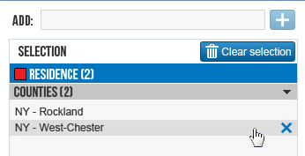
Figure 4: Current Selection List

In addition to being displayed on the map, the selected features are also displayed in the current selection list. The list displays both the Residence and Workplace Geographies that are selected. The end user can remove items from the list using the “X” button or clear the entire selection in one click with the “Clear selection” button.

Adding members by name

The add textbox at the top of the dialog allows adding a new member by entering its name for geographies that have meaningful names (counties, etc.). When the user types a few letters in the textboxes, a list of corresponding elements is displayed to choose from. The user can then use the “+” button to add it to the selected list.

Thematic Display Tool - Indicators (Demographics)

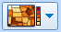 | Thematic Display Tool |  | This dropdown list allows choosing from a list of common demographic indicators for display on the map background (e.g. total population). By default, no background thematic maps are displayed. This option will only be available for layers where census data is available (state, counties, etc.).
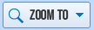 |  | Zoom To Tool |  | Allows searching for specific map features by name using the Search Dialog

When you click on the zoom To Tool, a dropdown menu is displayed.

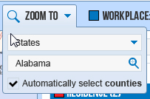
Figure 5: Zoom To Dialog

A list of the following geographies is available to choose from:
- State
- County
- Minor Civil Division (MCD)
- Place
- Metropolitan Statistical Area (MSA)
- Metropolitan Statistical Area – Principal City
- Public Use Microdata Sample Area (PUMA)
- Urbanized Area
- Tract

Users can type-in the name to search for and click on the search icon to zoom to the feature location on the map. When the checkbox “Automatically select” is selected, all features (from the level selected) that are within the search feature are automatically selected. For example, a use case for this would to to automatically select all counties in Alabama.

NOTE: Traffic Analysis District (TAD) and Traffic Analysis Zone (TAZ) are not available for searching.

Viewing a table

From the report folders view, users will open a table for viewing simply by clicking on the table name. For an anonymous user, each report will have a preset list of dimensions none of which can be eliminated by the end user. When a site administrator opens a table, an extra pane will appear to the left of the table to allow additional dimensions to be added/removed from the table. Users will not have access to this functionality.

A table view will have rows, columns and slicers axes which contain one or more dimensions containing selectable members with hierarchies. An example is shown below:

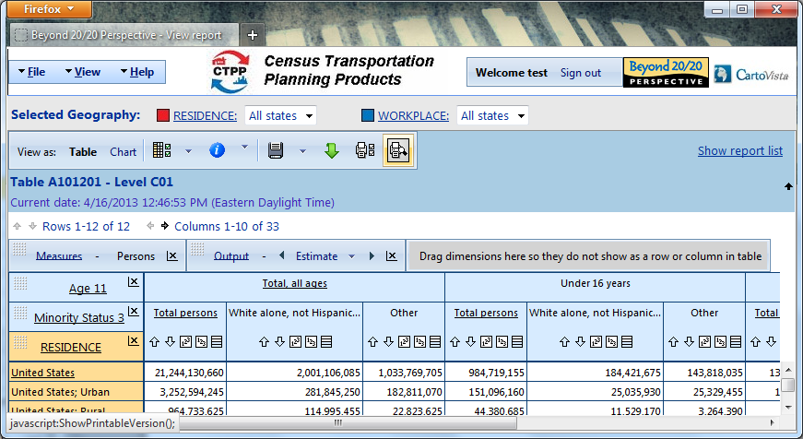

From within this view, users will have the option to rearrange the report, add features such as suppression and data scaling, and control how totals and percentages specified in the member selection pages will affect the table.

Dimensions (such as Age, Minority Status) called regular dimensions have common member selection behavior throughout the application. The following dimensions are exceptions and have either limited functionality or extended functionality (as described in separate sections of the document).

Measures - There will a special dimension called Measures which contains values for elements or cells in the body of the table. This is standard to the database technology used to drive the CTPP application and is key to understanding the analytic uses of the interface and for interpretation of the report. Every CTPP table will have a single measure, and users will not be allowed to modify this selection. Typically this measure will be the count of persons, but could also be the aggregate travel time, mean household income, number of respondents, etc.

Output (or Reliability) - There will be a special dimension called Output (or Reliability) as described in Section 8 below.

Geography - The Geography dimensions (Residence and Workplace) and subsequent visualization of flows are the basic building blocks of the CTPP application and will have special member selection screens as indicated in section 5 above.

Making selections on dimensions

This section will discuss member selection for regular dimensions only. Selection screens vary by type of dimension with geography as the primary differentiator. Member selection of geography within a report is described in Section 5.3.

The selection of members for regular dimensions has 5 tabs as shown below – Members, Totals, Percentages, Custom Groups and Calculated (Formula based) members. The functionality for all of these tabs is described here. Tabs other than the Members tab will behave exactly the same for geography selection and were not presented in section 5 above.

Members tab

Standard member selection for regular dimensions is simple point and click of checkboxes with options for clearing all, selecting all, range selections. This behavior is documented through online Help and Tutorials within the Perspective application.

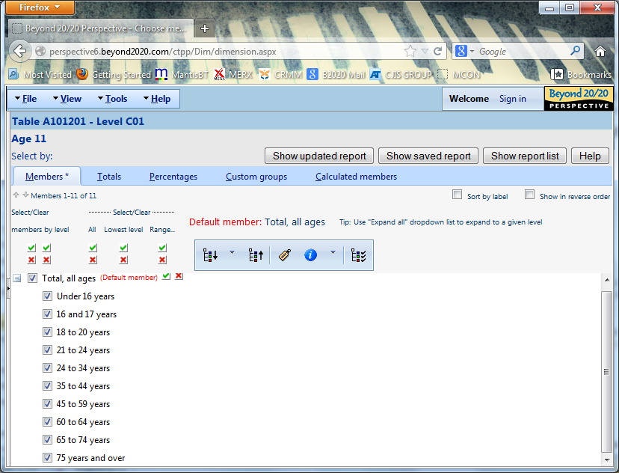

Totals tab

On the Totals tab, users can add custom calculations to the table. These include totals, averages, min/max, and other statistical functions. These are documented in Perspective online Help and through tutorials within the Perspective application.

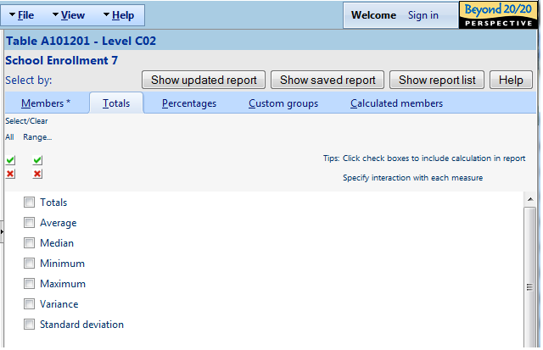

The Totals tab is only displayed for non-Measures hierarchies on which calculations are enabled. The check boxes beside each total calculation are only shown if the following conditions are met:

- The “Members” tab contains selections (i.e. marked with “*”);
- No selected members are descendants of other selected members;
- No selections are done in “Custom groups”, “Custom bands”, and “Calculated members” tabs.
If any of the above conditions are not met, the check boxes are not displayed and a message is displayed on top of the page informing the user why total calculations are not available for selection. Previously selected calculations get un-selected and not included in the report.

Selected total calculations always appear above all other selections in the report and their order is fixed.

The interaction with each measure can be specified from within the table view.

All actions performed in “Totals” tab will be preserved with hierarchy selections and will also be included in the Selection Set for current hierarchy, if one is saved.

Percentages tab

The Percentages tab is shown below.

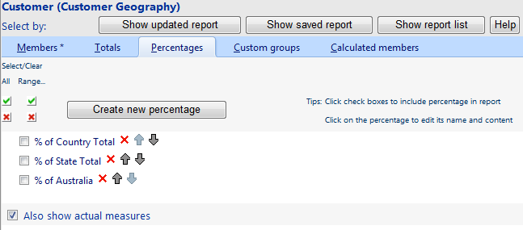

All percentages are user-creatable. Each percentage may be based on total selected or on specific member. If the percentage is based on total selected, the check box beside it only appears when all conditions required for Totals Calculations (see previous section) are met.

Selecting percentages means creating new measures with the percentage title added as suffix to existing measures. The user has a choice of displaying only the percentage measures or both the actual and percentage measures. This is controlled by the “Also show actual measures” check box.

In addition to creating new Percentages the user can edit existing Percentages (by clicking on a percentage), select and un-select them from the report (by using the check box), delete them (by using “x” button) and change their order (by using the arrow buttons).

Clicking on a percentage will take the user to a new page described below. The same page is displayed when the user clicks on the “Create new percentage” button.

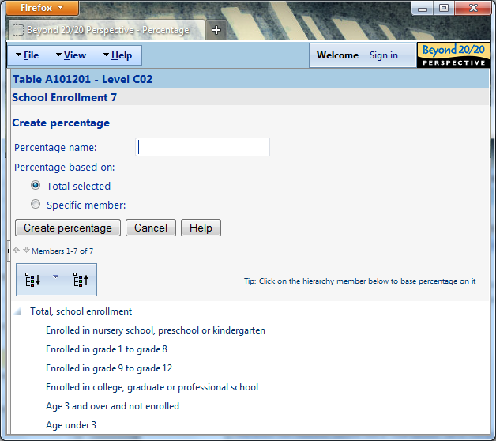

On this page the user can enter the name for the percentage and choose if it’s based on Total Selected or Specific Member. In the latter case, the member is chosen by clicking it in the tree view. The “Specific member:” box is read-only and displays the caption of the selected member.

Clicking the “Update percentage” button (or “Create percentage” button for new percentages) saves the percentage and takes the user back to the Member Selection page (Percentages tab).

Custom groups tab

The Custom groups tab is shown below. Custom groups for regular dimensions are documented in Perspective online Help and through tutorials within the Perspective application.

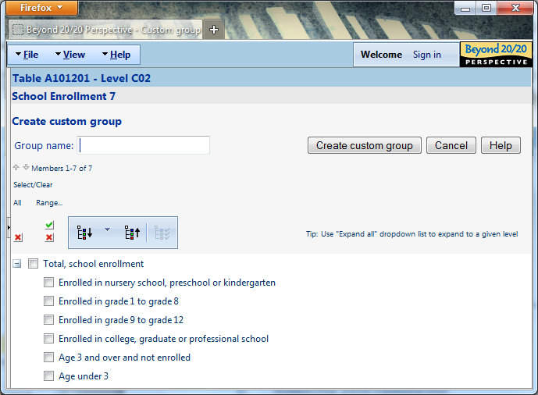

Calculated members tab

A calculated member can be created in any Hierarchy except Measures and Time-series hierarchies similar to Custom Groups above. The formula used for the Calculated Member can only use other members of the same hierarchy, simple arithmetic operators and numeric constants. Parentheses can also be used as needed.

If no Calculated Members have been previously defined, the display will look like the one above. The user can click “Create new calculated member” button to start creating calculations.

If Calculated Members already exist for current hierarchy, they are listed as shown below. In addition to creating new calculations the user can edit existing calculations (by clicking on a member), select and un-select them from the report (by using the check box), delete them (by using “x” button) and change their order (by using the arrow buttons).

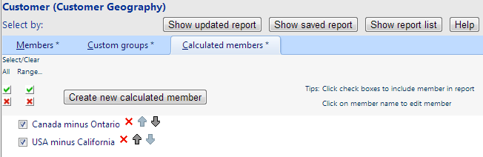

The following page is used for creating and editing Calculated Members.

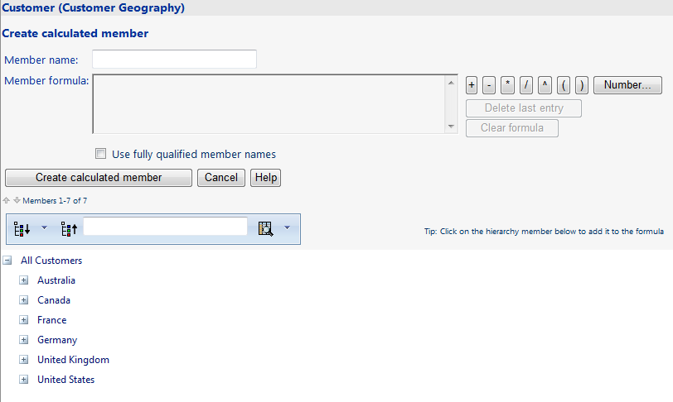

When creating new calculated member the user needs to specify the member name and then create the formula using the buttons to the right of the formula box and the hierarchy members displayed in the tree view (as indicated in the Tip).

Clicking on a hierarchy member in the tree view adds its Key or Unique Member Name to the formula (depending on the state of “Use fully qualified member names” check box). In some cases member keys are not unique, check “Use fully qualified member names” if this is the case.

Clicking on any operator button or a parenthesis button adds the text on the button to the formula. Clicking on the “Number…” button displays a small dialog (shown below) which allows adding a numeric constant to the formula.

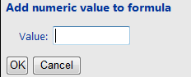

Two additional useful buttons are present in the second row of buttons to the right of the formula box. Clicking “Delete last entry” removes the latest item (member, operator, parenthesis or constant) from the formula. Clicking “Clear formula” removes all entries from the formula.

The formula box is read-only and cannot be edited directly.

When the member name and formula has been entered, the user can click the “Create calculated member” button to save the new member and return to “Calculated members” tab of Member Selection page.

The UI is slightly different when editing existing Calculated Member. A sample screen is shown below (with formula box filled).

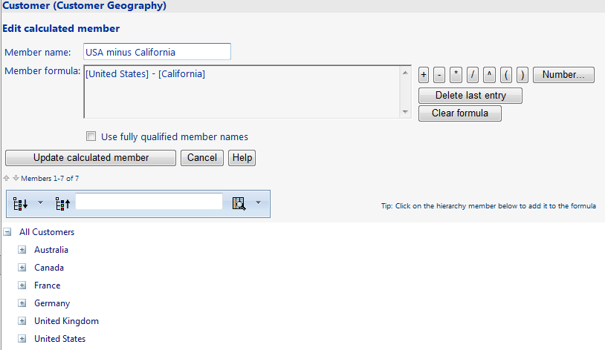

If the user checks “Use fully qualified member names” box, the formula will display the Unique Members Names instead of Keys as shown below.

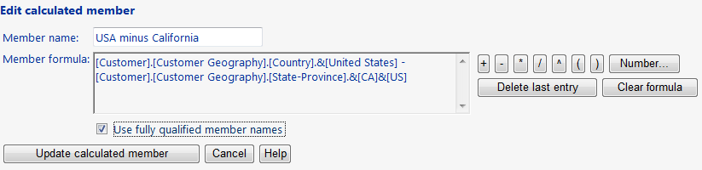

Within the table view, the user can organize the report by selecting “Rearrange report” from the “Table options” menu. The system presents the dialog shown below.

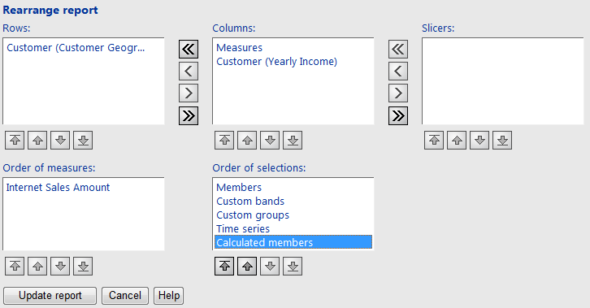

In this dialog, the user can specify how Calculated Members are ordered relative to other selection elements.

Data accuracy – the Output dimension

Every table will have a special dimension for tracking the reliability of the data. This dimension, containing Estimate, Margin of Error and Standard Error, is shown below. Optionally, a new chart type for the error bars can be created using the Upper and Lower Bound, easily derived from provided data. This Charting functionality is not presently a part of standard Perspective charting but has been developed for another application using provided SE data inherent to that application. Incorporating this feature will take about 5 developer days and can be discussed at project completion.

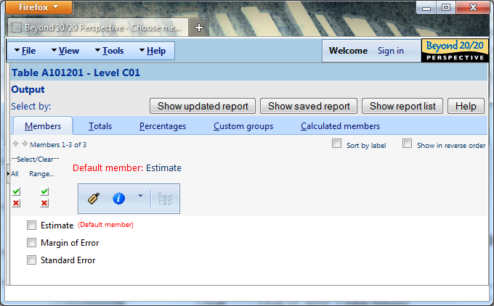

The data cubes underlying the product will include real values for the Estimate and the square of the standard error (called SE2 and calculated when the cube is built). The cubes will have formulas for deriving the SE and MOE from the SE2 as follows:

Margin of error – MOE with calculation SE x 1.732
Standard Error – calculation is square root of SE2

The advantage of this approach is that the data cubes will then automatically calculate error terms when aggregating estimates.

An upper bound and a lower bound can be derived by adding/subtracting the MOE to/from the estimate.
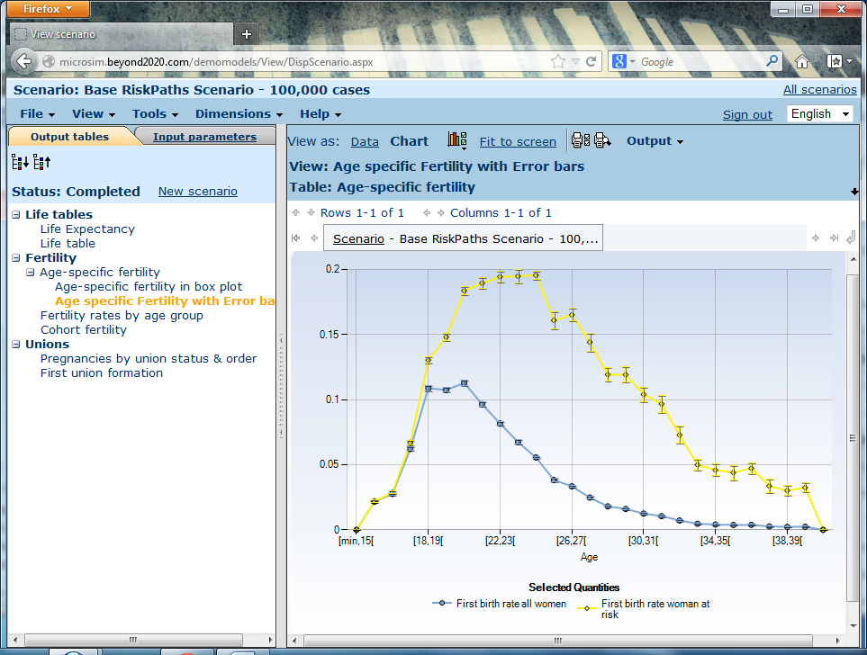

Organizing a report

Once in the report view, the end-user has the option of viewing the data in Table, Map or Chart format.

The Table view and the positioning of the dimensions on the rows, columns and slicer areas will affect the Map view and Chart views.

Dimensions cannot be added or removed from the report. Each report will always contain Residence, Workplace or both (Flows). All reports will have the Measures and Output dimensions.

The report organization is set by the user by arranging (pivoting) the dimensions between the row, column and slicer axes or areas of the view. Arranging dimensions is described in the following Perspective tutorial here:

http://perspective6.beyond2020.com/ctpp/Tutorials/TutorialSpawned.aspx?Language=en&TutorialIndex=4

Simplicity of presentation is achieved by minimizing member selection for each dimension by clicking on the underlined title of the dimension in any view of the report. Regular member selection is described in the following tutorial:

http://perspective6.beyond2020.com/ctpp/Tutorials/TutorialSpawned.aspx?Language=en&TutorialIndex=3

Viewing the data on a thematic map

Thematic maps are available through the report view as Table, Map or Chart menu option.

When clicking on the map menu item, the thematic interface is displayed, based on the selected table (either a residence, workplace or flow table).

Residence and Workplace tables are displayed with a base interface. Flow tables are displayed with the base interface and the flow tools (see Thematic Map Interface – Flows).

Thematic Map Interface (Base)

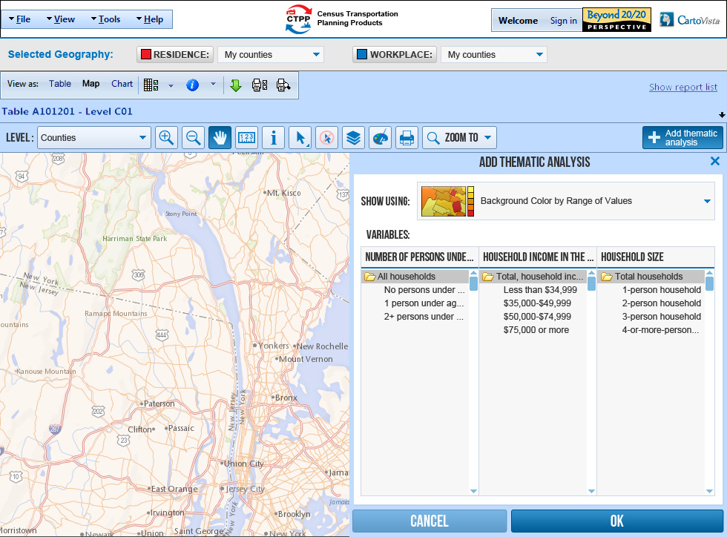
Figure 6: Thematic Map Interface (Shown at startup)

Thematic Analysis

CartoVista features advanced thematic mapping capabilities to display the CTPP data in innovative and meaningful ways. CartoVista allows the user to overlay several measures on the map and build rich, powerful data displays for analysis.

CartoVista thematic analysis can use a combination of polygon color, graduated symbols, symbol color and pie charts to represent measures on the map.

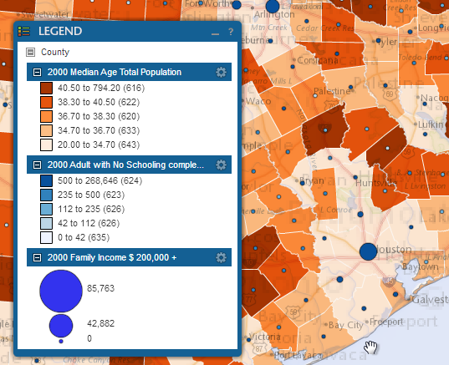
Figure 7: Sample Multi-Variate Thematic Analysis

Since Thematic Analyses in CartoVista are additive, users have to choose the measures to represent and how the data will be displayed. This is done with the Add Thematic Analysis Button and Dialog. This dialog is displayed automatically when the user clicks on the thematic map menu from the Perspective top bar (next to the table and chart menu)

Add Thematic Analysis Button and Dialog

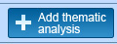

This button allows adding a new thematic analysis to the map for the selected geographic level.

When the end user clicks on the Add thematic analysis button, the Add Thematic Analysis Dialog is displayed.

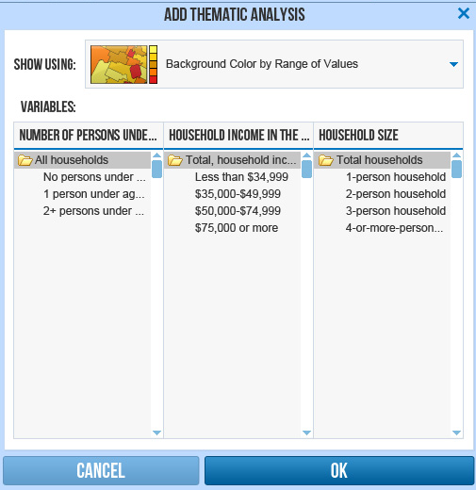
Figure 8: Add Thematic Analysis Dialog

This dialog allows choosing the type of thematic analysis (show using option). The following types of options are available:

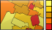 | Background Color by Range of Values (Default selected option)

In CartoVista, this type of thematic map, also known as a choropleth map will help you understand and compare your values by displaying color ranges. When you select this type of thematic analysis, CartoVista reads your data values and calculates appropriate ranges automatically.

Once this type of theme is displayed you can then use the Thematic Styles Dialog to customize the display. With the different options you can:
- Choose the number of ranges.
- Change the range calculation method
- Change each range thresholds by typing a number in the text box.
- Use the histogram / graph window to visually change the range thresholds based on inflection points in the data set.
- Choose a color scheme for the range map or specify colors individually.
- Reverse the colors.
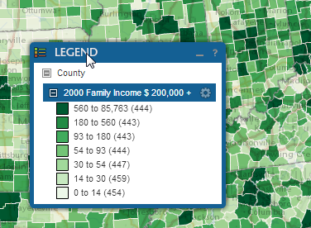
Figure 9: Background Color by Range of Values Theme

Background Color by Gradient

This type of thematic map, also known as a continuous choropleth map will help users understand and compare the measures by applying continuous colors (gradient) to the map features. The color gradient to use for the theme is defined by 2 colors, for the minimum and maximum value in the data. Each indicator value gets a color based on the gradient defined by the maximum and minimum values.

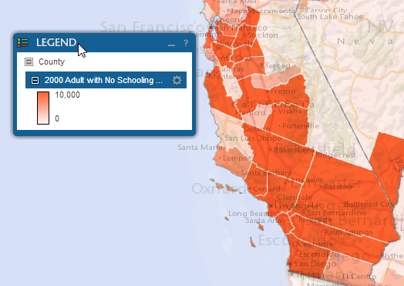
Figure 10: Background Color by Gradient Theme

In addition to color on the polygons, CartoVista includes Symbol Overlay themes. Symbol Overlays are a special type of theme that creates symbols on top of the map feature. This type of thematic analysis can use a combination of graduated symbols, symbol type (shape) and colors to represent values on the map.

Foreground – Graduated Symbols

A symbol theme with graduated symbols is used to display a measure as graduated symbols on the map. The larger the symbol is, the higher the value is. From the Thematic Styles Dialog, it is possible to choose the method used to calculate the size of the symbols (Square root, Constant or Log).

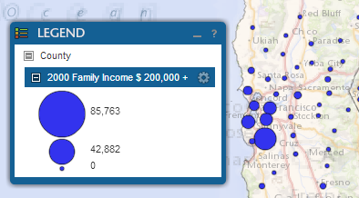
Figure 11: Foreground – Graduated Symbols Theme

Foreground – Symbols by Color Ranges

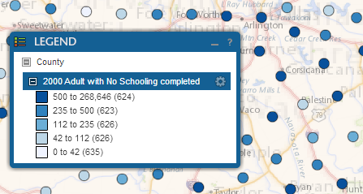
Figure 12: Foreground – Symbols by Color Ranges Theme
This type of theme by color (ranges) shows different symbols on the map with different ranges of colors.

Like background theme on polygons, once this type of theme is displayed you can then use the Thematic Styles Dialog to customize the display. With the different options you can:
- Choose the number of ranges.
- Change the range calculation method
- Change each range thresholds by typing a number in the text box.
- Use the histogram / graph window to visually change the range thresholds based on inflection points in the data set.
- Choose a color scheme for the range map or specify colors individually.
- Reverse the colors.

Foreground Symbols by Color Gradient

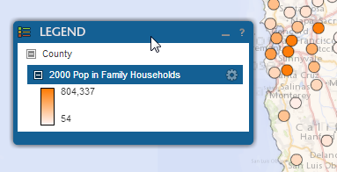
Figure 13: Foreground Symbols by Color Gradient Theme

A symbol theme with symbol color is used to show a measure with continuous colors. The minimum and maximum values of the chosen measure are associated with different colors. These two colors are used to create a gradient that includes a representation of the intermediate values.

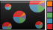 | Foreground - Pie Chart

In statistical analysis, pie charts are useful to compare values for different categories of information. The area of each sector in a pie chart indicates the category's relative importance in relation to others.

In CartoVista, pie charts are displayed as an overlay theme on top of the map features. When displaying a pie chart theme on a layer of regions, the pies are created at the centroid of each object.

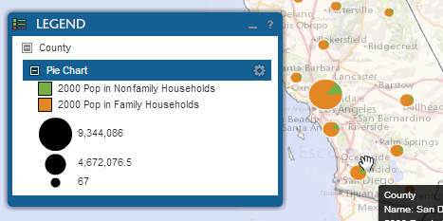
Figure 14: Foreground - Pie Chart Theme

Measure selection (variables)

This part of the dialog allows choosing the variable to map based on the dimensions in the underlying table. Up to 3 dimensions can be associated with a CTPP table. If a table contains only 1 or 2 dimensions, the number of tabulations (lists) will be adjusted accordingly. Each dimension tab list will show all the members available, including hierarchies. The end user can select one or more items in the list. At least one item has to be selected in each dimension tab list.

For example, in the sample below, a user could decide to choose to create a map by selecting both the 1 and 2 person households.

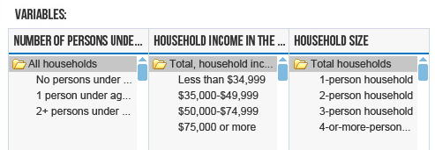

Measure selection (variables) for Pie Charts
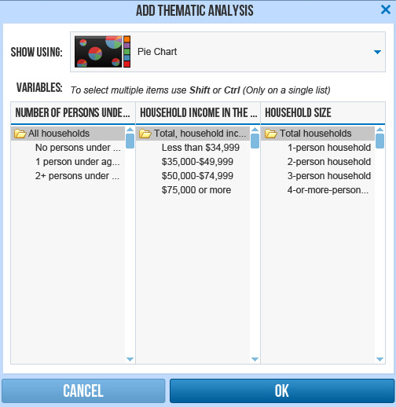
Figure 15: Add Thematic Analysis Dialog

When choosing the Pie Chart option, the end user can choose from a single list and has to select multiple items (for comparisons)

Map Display

Once the user clicks on the OK button, the map is updated to display the selected analysis.

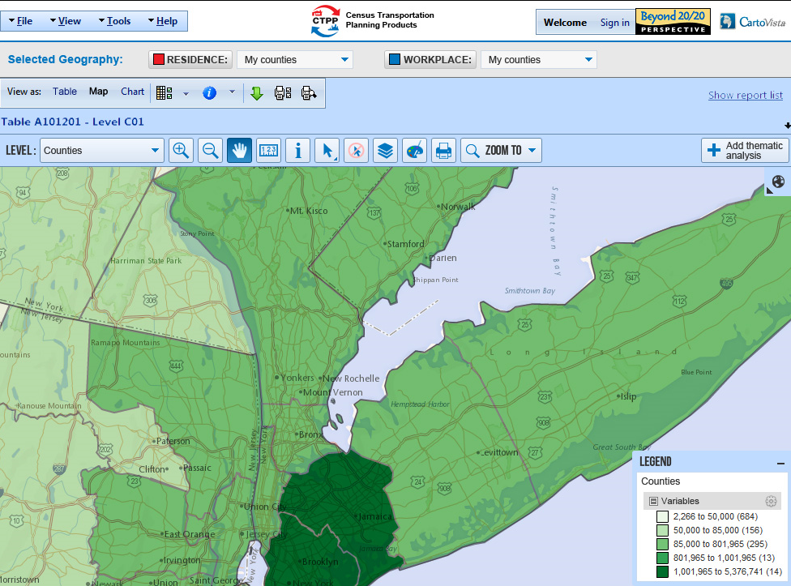
Figure 16: Resulting Thematic Map

The thematic map interface includes a top bar with conventional map tools.

Geographic Level

The Geographic Level Dropdown allows choosing the geographic level, based on the currently selected geographies. The user can choose the level if there are more than one geographic level in the selection. If there is only a single level in the current selection, the dropdown is disabled.

The toolbar includes the following map navigation tools (same as selection interface):

 | Zoom-in Tool | Click on the map to display a closer view or draw a rectangle
 | Zoom-out Tool | Click on the map to display a wider view
 | Pan Tool | Click and drag the map to recenter

Ruler Tool
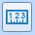 | Ruler Tool

The ruler tool allows measuring distances on the current map in miles. To use this tool end users have to:
- Select the Ruler Tool from the toolbar.
- Click on the map at multiple map locations to define a path and get the cumulative distance.
- Once done, double-click to end / restart.
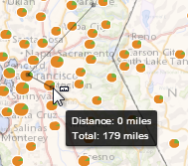
Figure 17: Distance Measurement

Querying the map (Info Tool)
 | Info Tool / Info Tool Window | Displays information about the geographic level features (attributes) for a specific point on the map. Results are displayed using the Info Tool Window. The info tool window also displays the clicked map coordinates in latitude/longitude.
Figure 18: Info Tool Window

Selection Tools
The selection tools in the thematic map interface are displayed with a sub-menu under the main selection tool component. The end user can click on the selection tool to pick one of the selection methods below.

 | Direct Selection Tool | Select features by clicking on the map
 | Rectangular Selection Tool | Draw a rectangle on the map to select features
 | Circular Selection Tool | Draw a circle on the map to select features
 | Polygonal Selection Tool | Draw a polygon on the map to select features
 | Unselect All Tool | Unselect all features from the map

NOTE: All selection tools support SHIFT/CONTROL for multi-select.

The selection results in a thematic map are displayed on the map and in the selection window.

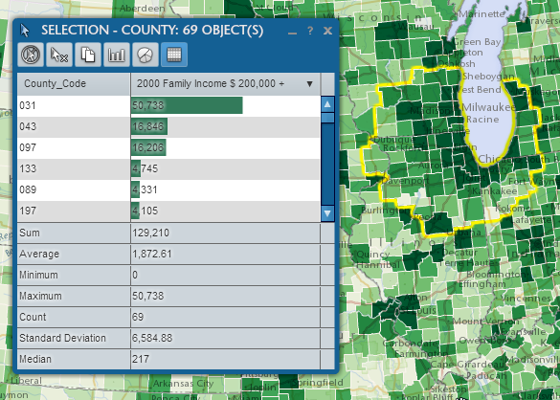
Figure 19: Selected Features and Selection Window

Selection Window

When you use the selection tools, the selection window is displayed to display the list of selected items.
- The title of the dialog indicates the total number of features that are selected.
- A list of selected items is displayed in the dialog with all the feature attributes and current indicator values.
- Common statistical fields are displayed at the bottom of the dialog, for numeric values: Sum, average, minimum, maximum and standard deviation
- Users can click on the column titles to reorder the items in the selection.
- Users can also double-click on a row to zoom to the feature on the map. An animation is displayed to highlight the featureAdd Thematic Analysis Button

Selection Window Toolbar
The selection toolbar is displayed at the top of the selection window. Users can use these button tools to either unselect items in the selection or copy the data to the clipboard, or view the selection data as a chart.

 | Unselect All | The Unselect All tool clears the selection.
 | Unselect Highlighted Items | The unselect item tool is used to unselect a single item from the current selection. Select this tool and then click on the item you wish to remove from the selection.
 | Copy to Clipboard | The Copy to clipboard tool allows you to copy the selected data to the clipboard. You can then paste the data in a spreadsheet (Excel for example) or any other application.
 | View Selection as Histogram Chart | The view Selection as Histogram Chart Button is used to display the currently selected features in a chart window. When you click on the button, a dialog is displayed to choose the indicator(s) you want to view from the selection window. You can select more than one indicators.
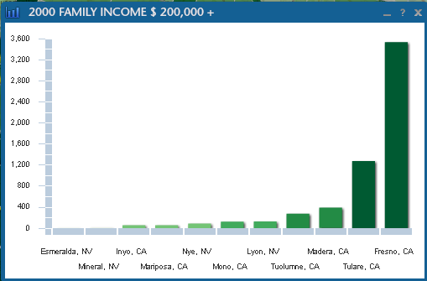
Figure 20: Chart of the selected records

Layer Control Tool / Dialog

Layer Control Tool / Dialog

Users can use this dialog to control the visibility and labeling of map layers.
Each map layer is displayed with two icons on the right. The eye icon controls the layer visibility. Clicking on the label icon turns the map layer on or off.

The opacity slider allows specifying the map layer opacity.

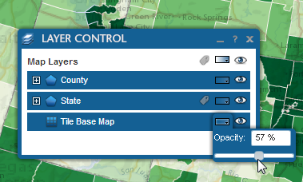
Figure 21: Layer Control Dialog

Thematic Styles Tool / Dialog

Thematic Styles Tool / Dialog

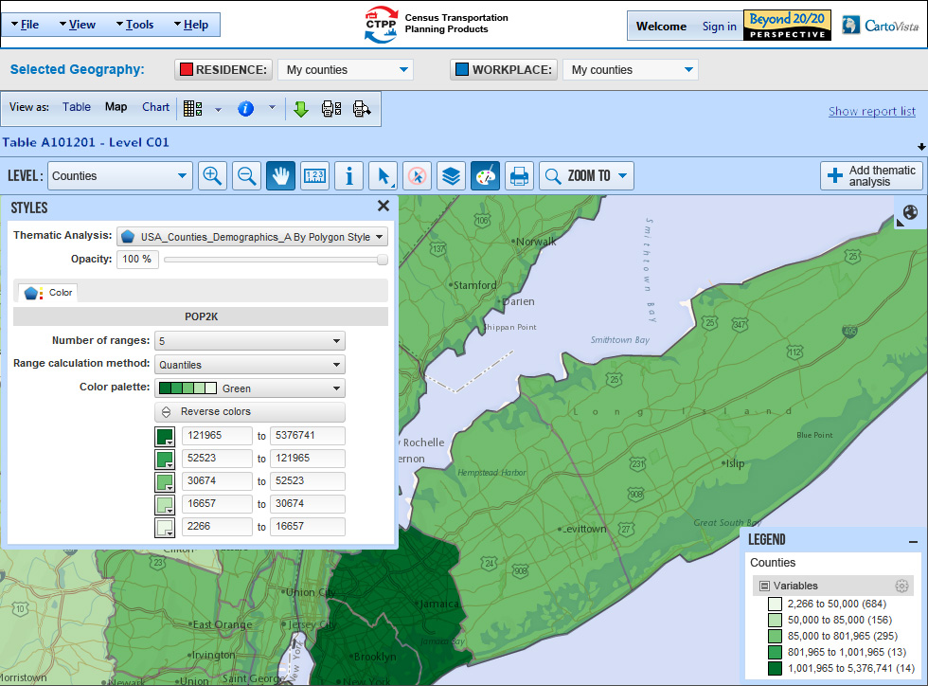
Figure 22: Thematic Styles Dialog shown in the interface

Map Legend

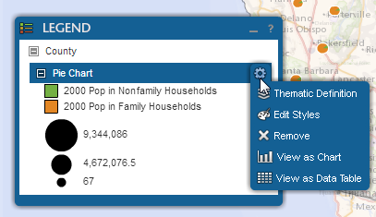
Figure 23: Map Legend Component and Contextual Menu
The map legend window shows the colors, symbols and values for the displayed thematic analyses. For style themes, the number in gray (in parenthesis) beside each range or individual value indicates the number of records in each class. For overlay themes, the legend displays either the associated symbols or the colors used in the pie and bar charts.

Like any other window in CartoVista, users can click and drag the legend window to move it.

The legend window content is collapsible. To expand or collapse individual map layers or specific themes, users can click on the plus and minus icons.

For each thematic analysis displayed in the legend, a contextual menu is available and displayed when you mouse over the title of the thematic analysis.
To access the menu users need to click on the wheel icon at the right end of the analysis title.
This contextual menu is very useful as a shortcut to view details on the analysis displayed or making changes.

The following options are available:

Thematic Definition | Click on this menu item to change the type of thematic analysis displayed or pick different indicator(s) using the Edit Thematic Analysis Dialog
Edit Styles | Click on this menu item to change the styles (colors, symbols, number of ranges, calculation methods, etc.) for the analysis displayed using the Thematic Styles Dialog
Remove | Click on this menu item to remove the thematic analysis from the map
View as Chart | Click on this menu item to view the thematic data as a Chart Window. For range thematic analysis, the chart can be used to change the range thresholds graphically.

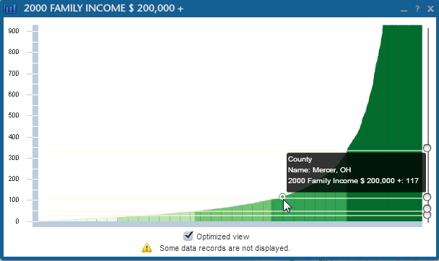
Figure 24: Histogram Chart with Range Thresholds Sliders (Result of “View as Chart”)

Overview Map Window
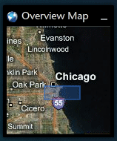
Figure 25: Overview Map
The overview map window is used to show the geographic context of the main map, at a smaller scale. This allows the end user to view the area covered by the main map and provides additional map navigation capabilities. You can click and drag the overview map window to change the view of the main map.

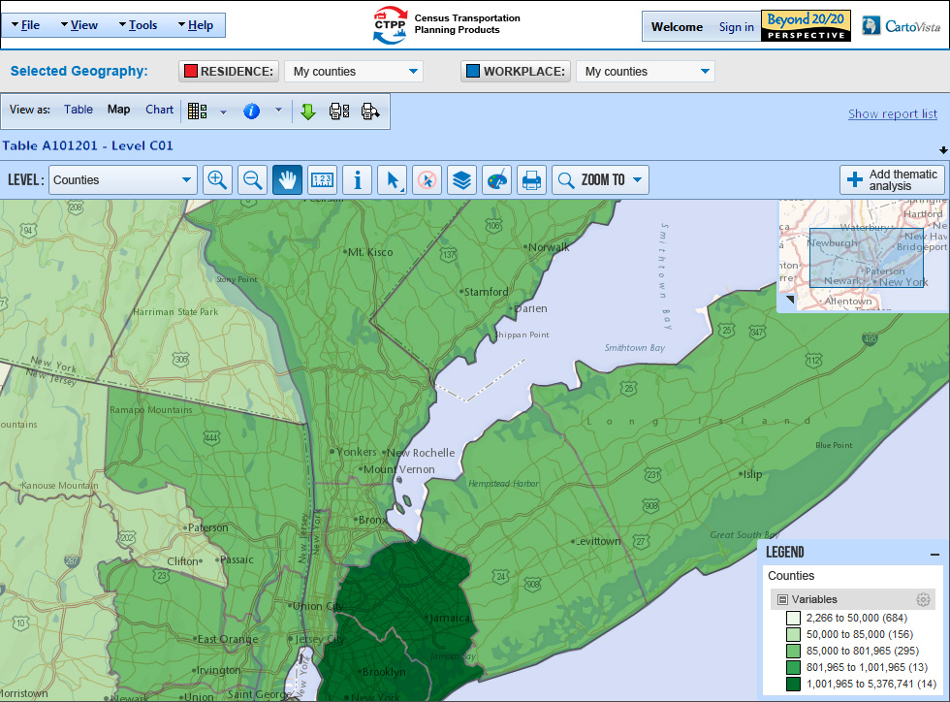
Figure 26: Overview Map in the interface (Shown on the top right)

The overview map can be docked on any of the side of the application to leave more real estate for the map and windows.

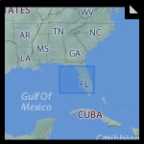
Figure 27: Overview Map Window - Docked on the bottom left

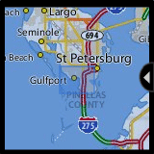
Figure 28: Overview Map Window - Docked on the left
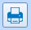 | Print Tool

The print tool allows accessing the print layout dialog to print and create image/PDF outputs.

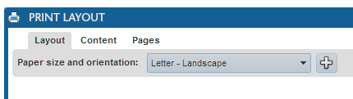
Figure 29: Print Layout: Paper Size and Orientation Menu
A print layout template will be setup with the CTPP logoc, a map title, the legend and the current date. The title will be editable in the print layout.
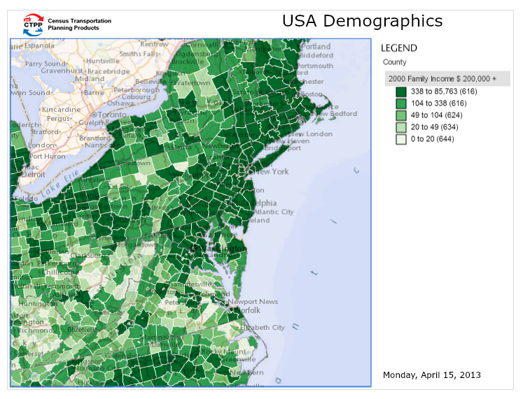
Figure 30: Print Layout Template

Print Layout Buttons
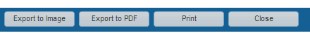
Figure 31: Print Layout Buttons
The print layout buttons allow to save the map layout as an image (.PNG), Export to Adobe PDF or Print directly to the printer.

Zoom To Tool

 | Zoom To Tool | Allows searching for specific map features by name using the Search Dialog

When you click on the zoom To Tool, a dropdown menu is displayed.

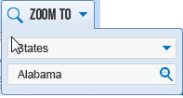
Figure 32: Zoom To Dialog (Thematic Mapping)
A list of the following geographies is available to choose from:
- State
- County
- Minor Civil Division (MCD)
- Place
- Metropolitan Statistical Area (MSA)
- Metropolitan Statistical Area – Principal City
- Public Use Microdata Sample Area (PUMA)
- Urbanized Area
- Tract

Users can type-in the name to search for and click on the search icon to zoom to the feature location on the map.

NOTE: Traffic Analysis District (TAD) and Traffic Analysis Zone (TAZ) are not available for searching.

Thematic Map Interface - Flows

The Flows interface is available when the end user selects a flow table.
The Level dropdown allows choosing a flow level from one of the following valid flows:

- State to State
- County to County
- Minor Civil Division to Minor Civil Division
- Place to Place
- Principal City to Principal City
- Public Use Microdata Sample Area to Public Use Microdata Sample Area (POW)
- County to Place
- Minor Civil Division to Place
- Public Use Microdata Sample Area to Place
- Tract to Tract
- Traffic Analysis District to Traffic Analysis District
- Traffic Analysis Zone to Traffic Analysis Zone
- Traffic Analysis District to Traffic Analysis Zone
- Traffic Analysis Zone To Traffic Analysis District
- Place to Traffic Analysis Zone
- Traffic Analysis Zone to Place

As elsewhere in the application, the selected geographies are displayed on the map in Red for Residences and in Blue for Workplaces.

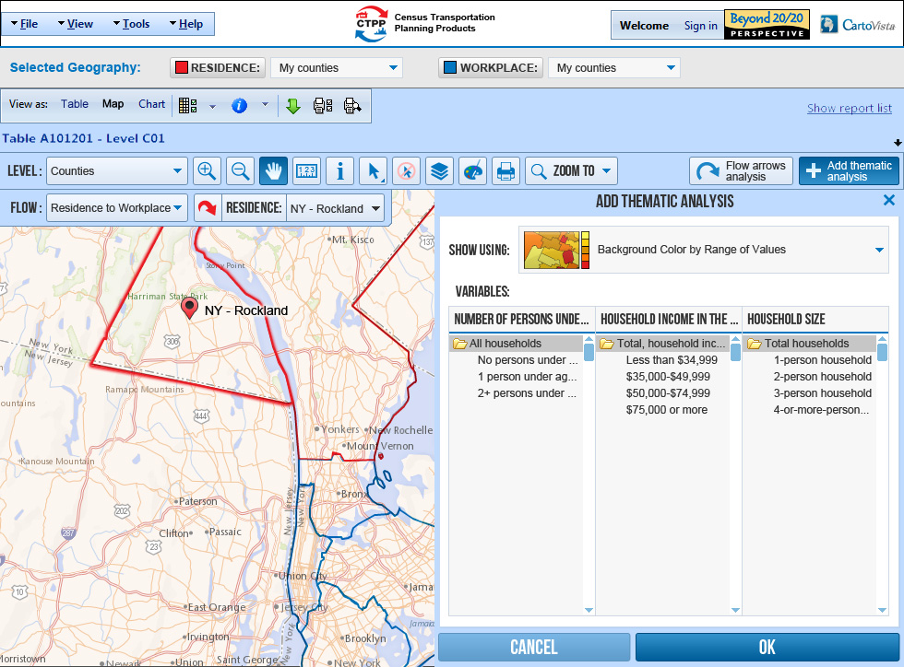
Figure 33: Thematic Map Interface for Flows (Add Thematic Analysis Dialog)
The flow interface includes the concept of defining the flow direction which can be either:

- From Residence to Workplace
- From Workplace to Residence

Users can choose one or the other by picking from the dropdown list in the flow tool bar.

The flows map interface requires the selection of either an origin or a destination (depending on what flow is selected) to enable thematic and flow arrows analysis.

When using a flow from Residence to Workplace, an origin is defined by default (the first geography from the current residence list is selected). In the example above, this is Rockland County in NY.

This origin is also displayed on the map with a PushPin icon
to identify the feature that it is used as the origin.

Figure 34: Map Pushpin Icon

The current origin/destination is also displayed in the Flow Tool Bar where a drop down menu can be used to switch to another origin/destination. The end user can also use the Flow Tool and click on the map to pick a different origin/destination.

Figure 35: Flow tool (Click on the map to define the origin/destination visually)

Figure 36: Flow Tool Bar

The Add Thematic Analysis Menu for Flow maps works like normal thematic maps. Based on the example above, an end user would get the following thematic representation.

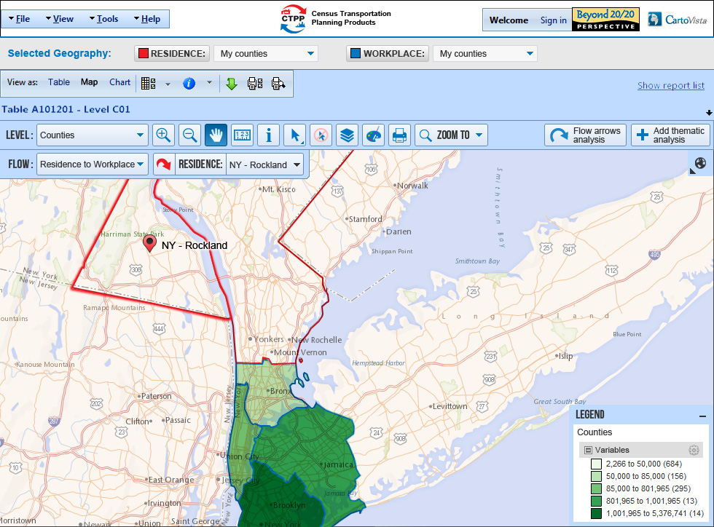
Figure 37: Resulting Thematic Map (On Selected Workplace Counties)
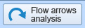

The Flow arrows Analysis button is available, in addition to the thematic capabilities defined in the base thematic map interface.

When clicking on this button, the Flow Arrows Dialog is displayed.

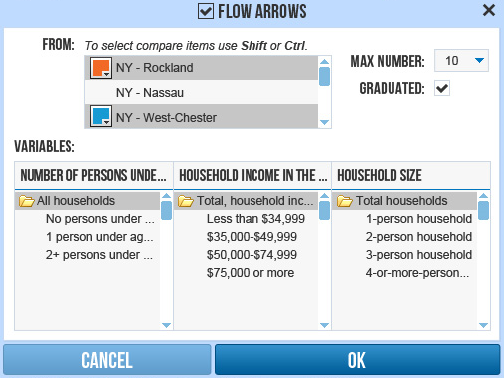
Figure 38: Flow Arrows Dialog
The “From” list in this dialog presents all of the flow origin geographies (residence of workplace depending on the flow direction).

Users can select more than one item from the list using the SHIFT and CONTROL keys on the keyboard. The color associated with each selected feature can also be chosen by the end user (with a color picker).

Using different colors allows seeing more than one flow origin on the same map.

The Max number drop down allows choosing the number of flow arrows that will be drawn on the map. The default value is 10. The graduated checkbox defines if the arrow lines should be graduated based on the value or not (enabled by default).
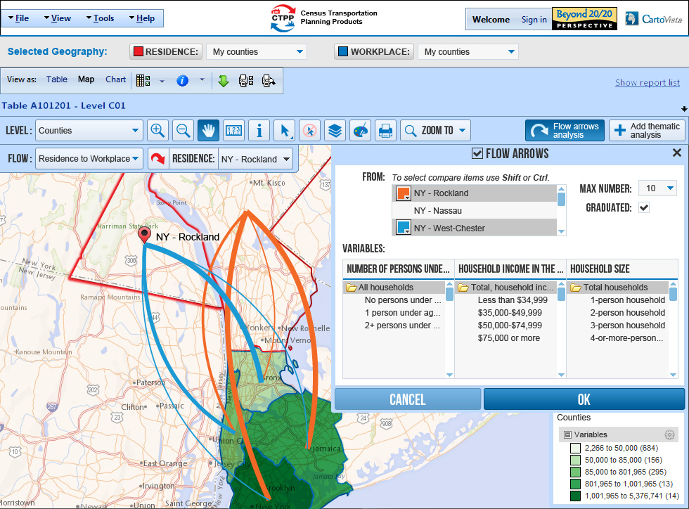
Figure 39: Result: Display of Flow Arrows / Map and Dialog

The flow arrows checkbox allows turning the arrows on or off in the map.

Charts

The CTPP web interface supports dynamic exploratory charting using the standard features in Perspective. The methodology is dimensional in approach with the innermost axes of the columns along the X-axis and the inner dimensional of the rows along the Y-axis. The chart options are shown in the screen capture below:

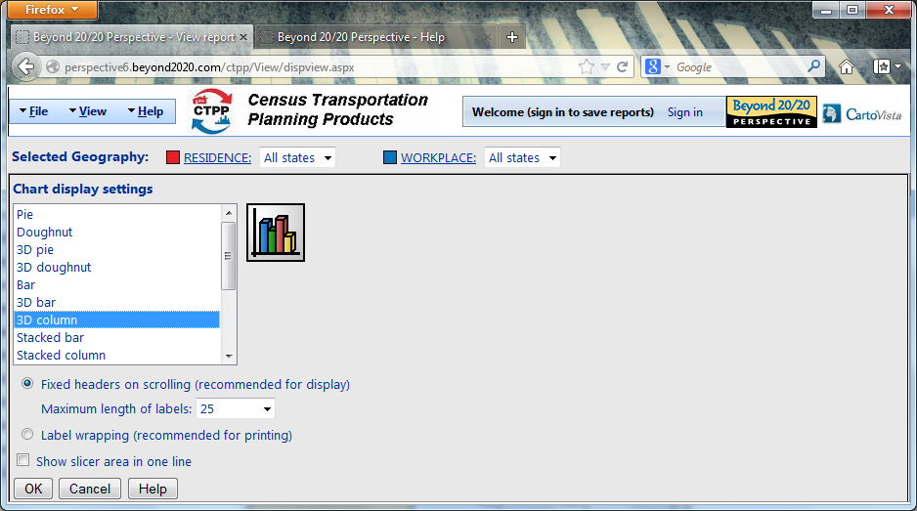

A sample chart:

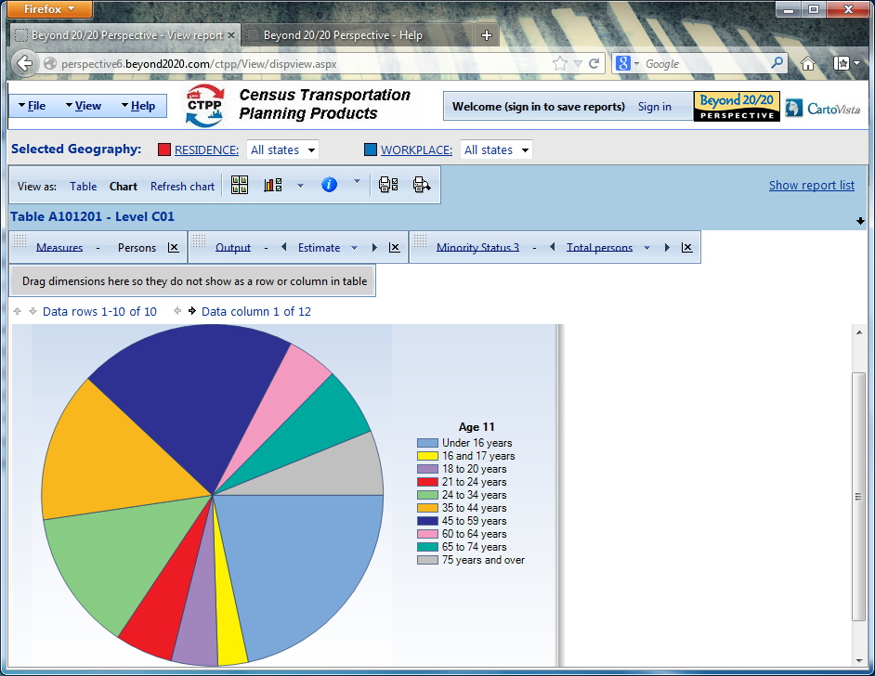

For more information on Charting, watch the tutorial at the following link:

http://perspective6.beyond2020.com/ctpp/Tutorials/TutorialSpawned.aspx?Language=en&TutorialIndex=5

Saving results

Once signed in, users will have the option of saving their information in three ways: by saving the report itself (exclusive of the Geography selections), by saving member selections (called Selection Sets) independent of the report, or by downloading the data to their device in various formats.

Access to saved information is through the 3 tabs on the Report List page as highlighted below:

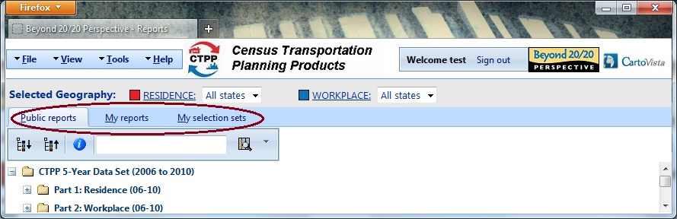

Saving the report view
Managing saved report is through the “My reports” tab. To save a private report, the user must be signed in. From the Report page, use the ‘Save Report’ or ‘Save Report As…’ button or the equivalent functionality on the File menu. The report will appear in the My Reports tab on the Report List screen (the entry screen). The Report will not be saved with the current Global Geography setting. This must be saved separately and restored accordingly when the saved report is opened.

Managing selections on a dimension (Selection sets)

To save or modify a selection set:

For signed-in users, Perspective provides the “Save selection set …” button next to the Dimension name in the Member selection page. All selection sets will be private; there will be no concept of Public sets. There will be no sets for the Measures or Output dimensions.

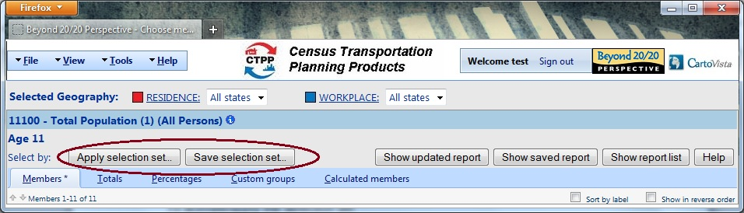

The user must provide a set name. All selection components will be saved. If the selection set with the name supplied by the user already exists, the user will be prompted to overwrite it.

Alternatively the user may choose to modify one of the previously saved sets. The dialog is shown below.

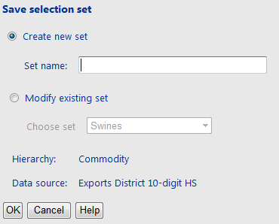

To activate or apply the selection set:

Signed in users can re-apply their saved selection sets in other reports.
From the Member selection page, Perspective verifies if any selection sets are saved that match the current Dimension title. If so, the “Apply selection set …” button will be displayed. When the button is clicked, a dialog will be displayed listing all available selection sets. The user will select from the list and click OK to proceed (or Cancel button to cancel this action).

The dialog is shown below.

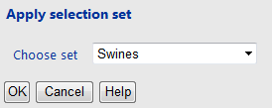

Applying the selection set replaces all selection components in the currently displayed dimension (Members, Custom Groups, Custom Bands). Members that are present in the selection set, but not present in the current dimension will be ignored.

To manage all selection sets for all dimensions:

Managing a saved selection is through the “My selection sets” tab on the Report List page. The list of set names with check boxes will be displayed. If any check boxes are selected the Delete button will be enabled; if exactly one set is selected the Edit button will be enabled. In the “Edit selection set” dialog the user will be able to change the set name and see the Data source and Dimension for which the set was originally saved. The dialog is shown below.

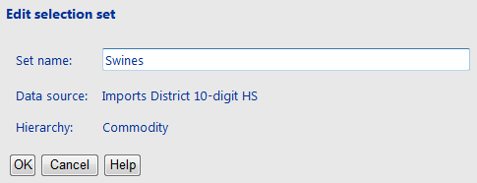

If another set with the same name already exists for the current user, an error message will be displayed.

When the user deletes all selection sets then “My selection sets” tab will no longer be displayed.

Download to Excel, CSV and mapping formats

The CTPP download functionality will support Excel, CSV, and will handle the geographic export types -- SHP, GML, TAB.

