American Association of State Highway and Transportation Officials| 99

Test Documentation
6

GENERAL REPORTING RECOMMENDATIONS

f primary importance in the guidelines presented herein is the preparation of a comprehensive test report. The test(s) should be documented in suffi cient detail so that, if necessary, others
O
could repeat the test(s) and obtain similar results. Liberal use of photographs is encouraged to docu- ment before, during, and after test conditions. Reference should be made to Chapter 3 for key pre-test, test, and post-test parameters.

The test report should be prepared as a formal technical report. The guidelines presented herein are intended as minimum requirements. A testing agency may, at its own discretion, include additional details in its test reports. Also, individual user agencies may have different reporting requirements, and it may be advisable to review such requirements to ensure that they are covered in the test reports.

    - GENERAL INFORMATION
The following general information should be included with the test report:

    - Title page
    - Technical Report Documentation Page
    - Disclaimer statement (if applicable)
    - Acknowledgments (if applicable)
    - Table of contents
    - List of fi gures
    - List of tables

The title page should include the title of the report, name(s) and affi liation(s) of the authors, name and address of the test facility, report number, sponsoring agency, and the date of the report. The federal Technical Report Documentation Page should be completed and included as part of the report. However, disclaimer statement and acknowledgments are optional and may be included if applicable.

    - REPORT CONTENTS
A recommended table of contents for the test report is given in Table 6-1. In general, the report should include, as a minimum, the following chapters or sections:

100 | Manual for Assessing Safety Hardware

Introduction. The introduction chapter should include the following sections:

    - Problem statement—A description of the background of the study.
    - Objectives—A listing of the project objectives.
    - Scope—A description of the scope of the project, including any analytical studies and crash tests
conducted.

System Details. The test article and test installation should be fully described with engineering draw- ings and material specifi cations. Key parameters that should be recorded are given in Section 3.4. The engineering drawings shall be drawn to scale with appropriate dimensions and labeling to facilitate their use by others. It is desirable to have the drawings prepared in an electronic format, suitable for inclu- sion into the updates of A Guide to Standardized Highway Barrier Rail Hardware (8) or A Guide to Small Sign Support Hardware (9). For test articles with multiple design drawings, only the system and installation drawings should be included in the main report. The remaining design drawings should be included as an appendix to the report.

As appropriate, any revisions to the design made during the course of the test program should be fully documented. The documentation should include a detailed description of the revisions and which tests are conducted with the revised design. Also, any special fabrication and installation procedures (such as heat treatment, weldments, bolt tension, galvanizing in critical stressed areas, etc.) that may infl uence impact performance should be delineated.

For test articles installed in soil, the soil conditions should be carefully documented, including type of soil used; why it was selected; its adherence to recommended specifi cations; installation procedures (e.g., drill and backfi ll, trench, etc.); dimensions of backfi ll (length, width, and depth; or diameter and depth); and any special installation details. Furthermore, the soil properties and strength as measured at the time of test should be documented with each crash test as well as the latest soil strength calibration results (see Figures 3-1 and 3-2 for details on reporting requirements on soil strength).

Test Requirements and Evaluation Criteria. A discussion of the test requirements should be presented, including the required crash test matrix and the actual crash tests conducted. If an abbreviated crash test matrix is used, the rationale for not conducting certain crash tests should be explained. Any prior testing of the device or feature should be referenced and the results summarized.

Also, the evaluation criteria for assessment of the crash test results should be delineated for each of the crash tests conducted.

Test Conditions. Detailed documentation of the test conditions is presented in this chapter, including test facility, vehicle tow and guidance system, properties of the test vehicles, and the data acquisition systems (both electronic and photographic). Any dimensions of the test vehicle(s) that fall outside of the recommended tolerances should be noted in the test report. The data acquisition systems should be fully described, together with the procedures used in calibrating and processing the data.

Crash Test Descriptions. Detailed documentation of each crash test conducted should be provided in separate chapters, including the impact sequence and post-impact vehicle trajectory, system and

Chapter 6—Test Documentation
| 101

component damage, vehicle damage, occupant risk values, and a discussion summarizing the test and evaluation results. Test documentation should include a summary sheet of the test results that presents an overview of the crash test results with four or fi ve sequential photographs. Additional documentation should include more closely spaced sequential photographs of all important camera views; documentary photographs showing the impact location, system damage, and vehicle damage; and tables and fi gures illustrating the extent of test article and vehicle deformation. It is desirable that weather conditions that may affect test results be reported, including those at the time of the test as well as those preceding the test (e.g., the extent of subfreezing or rainy weather).

Conclusions and Recommendations. A summary of all test results in both narrative and tabular forms should be provided with appropriate conclusions and recommendations.

References. A list of any references used or cited in the test report should be provided.

Appendices. Materials too bulky to be included in the main report should be presented in the appen- dices. Some typical items include detailed design drawings of the test article, occupant compartment deformation measurements, accelerometer data analysis, and documentation of in-situ soil test results for each of the crash tests.

    - FINDINGS PRESENTATION FORMATS
To facilitate comparison of fi ndings from two or more testing agencies, Table 6-2 shows a list of items pertaining to the fi ndings and their presentation format.

It is recommended that the report contain, for each crash test, a summary page with the following in- formation, as shown in Figure 6-1. An example of the use of Figure 6-1 is shown in Figure 6-2. Note that data items that are not applicable may be omitted from the summary page, as deemed appropriate.

- Sequential photographs—Provide a series of representative sequential photographs here. The sequential photographs may be taken from selected frames of high-speed fi lm or video, or from frames of a sequence camera. They should cover, as a minimum, the time between impact and exit and may be extended as necessary to show the response of the vehicle/test article during the contact phase. For longitudinal barrier tests, an overhead view and/or a view parallel to the barrier is preferred. For terminal or crash cushion tests, an overhead view is preferred. For other features, a view perpendicular to the vehicle’s approach path is preferred.

- Plan view—Provide the plan view of the installation, showing the overall layout of the instal- lation, the impact point of the vehicle with the test article, and the post-impact trajectory of the vehicle and the test article.

- Cross-sectional view—Provide, if appropriate, a cross-sectional view of the test article, showing basic dimensions, heights, and if applicable, the depth of embedment of the test article.

- General information—Report the test agency, test number, and date of the test.

102 | Manual for Assessing Safety Hardware

TABLE 6-1. Recommended Table of Contents for Crash Test Reports

I. INTRODUCTION
  - Problem Statement
  - Study Objectives
  - Scope of Study
II. SYSTEM DETAILS
  - Test Article and Installation Details (including scaled drawings)
  - Design Modifi cations during Tests (if any)
  - Material Specifi cations
  - Soil Conditions (if applicable)
III. TEST REQUIREMENTS AND EVALUATION CRITERIA
  - Crash Test Matrix
  - Evaluation Criteria
IV. TEST CONDITIONS
  - Test Facility
  - Vehicle Tow and Guidance System
  - Test Vehicle(s)
  - Data Acquisition Systems
V. CRASH TEST 1 (test number)
  - Test Designation and Actual Impact Conditions
  - Test Descriptions
  - Test Article and Component Damage
  - Vehicle Damage
  - Occupant Risk Values
  - Discussions (if applicable)
VI. CRASH TEST 2 (test number)
Repeat Chapter V for next crash test (if applicable).
Two crash tests are shown for illustration purposes.
VII. CONCLUSIONS AND RECOMMENDATIONS
  - Summary and Conclusions
  - Recommendations (if applicable)
REFERENCES
APPENDIX A. DETAILS OF TEST ARTICLE
APPENDIX B. CRASH TEST 1 (test number)
  - Occupant Compartment Deformation
  - Accelerometer Data Analysis
  - EDR Data
APPENDIX C. CRASH TEST 2 (test number)
  - Occupant Compartment Deformation
  - Accelerometer Data Analysis
  - EDR Data

Chapter 6—Test Documentation
| 103

TABLE 6-2. Recommended Format for Reporting of Findings

Item | Description | Format
Photography Still  High-Speed Cine/Video | Before and after of test vehicle and test article  Selected sequential frames (8 minimum) during impact | Photos Photos
Vehicle Accelerations | x, y, z components; fi ltered (see Section 4.3.2) | Plotsa
Vehicle Angular Displacements | Roll, pitch, and yaw vehicular displacements | Plotsa and maximum values
Vehicle Trajectory | Vehicle trajectory and location of vehicle fi nal rest | Scaled Drawing, Photos, and Narrative
Damage  Test Article Deformation  Permanent Dynamic  Key Elements Vehicle  Exterior  Interior | Length of contact Profi le of deformation  Magnitude and location of maxi- mum deformation  Damage to key elements Damage to exterior  Damage to interior Magnitude and location of maxi-  mum deformation | Narrative Plota/Table  Photos and Narrative Photos and Narrative  Photos and Narrative VDSBb and CDSb Scales and NASSb Measurement Tech  Photos and Narrative Deformation Measurement Photos and Narrative
Optional  Dummy  Accelerations  Femur Load Seat Belt  Other Instrumentation | x, y, z components of head and chest; (see Section 4.3.2) Femur load cell  Seat belt load cell Load cell, strain gauge, etc. | Plotsa Plotsa  Plotsa Plotsa
a Plots should be scaled to maximize resolution of parameters. b See Section 4.2.1.4.

1. Sequential Photographs

2. Plan View 3. Cross-Sectional View

- General information:
  - Test Agency
  - Test Number
- Exit Conditions:
  - Speed
  - Angle

  - Date
- Test Article:
  - Type
  - Exit Box Criterion
- Post-Impact Trajectory:
  - Vehicle Stability

  - Installation Length
  - Key Elements
- Soil conditions:
  - Type of Soil
  - Stopping Distance
- Occupant Risk:
  - Longitudinal OIV
  - Lateral OIV

  - Soil Strength
- Test Vehicle:
  - Type/Designation
  - Make and Model
  - Test Inertial
  - Gross Static
- Impact Conditions:
  - Speed
  - Longitudinal RA
  - Lateral RA
- Test Article Damage:
- Test Article Deflections:
  - Permanent Set
  - Dynamic
  - Working Width
- Vehicle Damage:

  - Angle
  - Location/Orientation
  - VDS
  - CDC

    - Max. Deformation
104 | Manual for Assessing Safety Hardware
Figure 6-1. Recommended Format of Summary Sheet for Crash Test Results
© 2009 by the American Association of State Highway and Transportation Officials.
All rights reserved. Duplication is a violation of applicable law.

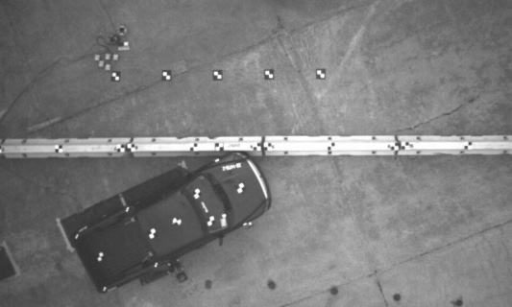
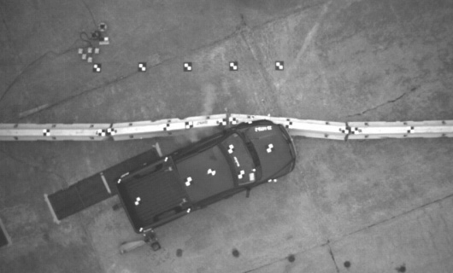
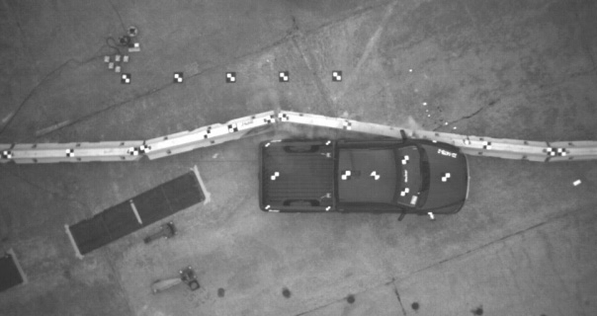
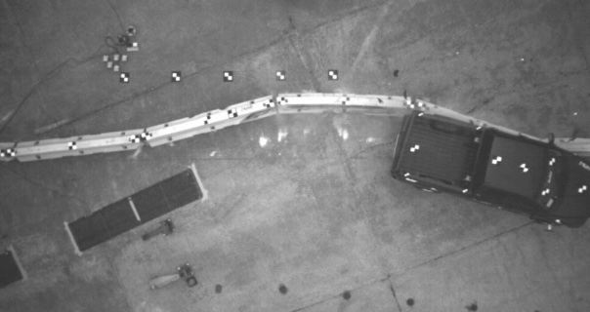
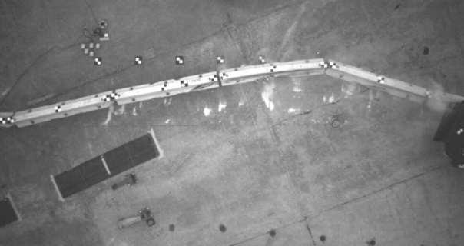
0.000 sec 0.078 sec 0.216 sec 0.400 sec 0.628 sec

258 ft [78640.04 mm]

25.4° 9 ft 10 in. [3006.70 mm]
Tire Marks
Tire Marks LF Tire

• Test Agency.............................. MwRSF
Chapter 6—Test Documentation | 105
Figure 6-2. Example of Recommended Summary Sheet for Crash Test Results
© 2009 by the American Association of State Highway and Transportation Officials.
All rights reserved. Duplication is a violation of applicable law.
• Test Number ............................. 2214TB-2
• Date .......................................... 10/12/04
- Test Article ............................... Free-Standing Temporary Barrier
• Total Length ............................. 200 ft (62.34 m)
- Key Elements – Barrier
Description ....................... F-Shape Barrier
Length............................... 150 in. (3810 mm)
Base Width ....................... 22.5 in. (572 mm)
Height ............................... 32 in. (813 mm)
- Test Vehicle
Type/Designation.............. 2270P
Make and Model ............... 2002 Dodge Ram 1500 Quad Cab Pickup Curb .................................. 4,777 lb (2167 kg)
Test Inertial....................... 5,000 lb (2268 kg)
Gross Static....................... 5,000 lb (2268 kg)
- Impact Conditions
Speed ................................ 62.0 mph (99.7 km/h)
Angle ................................ 25.4 deg
Location/Orientation......... 4 ft (1.2 m) upstream barriers 8 & 9 joint
- Exit Conditions
Speed ................................ 48.5 mph (78.1 km/h)
Angle ................................ 15 deg (estimated)
- Post-impact Trajectory
Vehicle Stability ............... Satisfactory
Stopping Distance ............. 25 ft (78.6 m) downstream
9.8 ft (3.0 m) laterally behind
• Vehicle Snagging ...................... None
- Vehicle Pocketing ..................... None
- Occupant Impact Velocity
Longitudinal...................... 16.99 ft/s (5.18 m/s) < 39.4 ft/s (12 m/s)
• Lateral (not required) ................ 17.29 ft/s (5.27 m/s) < 39.4 ft/s (12 m/s)
- Occupant Ridedown Deceleration (10 msec avg.) Longitudinal...................... 7.17 < 20 G
Lateral (not required) ........ 11.37 G
• THIV......................................... 22.60 ft/s (6.89 m/s)
• PHD .......................................... 11.52 G
- Test Article Damage ................. Moderate
- Test Article Deflections
Permanent Set ................... 73 in. (1854 mm)
Dynamic............................ 80 in. (2023 mm)
Working Width ................. 102 in. (2595 mm)
• Vehicle Damage........................ Moderate VDS .................................. 11-LFQ-3
CDC .................................. 11-LYES4
Maximum Deformation .... 4.25 in. (108 mm) at front floor pan

106 | Manual for Assessing Safety Hardware

- Test Article—Describe, to the extent possible and as space permits, the test article:
  - Type—Identify basic type of article tested (e.g., longitudinal barrier/bridge rail).
  - Installation length—Report the installation length of the test article. For a longitudinal barrier
test, this is the length of the standard barrier section, exclusive of the end terminals. For a terminal test, it is the length of the terminal and the adjoining longitudinal barrier; lengths of each should be given separately. For a crash cushion test, it is the length of the cushion and backup structure, if necessary; lengths of each should be given separately. For a TMA, it is the length of the cushion and the support truck; lengths of each should be given separately. It is not applicable for tests of support structures, work zone traffi c control devices, and break- away utility poles.
  - Key elements—Provide descriptions of the key elements of the test article, such as rails, posts,
support structures, etc., and include, as appropriate, size/dimension and material properties.

- Soil conditions—Report, if applicable, the soil conditions for the test article:
  - Type of soil—Report the type of soil used and a note should be made if there are unusual soil conditions different from those recommended in Section 3.3.1.
  - Soil strength—Report the measured soil strength at (1) initial calibration tests and (2) time of the crash test.

- Test vehicle—Parameters of interest are as follows:
  - Type/Designation—Indicate whether a production model vehicle (and its designation) or a surrogate (bogie or pendulum) test vehicle was used. For a production vehicle, also indicate the designation of the test vehicle used in the test (i.e., 1100C, 2270P, 10000S, 36000V, or 36000T).
  - Vehicle make and model—Indicate actual make and model year if a production model vehicle was used or the make and model year simulated by the surrogate.
  - Mass—See Section 4.2.1.1 for defi nition of these parameters.

- Impact conditions—Report the actual impact conditions of the test, including:
  - Speed—actual impact speed as determined from an electronic speed trap or fi lm analysis.
  - Angle—actual impact angle as determined from fi lm analysis.
  - Location/orientation—actual location of point of impact. Also, report the vehicle heading
angle if the vehicle is in a non-tracking mode at impact.

- Exit conditions—The exit conditions should be measured at the time the vehicle loses contact with the test article (see Section 5.4 for further discussion), including:
  - Speed—actual exit speed as determined from fi lm analysis.
  - Angle—actual exit angle as determined from fi lm analysis. Also, report the vehicle heading
angle if the vehicle is in a non-tracking mode at exit.
  - Report whether the exit box criterion is met or not.

- Post-impact trajectory—Report the stability and the stopping distance (or point of fi nal rest rela- tive to the initial point of impact) of the vehicle. Also, report the rebound velocity of the vehicle if applicable.

Chapter 6—Test Documentation

- Occupant risk values—Occupant risk values are computed as described in Section A5.3 of Appendix A and in Appendix F, including:
| 107

  - Occupant Impact Velocity (OIV), and
  - Ridedown Acceleration (RA).

- Test article damage—Provide a brief summary of the damage to the test article.

- Test article defl ections—Report the permanent and dynamic defl ections of the test article plus the working width during impact. These measurements normally apply to longitudinal barriers, termi- nals, crash cushions, and TMAs. Permanent defl ection is the residual lateral displacement of the test article remaining after the impact. Dynamic defl ection is the maximum lateral displacement
of the test article on the traffi c side that occurs during the impact. The working width is the maxi- mum dynamic lateral position of any major part of the system or vehicle. These measurements are all relative to the pre-impact traffi c face of the test article. For the working width, the height of the maximum working width should also be documented and reported.

- Vehicle damage—Report damage to the vehicle (see Section 4.2.1.4 for discussion of Vehicle Damage Scale (VDS) and Collision Damage Classifi cation (CDC). See Section 5.3 and Appendix E for discussion of measurement of occupant compartment deformation), including:
  - VDS and CDC scales for exterior damage
  - Occupant compartment deformation and penetration
  - Extent and location of maximum occupant compartment deformation/intrusion
  - Undercarriage damage to floorboard, fuel tank, oil pan, and rear trunk

  - Windshield damage rating, if applicable

If available, report Event Data Recorder (EDR) data and airbag deployment information as an appendix to the test report.

As part of the documentation, a video of the test(s) should be prepared. The video should include a title block identifying the test, test con- ditions, date, and sponsoring agency, before-and-after documentary coverage of the test article and vehicle, and high-speed views of the impact (both profi le and overhead). Also, it is important that the test report contain an ample number of photographs of the pre-test, test, and post-test conditions.

    - ASSESSMENT
For each crash test conducted, the impact performance of the test article should be discussed with regard to the three evaluation factors: structural adequacy, occupant risk, and post-impact vehicular trajectory. It is recommended that an assessment summary page, as shown in Table 6-3, be prepared to address each relevant evaluation criterion of Table 5-1. Note that example entries shown in Table 6-3 are for illustrative purposes only and are not all-inclusive.

In case of multiple crash tests, a table summarizing the results of the individual tests should be provid- ed, as shown in Table 6-4. Again, the example entries shown in Table 6-4 are for illustrative purposes only and are not all-inclusive.

108 | Manual for Assessing Safety Hardware

TABLE 6-3. Example of Recommended Assessment Summary Page for Individual Crash Tests

Test No.: EXP-1 Date: April 12, 2005 Test Agency: Midwest Roadside Safety Facility

Evaluation Criteria |  |  |  | Test Results | Assessment
Structural Adequacy  A. Test article should contain and redirect the vehicle; the vehicle should not penetrate, underride, or override the installation, although controlled lateral defl ection of the test article is acceptable. |  |  |  | Vehicle contained and smoothly redirected. | Pass
Occupant Risk  H. Occupant Impact Velocities (OIV) (see Appendix A, Section A5.3 for calculation procedure) should satisfy the following limits: |  |  |  | Longitudinal OIV = 33 ft/s (10 m/s)  Lateral OIV = 8 ft/s  (2.5 m/s) | Pass
 | Occupant Impact Velocity ft/s (m/s)
 | Component | Preferred | Maximum
 | Longitudinal and  Lateral | 30 (9) | 39 (12)
Vehicle Trajectory  N. Vehicle trajectory behind the test article is acceptable. |  |  |  | Not applicable | Pass
Note: Table entries are not all-inclusive and are for illustration purposes only. This table will typically require more than one page to complete.

TABLE 6-4. Example of Recommended Assessment Summary Page for Multiple Crash Tests

Evaluation Factors | Evaluation Criteria | Test EXP-1 | Test EXP-2 | Test EXP-3
Structural Adequacy | A | N/A | S | N/A
 | C | S | N/A | S
Occupant Risk | D | S | S | S
 | F | S | S | S
 | H | S | N/A | N/A
 | I | S | N/A | N/A
Post-Impact Vehicular Response | L | N/A | S | S
 | M | N/A | S | S
 | N | S | N/A | S
Test No. |  | 3-31 | 3-38 | 3-39
Pass/Fail |  | Pass | Pass | Pass
Note: S—Satisfactory
U—Unsatisfactory N/A—Not Applicable

Chapter 6—Test Documentation
| 109

Finally, a conclusion should be presented as to acceptability of the impact performance of the test article based on results of the crash test(s). Recommendations should be offered as to modifi cations that may improve the impact performance and cost-effectiveness of the test article. Recommendations should be categorized as either desirable or essential. Known or predictable limitations of the test ar- ticle, such as sensitivity to foundation conditions or effects of improper orientation of the test article, should be discussed. Recommended applications may also be identified.

MASH–1
ISBN: 978–1–56051–416–9
444 N Capitol St. NW Ste. 249 Washington, DC 20001

www.transportation.org

