American Association of State Highway and Transportation Official| | | 157

# Soil Strength Performance Test

B

**B1 Purpose**

The purpose of this dynamic soil performance test is to assure consistency and appropriateness of the foundation conditions for soil-based installations. By basing soil conditions on dynamic load response rather than a material and method specification for installation, consistency between tests, both among and within different testing agencies, will be assured. Fill materials, installation methods, and in-situ soil conditions will influence the results of this test. Also, in-situ soil conditions may even vary with location at a given test facility, so several tests may be required to assure compliance of installations at various locations.

**B2 Application**

While there are in-situ soil conditions that will provide the required minimum performance without the use of structural fill surrounding the installation, a stiffer fill material surrounding the embedded test post will be required in most situations to achieve the required soil resistance. The required lateral extent (hole size) of this fill established utilizing this standard instrumented post will be the minimum lateral extent required for testing of all future soil-based appurtenances. Note that it is acceptable to utilize a greater lateral extent of fill as this test establishes a minimum soil resistance. Also, the depth of the structural fill should always extend below the installed appurtenance.

**B3 Instrumented Post**

The use of an instrumented post as a surrogate to dynamic testing with a bogie or pendulum is intended to minimize the effort and costs associated with dynamic testing. The test post detail shown in Figure B-1 is offered as an acceptable design. However, other variants incorporating similar load measurement capabilities will be acceptable. Use of a standard W6 by 16 (W152 by 23.8) structural shape is required to assure compatibility between testing houses. Any appropriate load cell is acceptable for testing. However, the following notes of caution should be borne in mind. First, it is critical that the load cell not be preloaded. Second, it is not acceptable to utilize acceleration measurements from the impacting vehicle to determine post loading. The structural differences between different impactors can significantly influence the interpretation of load, which could in turn lead to inconsistencies between testing facilities.

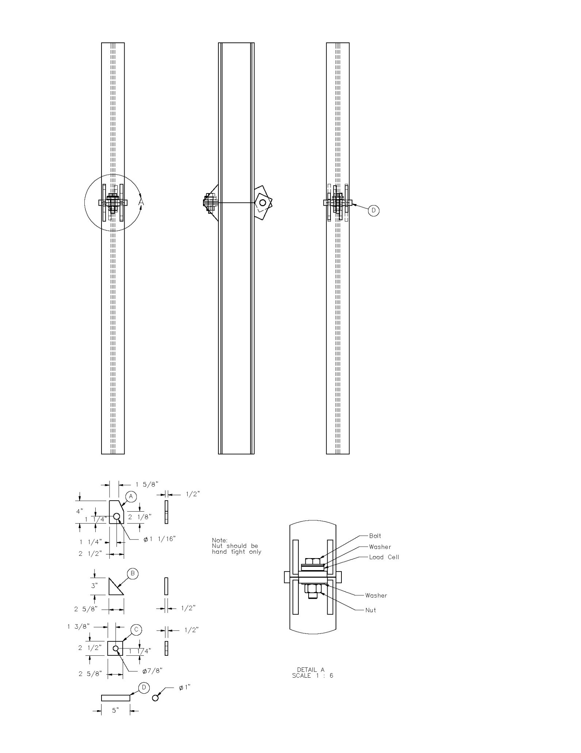

*Figure B-1. Instrumented Post*

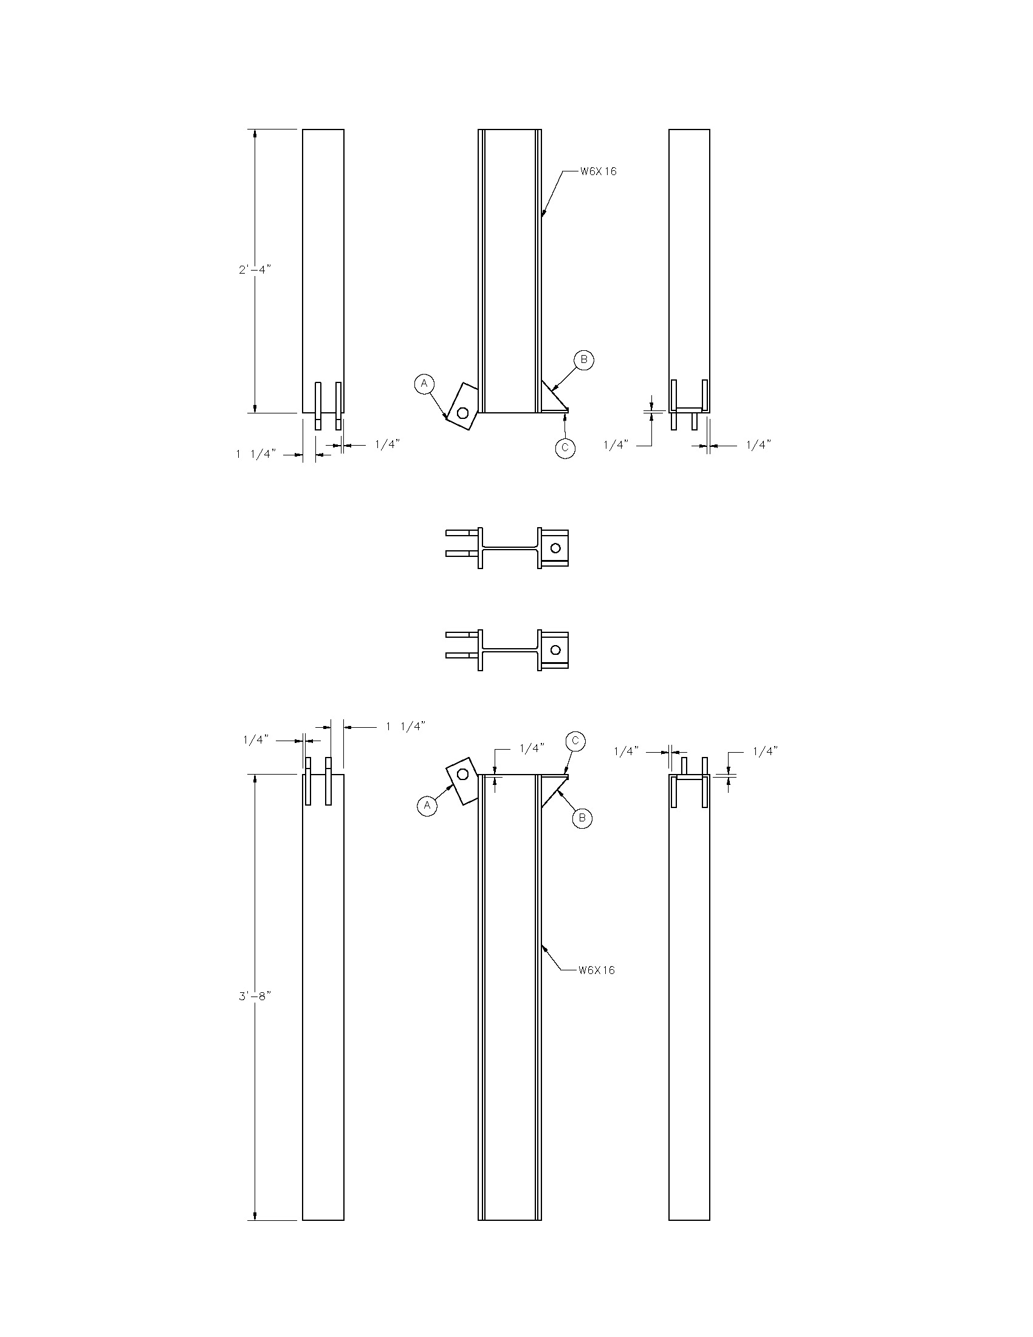

*Figure B-1. Instrumented Post (continued)*

**B4 Post Placement**

As shown in Figure B-2, the standard instrumented post should be placed with a 32 in. (813 mm) top height and 40 in. (1,016 mm) of embedment. The impact location should be at 25 in. (635 mm) above the ground line. Note that, because the objective of this performance standard is to establish a minimum load/deflection relationship, the method employed to place the post is to be decided by the test facility and may vary among testing agencies. Thus, it is important that the method employed for the installation be documented in detail. Required documentation of the installation is shown in Figure 3-1, Recommended Summary Sheet for Strong Soil Test Results.

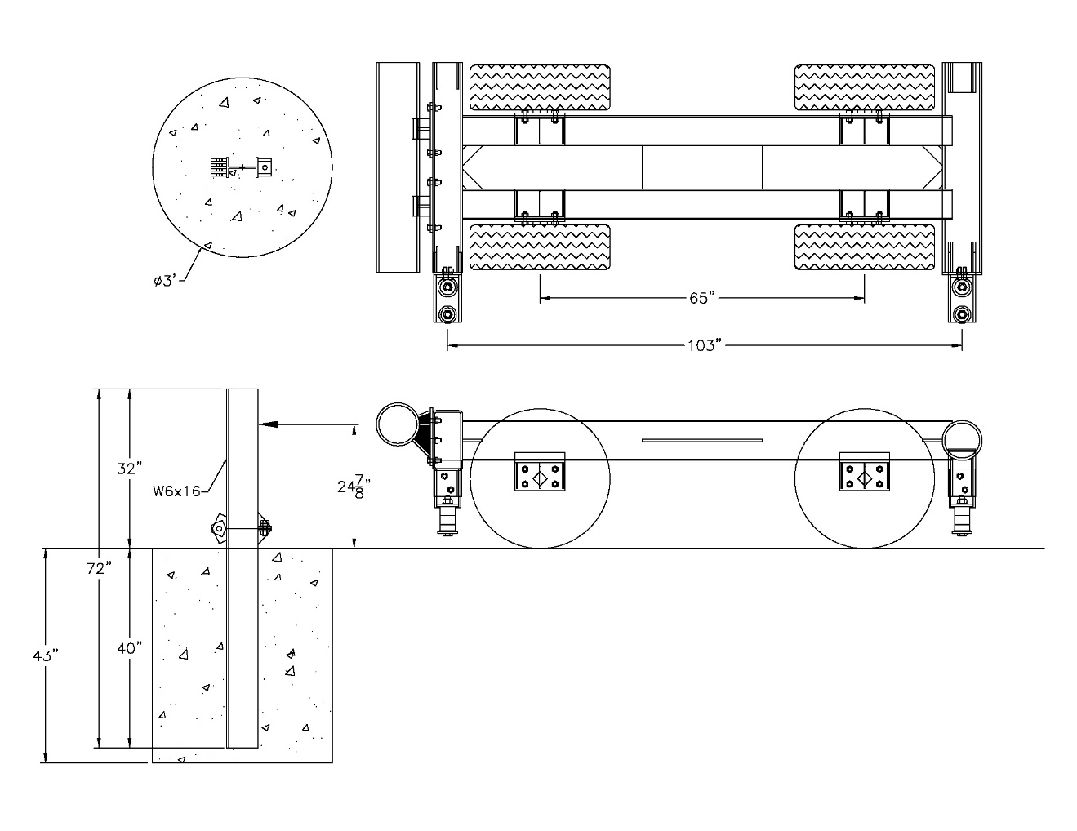

*Figure B-2. Dynamic Test Configuration*

**B5 Dynamic Test**

It is recognized that different testing facilities have various means with which to perform the dynamic testing. The specifications for the dynamic test are purposely set to be as open as possible. The desired impact conditions are:

* Impact location 25 in. (635 mm) above ground line
* Impact speed 20 mph (32.2 km/h)
* Minimum impacting vehicle/pendulum weight of 1,500 lb (680 kg)
* Rigid bumper or impact head on bogie vehicle or pendulum (Note that a crushable nose system can be implemented if post deflection is measured independently.)

Documentation required for the dynamic test includes:

* Description of bogie vehicle or pendulum and impact conditions
* Plot of post load (measured from a post mounted load cell) versus deflection (measured from high speed video or other electronic measurement technique), both determined at the load height
* Impact speed

As shown in Figure B-3, the minimum post load required for deflections from 5 in. (125 mm) to 20 in. (500 mm), measured at the impact height of 25 in. (635 mm), is 7,500 lbs (33.36 kN). If this force level is not achieved (as shown in Figure B-3) with a particular fill configuration, fill material, placement method, and native soil condition, it will be necessary to increase the lateral extent of the fill material or use a stiffer fill material. It would be most helpful if each testing facility establishes the unique relationships between the post load and the lateral extent of the fill material and other influencing factors, such as moisture content.

As mentioned previously, the native soil at a given testing facility may vary from location to location. In order to assure adequate soil resistance, the dynamic compliance tests should be performed at a location where the native soil is believed to have the lowest stiffness. In cases where the site of the dynamic test has different native soil than sites where actual crash tests are conducted, the “artificial” native soil used for the compliance testing should have lower stiffness than the actual native soil. In the case of cohesive soils, a modulus determined from an unconfined compressive strength test (ASTM D2166) for both the native and “artificial” soil can be compared. If the native soils are noncohesive, the recompacted “artificial” soil should have a lower density than that of the naturally occurring material. The native soil used in the dynamic compliance test should be documented, particularly if the soil used is different from the naturally occurring soils.

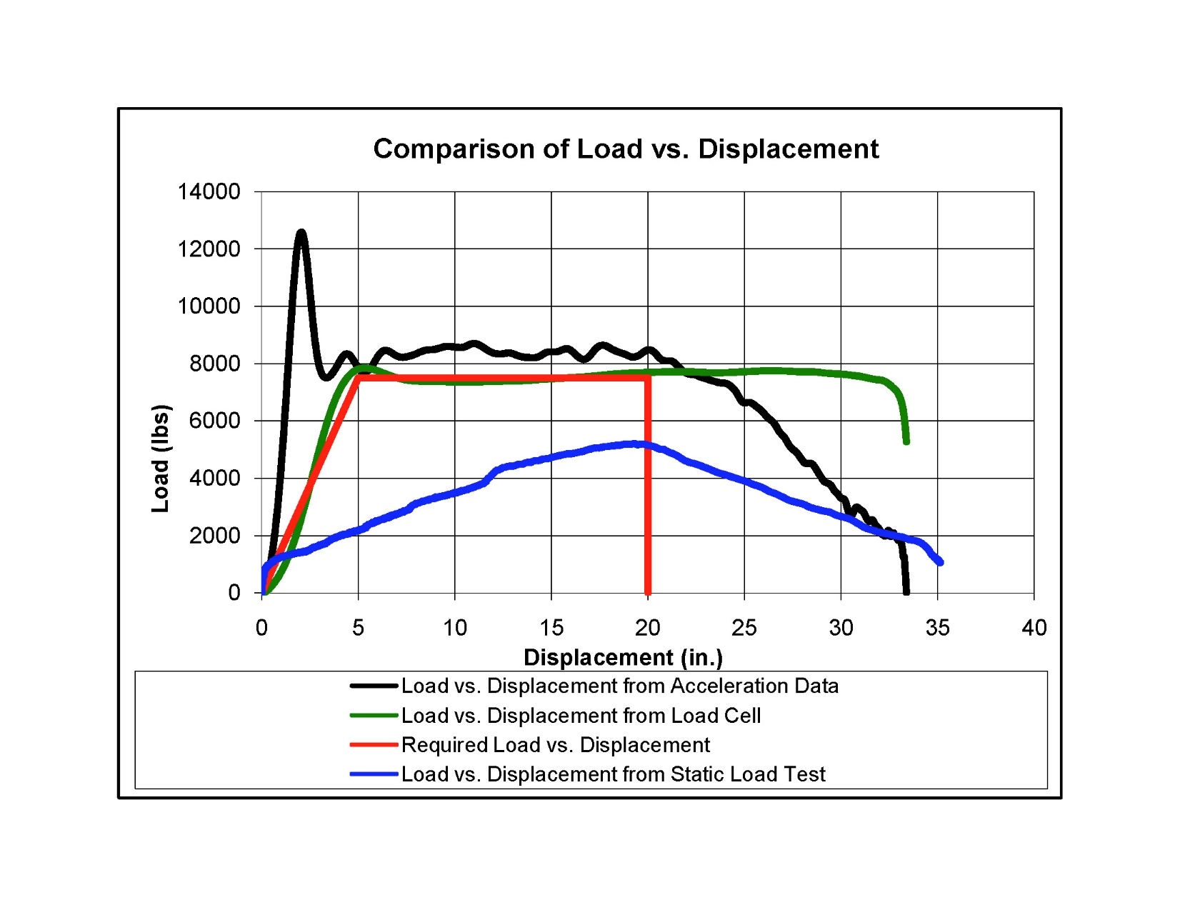

*Figure B-3. Dynamic and Static Test Results for Standard Post Test*

**B6 Assurance of Soil Performance**

Since soil performance can be influenced by a number of uncontrolled factors, it is necessary to assure that appropriate soil conditions exist on the test day. This could be accomplished by running a standard dynamic test in the vicinity of the anticipated full-scale test. However, there are obvious logistical and economic problems associated with this approach. Thus, a surrogate static test was recommended in place of the dynamic test to assure test day compliance.

The relationship between native soil and fill materials used in the standard dynamic test must be similar to those utilized for full-scale crash tests to assure consistency. It is recommended that the soil classifications of both the native soil and fill material from the standard dynamic test and the crash test be the same as defined by ASTM D2487. This comparison is available from Figures 3-1 and 3-2, both of which are recommended for inclusion in each crash test report. In addition to this classification, it is recommended that any noncohesive materials utilized in the construction of a soil-based system fall within ±10 percent of the results of the sieve analysis conducted on the fill material utilized in the initial standard dynamic test.

In order to assure that the test installation will have sufficient soil strength, a static push/pull test may be utilized, as shown in Figure B-4. To establish criteria for this static test, a second installation identical to that of the dynamic test should be constructed. This second installation will then be statically tested utilizing any convenient loading system, such as a winch or hydraulic ram. The standard post should be loaded at the same height as in the dynamic test. A plot of the load/deformation either measured or determined at the load height should be included on the soil test documentation, as shown in Figure B-3. It is recommended to use the same load cell as utilized in the dynamic test for the static test to minimize variability due to instrumentation. Deflection for the static test can be measured from any convenient reference point by hand or electronically measured as desired.

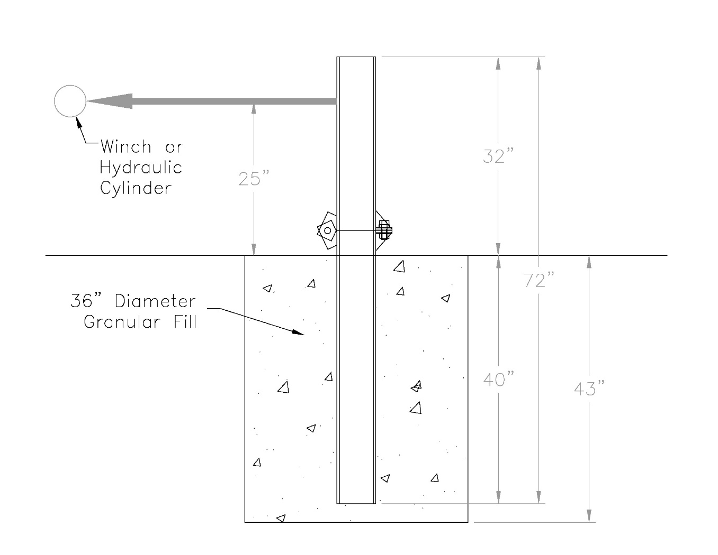

*Figure B-4. Static Soil Test*

During installation of each article for full-scale crash testing, two standard W6x16 posts should be installed in the immediate vicinity of the full-scale test article. These posts should utilize the same fill materials and installation procedures used in the standard dynamic test, even if the fill geometry is different for the full-scale test article. In addition, the static test posts should be installed at the same time as the posts in the impact region of the tested system. This installation should be located in an area where rainfall and other natural events will impact the test post in the same manner as the installed system. On the same day, but prior to the full-scale crash test, a static test of one of the standard posts should be performed. A plot of the load versus deformation should be compared to the standard established in the initial testing, as shown in Figure B-5. If the load measurements are at least 90 percent of those of the initial standard installation at deflections of 5, 10, and 15 in. (125, 250, and 375 mm), the soil condition is considered acceptable for full-scale crash testing. As shown in Figure B-5, a significant rain the previous evening has had a significant effect on the performance in this particular installation, and the soil conditions are not acceptable for testing. In this instance, additional time for drying was required prior to full-scale testing. The second installed standard post is intended for the purpose of retesting in case the soil conditions are not acceptable in the first test.

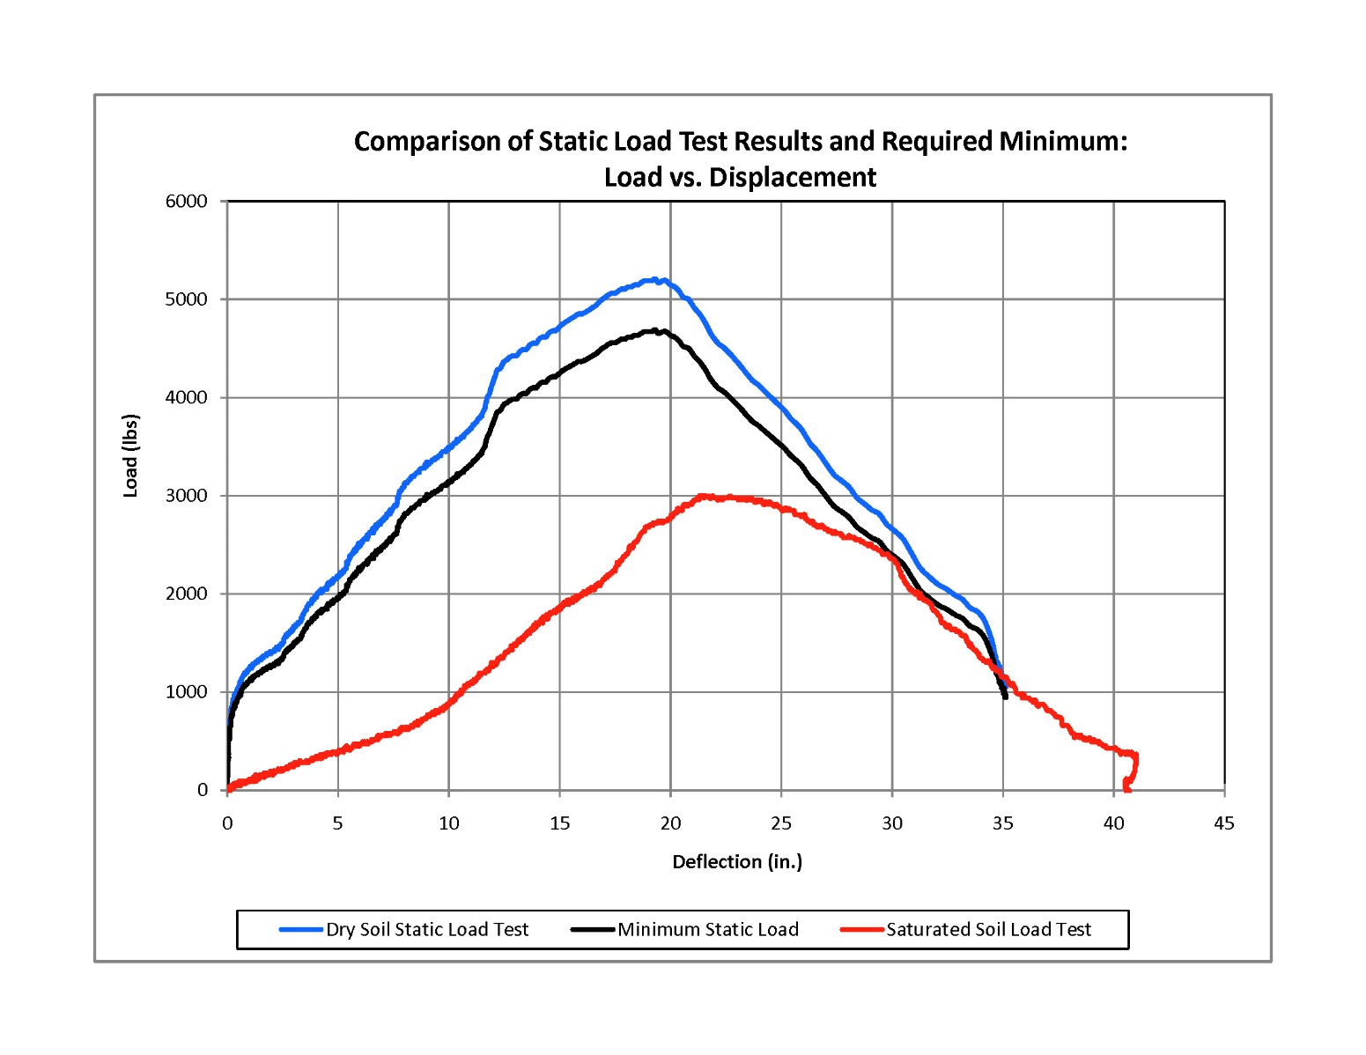

*Figure B-5. Test Day Static Load Test Compared to Standard Test*