Chapter 1-- Introduction
- No missing sections

Chapter 2 -- Test Matrices and Conditions
- No missing sections

Chapter 3-- Test Installation
- No missing sections

Chapter 4-- Test Vehicle Specifications
- No missing sections

Chapter 5 -- Evaluation Criteria
- Missing text found

Highlighted section-last paragraph on pg. 95 (balloted copy) is missing from the last paragraph on pg. 106 (Published copy)
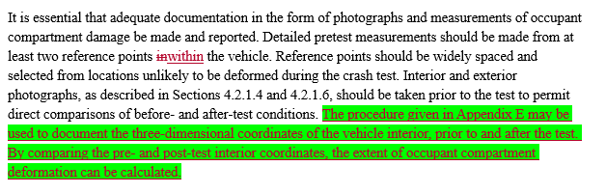
Chapter 6-- Test Documentation
- No missing sections

Chapter 7-- In-Service Performance Evaluation
- No missing sections

Appendix A-- Commentary
- Significant missing sections found (highlighted in green). Refer to “Appendix A- Comparison” word document
Missing paragraph on page 133 of published copy (can be found on pg. 123 balloted copy)
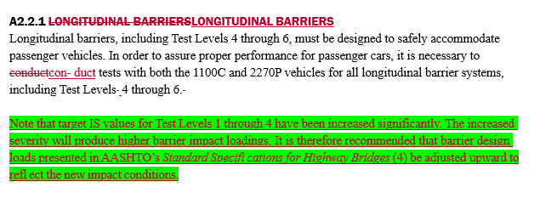
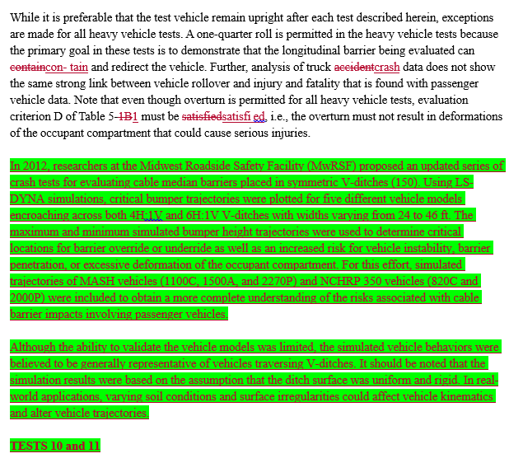
Tests 10 -18 are missing
- Refer to comparison document for additional missing sections

Appendix B-- Soil Strength Performance Test
- No missing sections
Appendix C-- Electronic & Photographic Instrumentation Specifications
- *Unknown-No balloted copy to compare to published version

Appendix D- Analytical and Experimental Tools
- Missing text found

D1.8 BOGIE TEST: Last paragraph on pg. 208 balloted copy vs.

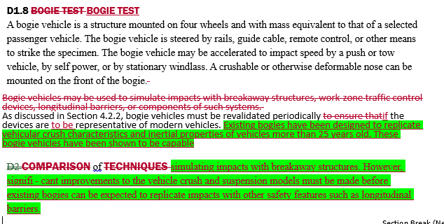
Appendix G- Occupant Risk Estimation for 1500A Vehicle

- Should the vosedan be 27078 m/s or 27.78 m/s? – pg 230 (balloted )/237 (published)

Appendix H- Test Vehicle Selection Procedures
- Missing text found: refer to Appendix H-Comparison” word document
Highlighted section found in the 2nd paragraph of balloted copy on pg. 236 is missing from the published copy on pg. 242.
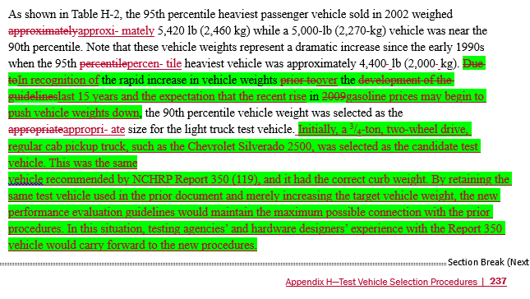

Highlighted paragraph missing: 1st paragraph on pg. 239 of balloted copy Published copy: pg. 245
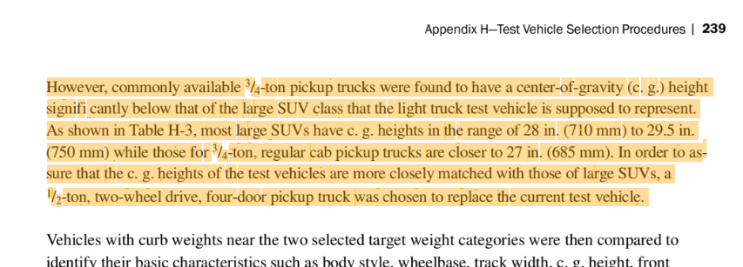

Glossary

Arrow board/arrow panel definition is missing from published copy